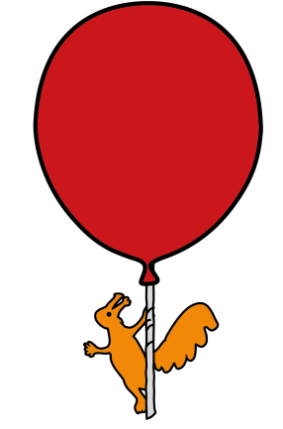


Supraregional Craniofacial Unit

Positional Plagiocephaly

Information for parents and carers

What is positional plagiocephaly?

It is a disorder that affects the shape of the skull, usually making the back or side of your baby’s head appear flattened.

The skull is made up of several “plates” of bone joined by seams (or sutures). As we grow older these seams gradually fuse – or stick together. When we are very young the bones of the skull are soft enough to be moulded. This means the shape of the head can be altered by pressure (usually at the back) to produces a flattened look. It is sometimes called “deformational plagiocephaly”. There are many other terms used to describe this condition including positional plagiocephaly or plagiocephaly without synostosis.

You may hear positional plagiocephaly referred to with discussion about craniosynostosis. This is a different condition where the skull plates fuse too early. In positional plagiocephaly the skull plates are not fused but are moulded into a different shape – a condition that does not require the surgical treatment that is often needed for craniosynostosis.

Positional plagiocepahly describes the condition where the head is asymmetrical due to deformation not because of fusion of the sutures.

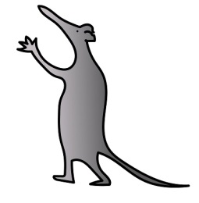
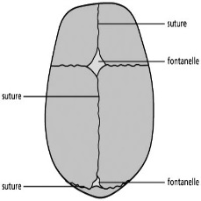

Normal skull of the new born

What causes positional plagiocephaly?

Positional plagiocephaly is the result of the baby's head staying in the same position for a prolonged period of time. The skull bones in a newborn infant are quite thin and flexible allowing for passage through the birth canal.

Why does this occur?

The main cause of the pressure is the baby’s sleeping position. Since the Back to Sleep campaign, doctors have recommended that all babies sleep on their backs to reduce the risk of sudden infant death syndrome (SIDS or ‘cot death’). Babies now spend much of their early lives lying on their backs (while sleeping, being carried about, in car seats etc).

The mattresses babies lie on are also firmer than before and it is the combination of these factors that has led to an increase in the number of babies with positional plagiocephaly.

Doctors still recommend that babies sleep on their backs as the benefit of reducing SIDS far outweighs any dangers due to positional plagiocephaly.

If the child is not repositioned every two to three hours, or if they indicate a preference to stay in the same position, molding of the skull from constant pressure and effects of gravity can occur in a gradual fashion that produces asymmetry of the head.

Babies born prematurely are at increased risk due to having a softer skull and spending even more time lying flat.

What are the symptoms of positional plagiocephaly?

There are no symptoms associated with positional plagiocephaly other than the flattened appearance of the back of the head – either evenly across the back or more on one side. It does not cause any pressure on your baby’s brain and development will not be affected by it in later life. Its importance is entirely cosmetic.

Nevertheless, if you are worried about any aspect of your baby’s health and are concerned that it might be connected with his or her head shape, you should always check with a doctor that all is well.

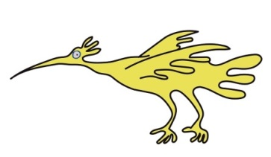
What does Positional Plagiocephaly look like?

You may notice that your child has one or more of the following:
- Flattening of one side of the back of the head.
- Forward movement of the forehead on the same side.
- Uneven positioning of the ears of the same side.
- One eye may appear smaller than the other.
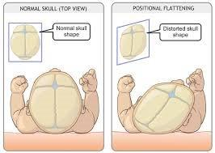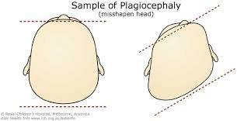
How is positional plagiocephaly diagnosed?
If your baby is not showing any other symptoms, your doctor will probably make the diagnosis by physical examination, typically, most children do not need x-rays to diagnose positional plagiocephaly. In occasional cases, an x-ray of the skull or a CT scan may be used to help differentiate different types of skull asymmetry from positional plagiocephaly.
Will my child’s head shape improve with time?
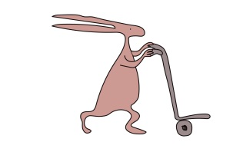
The answer is yes. Between four to six months of age, your child will develop improved head control, and around 6-8 months better movement and a lesser tendency to remain in a fixed position will occur. Other factors that will improve shape are:
• Child is old enough not to lie in one position for a long time
• Changing sleeping position lots of times each night
• Tendency to turn the head more easily in one direction than another
• Rapid brain growth in this age group.
Mild cases of positional plagiocephaly usually normalise within the first two years.
More severe cases improve slowly over months and even years, although a degree of flattening usually remains. It is very unusual for this to be enough to be provoke attention (teasing, for example) when the child attends school.
Can Positional Plagiocephaly affect the Brain?
It is important to realize that positional plagiocephaly is not a disease but a simple deformation of the skull. As a result, there is no effect on the development of the brain. As we like to say, the brain does not care what shape it is, as long as it has the space to grow.

Are there any other conditions that cause this?

The most common cause of positional plagiocephaly is due to positioning of the head in one position. Occasionally, tightness of one of the neck muscles can result in positional plagiocephaly if the child cannot look easily to the opposite side. This condition is known as torticollis and your child will be checked for this when he or she is seen in the clinic. There are some other very rare causes that cause the head to be tilted to one side, which will also be ruled out as the result of the clinic visit. Finally, skull asymmetry is very rarely caused by a premature fusion of the sutures between the different skull bones. This condition produces typical skull shapes and is easily picked out from skull asymmetry due to positional plagiocephaly.

Natural Improvement
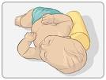
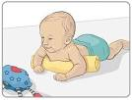

- Early recognition of Plagiocephaly - The younger the child is when it is first recognised the better the chances of stopping any progression. ‘Tummy Time’ you should not let your baby sleep on their tummies but the more time babies spend on their tummies, the better the chance of stopping the Plagiocephaly getting worse - and allow natural correction to begin. Encourage play on their tummies.
- Adjust their sleeping position so that everything exciting is in the direction they do not normally favor, for example by repositioning their toys or mobiles. A rolled up towel under the mattress may help them sleep with less pressure on the flattest part of their head.
- For children with difficulty turning their head in one direction, physiotherapy can be very helpful. The sooner they can turn their head easily form one side to another the sooner natural correction can begin.
- Prams, Car Seats, Cots and Playpens are OK to use, but remember that babies need a lot of time sitting on your lap, cuddling, active play time and chances to move.

Play with babies to get them moving, encourage crawling, rolling, reaching, pushing, pulling, holding and grasping.

Helmets and ‘Bands’

The use of these orthotic helmets remains controversial. If all actions listed previously are taken, does a helmet add anything? The answer is we do not know for sure. They often have to be worn for several months and for around 23 out of 24 hours of the day. If they are to be effective, it would seem sensible to start them when the head is still ’plastic’ enough to have the natural correction process encouraged by restricting growth in the ‘bulgy’ parts of the head while encouraging growth in the flatter areas by leaving them free- preferably before 6months of age. These Bands and Helmets are not currently funded by the NHS.

*A recent study has been published supporting management without helmets. “This study found no evidence of a significant or clinically meaningful difference in improvement of skull shape at 2 years of age between infants who were treated with a Helmet and those in which the natural course of skull deformation was waited”
*A study by Renske M van Wijk et al published in BMJ 2014;348:g2741

If you have any queries please contact:
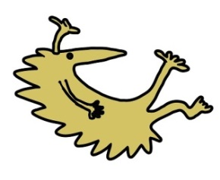
Alder Hey Children’s NHS Foundation Trust
Supraregional Craniofacial Unit
Eaton Road
Liverpool L12 2AP

Tel: 0151 282 4569

Fax: 0151 252 5018

Is there a support group?
There is no support group specifically for positional plagiocephaly, but the following group may be able to offer support and advice: Headlines: 44 Helmsdale Road, Leamington Spa, CV32 7DW.
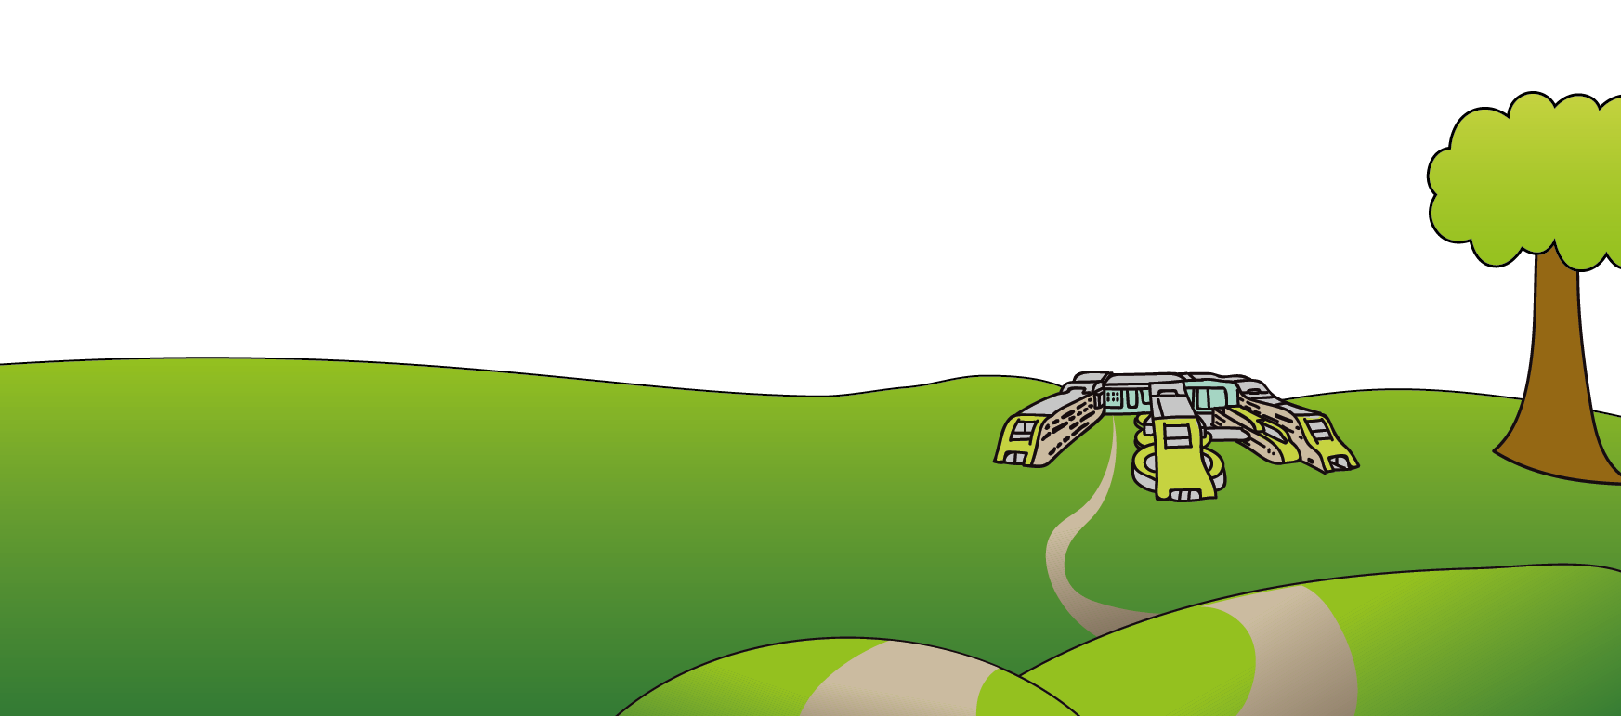
This leaflet only gives general information. You must always discuss the individual treatment of your child with the appropriate member of staff. Do not rely on this leaflet alone for information about your child’s treatment. This information can be made available in other languages and formats if requested.
Alder Hey Children’s NHS Foundation Trust
Alder Hey
Eaton Road
Liverpool
L12 2AP

Tel: 0151 228 4811
www.alderhey.nhs.uk

© Alder Hey Review Date: December 2027 PIAG: 032

