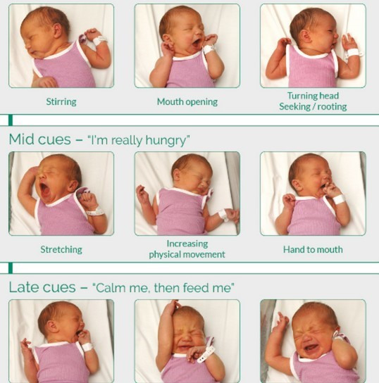

This leaflet only gives general information. You must always discuss the individual treatment of your child with the appropriate member of staff. Do not rely on this leaflet alone for information about your child’s treatment. This information can be made available in other languages and formats if requested

Alder Hey Children’s NHS Foundation Trust

****Eaton Road

Liverpool

L12 2AP

Tel: 0151 228 4811

[www.alderhey.nhs.uk](http://www.alderhey.nhs.uk)

**© Alder Hey Review Date: November 2027 PIAG: 342**



**Department Neonatal**

**Paced Responsive Bottle Feeding**



**Information for patients,**

**parents and carers**



**Intro****duction**

At Alder Hey, we promote breast feeding as the most natural way to feed your baby. However, if you decide you would like to bottle feed, either expressed breast milk or formula, you will be fully supported in doing this.

**What is paced responsive bottle feeding?**

Bottle feeding as responsively as possible helps with building a close and loving relationship between you and your baby. Try to limit the number of people who feed your baby as it is important for bonding that your baby gets to know your voice, smell etc first.

It is best to follow your baby’s feeding cues, rather than following the clock. Every baby will show different cues, which may include rooting, opening their mouth, sucking their fingers etc. Crying is the last cue, and you should try to avoid waiting for your baby to cry before feeding him/her. You will get to know your baby’s cues the more time you spend together (see image on back page)

If you are breastfeeding, try to wait at least 6 weeks before introducing a bottle to give your baby the best chance of learning what to

**How to do it**

* Hold your baby close to you, ideally in skin to skin, and upright with head supported but not restricted. Your baby needs to feel safe to have a positive feeding experience
* Invite your baby to take the teat by brushing it over his/her top lip. Never force the teat into your baby’s mouth

- Hold the bottle horizontally ensuring the teat is filled with milk. This will allow him/her to pace their feed and take pauses when they need to

- Try to look at your little one, gently talking and stoking them whilst feeding. This positively impacts on social and emotional development. It is also nice for you!

- If you are also breastfeeding, try to offer your baby their bottle in different positions. This will help them to adjust to both breast and bottle

**How to know when your baby has had enough or needs a break**

-Babies tend to tell you when they need to take a pause. They may stop sucking, push the teat away with their tongue, dribble milk or even fall asleep. This is a good time to wind your baby and then see if they show signs they want to have any more milk.

- Overfeeding your baby can lead to vomiting, reflux, obesity, discomfort etc and is a negative experience for your baby

*Never force feed your baby. This is distressing for them*

**Remember….. feeding is a communication and is a special time for you and your baby to get to know each other. Be patient and learn together.**