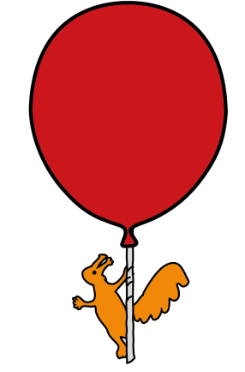


Pharmacy Department

Administration of medication via Enteral Feeding Tube

Information for parents/carers

Introduction

This leaflet has been put together to provide information and guidance to families and carers, on the administration of medications via enteral feeding tubes.

Medication administration through enteral feeding tubes may be appropriate in patients who are unable to take their medicines orally. Most medicines are not designed to be given through an enteral feeding tube, therefore it is important that great care is taken throughout the administration process.

However should you have any questions or problems, please do not hesitate to contact your doctor, nurse or pharmacist.

Types of Enteral Feeding Tubes

There are many types of enteral feeding tubes; they are available in many lengths and sizes and can be placed into a variety of places within the gastrointestinal tract. Some drugs are absorbed in a specific area of the body so your pharmacist will assess each drug to check where in the body it is absorbed, and tailored advice can be provided on the administration of individual drugs via enteral feeding tube.

As some enteral feeding tubes can be longer and narrower, they are more likely to block. The correct choice of drug formulation and effective flushing of the feeding tube are essential to avoid blockage.

Some children can have enteral feeding tubes that terminate in their stomach and in their jejunum (small intestine). It is important to only administer the medication into the enteral feeding tube that you have been told to, do not administer a medicine into another enteral feeding tube without first discussing with your doctor.

Gastrostomy tubes
Gastrostomy tubes go directly into the stomach. Some medications administered this way can delay the stomach emptying and this can cause reflux. Your child may need to sit upright if possible to help with the stomach emptying.

Jejunostomy tubes
Jejunostomy tubes go directly into the jejunum which is part of the small intestine. The jejunum cannot expand, so you may be instructed to use smaller volumes of flushes and different formulations of medications in order to reduce the volume being administered. Administering the medicine slowly over a few minutes can help to avoid irritation to the jejunum.

General Information on preparing medicines

- Wash your hands with soap and water before starting.
- Check the label to ensure you are giving the correct medicine (this can be particularly important if your child is on more than one medicine), and check the expiry date on the bottle.
- Medicines should be administered immediately after they are prepared, do not store for future use.
- Suspensions should be shaken well before drawing up a dose.
- Never mix medicines together, each medicine should be given separately and the tube flushed inbetween (unless directed otherwise by your doctor).
- Never use boiling water to prepare medicines as it can damage the medicine.
- When giving several medicines at the same time, ‘syrup’ medicines are usually given last.

Liquid medications (suspensions or solutions)

Administration of Liquids

- If you are administering a suspension, shake the bottle thoroughly to ensure the drug is mixed well.
- Draw the dose of liquid medicine into an appropriate size ENFit syringe (the amount of medicine in mL should be on the pharmacy label). Gently tap/flick the syringe to remove any excess medicine around the moat.

- Sometimes you will need to then dilute the dose with a specific amount of water, this is normally to try and reduce the thickness of the medicine, and/or reduce potential side effects. If you need to do this with a certain liquid medicine, you will be told by your doctor, nurse or pharmacist.
- Stop the enteral feed if it is running.
- Flush the enteral feeding tube with the recommended volume of water.
- Flush the drug dose down the enteral feeding tube.
- Finally, flush the enteral feeding tube with the recommended volume of water.
- Re-start the feed, unless you have been told to stop the feed for a specific amount of time following drug administration.

Tablets and capsules

Liquid formulations of medications are preferred, however sometimes your doctor will prescribe a tablet or capsule formulation. This can be for many reasons, such as:

- Risk of tube blockage if the liquid medicine is very thick.
- The liquid medicine may contain some ingredients that are problematic for your child, such as allergies, or dietary requirements.
- The volume of liquid medicine required to achieve your child’s dose may be too large.
- Not all tablets can be crushed, it is important not to crush tablets or open capsules unless instructed to do so by your doctor.

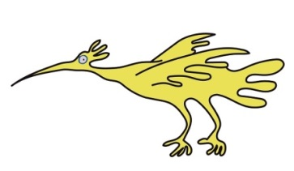
Modified release tablets, enteric coated tablets, cytotoxics, antibiotics and hormone tablets should not routinely be crushed.

Administration of Tablets

  - For normal tablets – place the correct number of tablets into the recommended volume of water and allow to disperse, mixing if necessary. Inspect the solution to ensure that there are no large particles that might block the tube. Most normal tablets will disperse in water, without the need for crushing, however if there are issues with a certain brand, the tablet could be crushed before mixing with water.
  - For soluble tablets – place the correct number of tablets into the recommended volume of water and allow to dissolve, mixing if necessary. Inspect the solution to ensure there are no visible particles.
  - For effervescent tablets – place the correct number of tablets into the recommended volume of water and allow to disperse, mixing if necessary. Inspect the solution once the effervescent tablet has stopped fizzing, to ensure there are no visible particles that may block the tube.
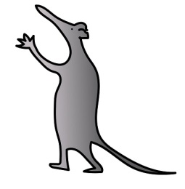
  - For dispersible tablets – place the correct number of tablets into the recommended volume of water and allow to disperse, mixing if necessary. Inspect the solution to ensure that there are no large particles that might block the tube.

- Draw up the entire contents using an appropriate size ENFit syringe.
- Stop the enteral feed if it is running
- Flush the enteral feeding tube with the recommended volume of water.
- Flush the medicine dose down the enteral feeding tube.
- Rinse the medicine pot with more water and using the same ENFit syringe, draw up this water and administer via the enteral feeding tube to ensure the total dose is given.
- Finally, flush the enteral feeding tube with the recommended volume of water.
- Re-start the feed, unless you have been told to stop the feed for a specific amount of time following drug administration.

For some tablets that disperse well in water, it may be easier and more accurate to remove the plunger from the ENFit syringe and place the tablet(s) into the barrel of the syringe. Replace the plunger and draw up the recommended volume of water into the syringe and allow the tablet to disperse or dissolve, shaking as necessary (you may want to place some kitchen roll over the tip of the syringe to stop any medicine spilling out). The syringe should be inspected before administration, for any visible large particles that may block the tube. Your pharmacist will provide more information on this.
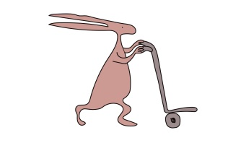
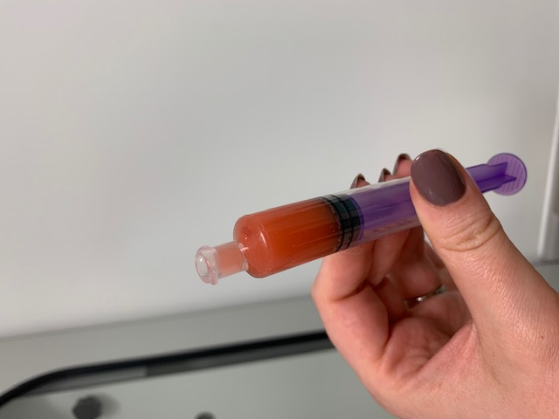
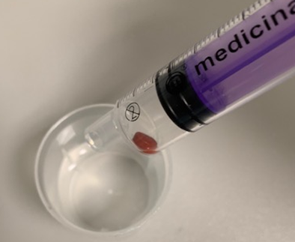
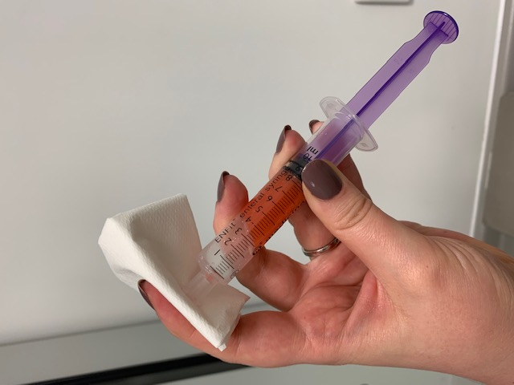
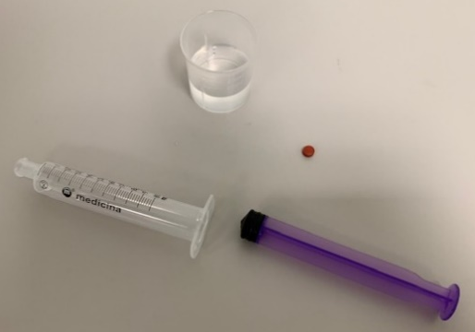

Administration of Capsules

- Open the capsule and pour the contents into a medicine pot. Add the recommended volume of water and stir to disperse the powder.
- Draw up the entire contents using an appropriate size ENFit syringe.
- Stop the enteral feed if it is running.
- Flush the enteral feeding tube with the recommended volume of water.
- Flush the medicine dose down the enteral feeding tube.
- Rinse, the medicine pot with more water and using the same ENFit syringe, draw up this water and administer via the enteral feeding tube to ensure the total dose is given.
- Finally, flush the enteral feeding tube with the recommended volume of water.
- Re-start the feed, unless you have been told to stop the feed for a specific amount of time following drug administration.

Flushing the enteral feeding tube

The enteral feeding tube should be flushed with water at the start of medication administration, between each drug, and at the end of medication administration. This is to prevent the drugs from coming into contact with each other and the feed whilst inside the tube, it also helps maintain patency of the tube.

Your dieticians will tell you how much water to use as a flush. You may have a fluid balance chart so you can record your child’s daily intake of fluid including the fluid from medication and flushes.

We recommend using freshly drawn tap water that has been boiled and cooled, for flushes and to mix medication with (if necessary).

Your nursing team will show you how to flush the enteral feeding tube, and also how to deal with blockages.
Health and Safety

- It is important to only use ENFit syringes when administering medicines via an enteral feeding tube.
- Enteral feeds can interact with some medicines.You will be told if there needs to be a break between medication administration and enteral feed administration.
- Do not add drugs to the enteral feed, unless you have been specifically told to do so by your healthcare professional team.
- When handling medicines, particularly tablets and capsule formulations, it is important to take appropriate precautions to minimise exposure/inhalation by the operator (mainly drug powder from tablet/capsule):

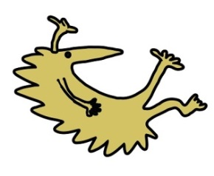
  - Perform preparation of drugs in a quiet room with a closed door and limit the movement of people through the room during preparation.
  - All equipment used for administering medicines must be cleaned in between each use to prevent cross-contamination of medicines. Work surfaces should be thoroughly cleaned following medication preparation to remove any drug residues and ensure the safety of others.
  - Medicines such as corticosteroids hormones, antibiotics, immunosuppressants, cytotoxics and phenothiazines are irritant or potent and extra precautions should be taken when handling these medications (e.g. wear gloves and face mask). Your doctor or pharmacist will let you know if any of your child’s medications need extra precautions whilst handling.

- Try and stick to a consistent method of administration, and administer your child’s medications at the same time each day.
- Monitor your child for any side effects or signs that the medication may not be working.
- If you notice any side effects, make a note of the timings as this may help us to identify and resolve any problems with medication administration.

When giving your child a medicine, if you notice anything unusual and are concerned, contact your doctor. You should continue to give the medicine as usual, unless your doctor tells you not to.

Anyone can report a suspected side effect to The Medicines and Health Care products Regulatory Agency (MHRA) via its Yellow Card Scheme; www.mhra.gov.uk/yellowcard
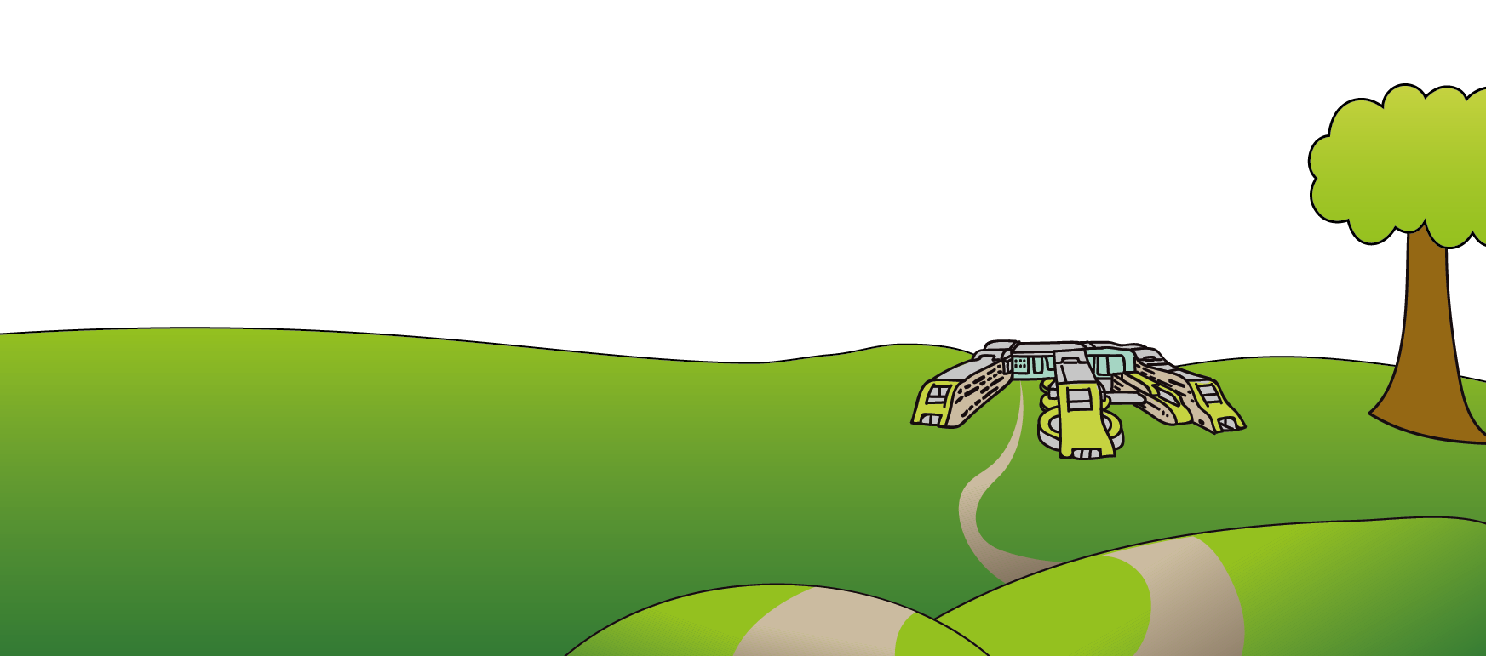
Useful videos and guides on administering medicines to your child can be found on www.medicinesforchildren.org.uk/advice-guides
This leaflet only gives general information. You must always discuss the individual treatment of your child with the appropriate member of staff. Do not rely on this leaflet alone for information about your child’s treatment.
This information can be made available in other languages and formats if requested.

Alder Hey Children’s NHS Foundation Trust
Alder Hey
Eaton Road
Liverpool
L12 2AP
Tel: 0151 228 4811
www.alderhey.nhs.uk
© Alder Hey Review Date: April 2025 (extended to October 2025) PIAG: 399

