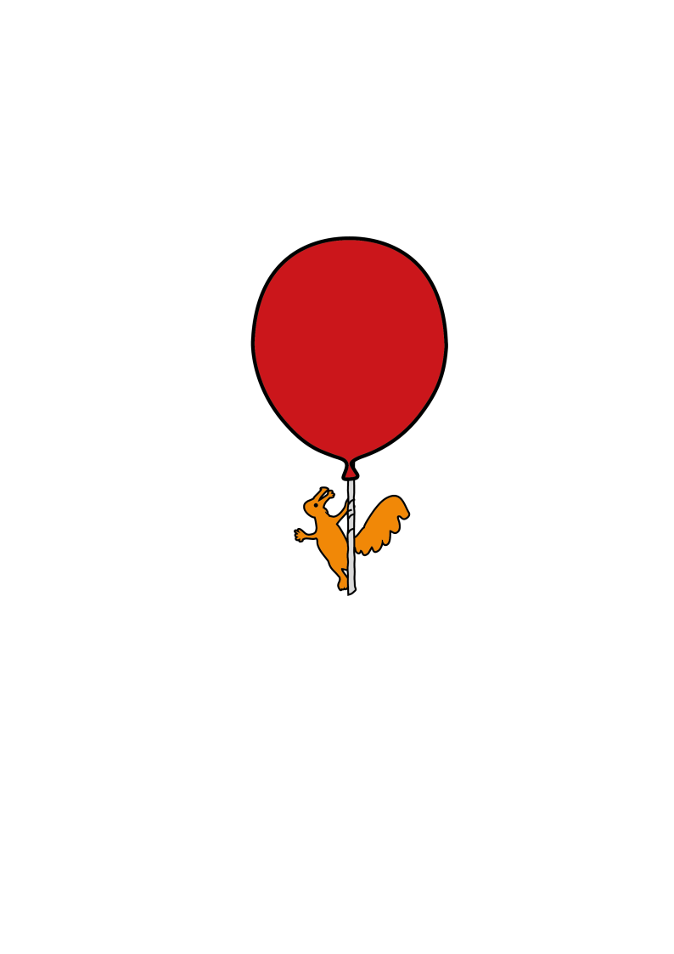

Ophthalmology Department

**Orthoptic Exercises**

Information for young people

**Introduction**

Following your assessment in the Orthoptic Eye Clinic today the Orthoptist has diagnosed convergence insufficiency as the likely cause of your symptoms.

**What is Convergence Insufficiency?**

There are six muscles connected to each eye that move the eyes around. The eye muscles closest to the nose should pull both eyes inwards smoothly when looking at an object close up. This is important for reading or other close work. Weakness of these eye muscles may cause problems in co-ordinating the eyes for close work activities - this is called Convergence Insufficiency.

**What symptoms does Convergence Insufficiency cause?**

Symptoms are associated with close work activities and include:

• Blurred vision, or words looking like they are ‘jumping’ or ‘jumbling’ on the page.

• Intermittent double vision.

• Headaches at the front of the head and around the eyes.

• Eye strain.

• Difficulty in changing focus from distance to nearby

**Treatment for Convergence Insufficiency**

There are different types of eye exercises to treat convergence insufficiency, and your Orthoptist will prescribe the relevant exercise for you. The best results are found when exercises are carried out regularly. You will be advised how often and for how long you will need to do the exercises at your appointment. You may feel a lot of strain on your eyes at first and some patients say that their symptoms initially get worse before they get better. This is normal. You should come to all your follow up appointments so we can check on progress and any problems you may have experienced.

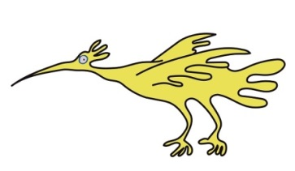

**Types of Eye Exercises**

These are basic instructions which should be followed. Your Orthoptist may tailor these to your individual needs and will demonstrate the technique to you in your appointment.

**Smooth Convergence**

This exercise is usually done with a pen or a target on a lollipop stick

1. Keeping your head is straight and still; begin with the target held at arms-length slightly below your eye level. Focus on the target ensuring it is clear and single.

2. Gradually move the target towards your nose making sure you continue to focus on the target whilst single vision is maintained.

3. At the point at which the target becomes double, stop moving the target, but continue to focus on it. Do not look away.

4. Using your eye muscles try to force the two images together to make one single image. Ensure that you keep both eyes open and focused on the image.

5. If single vision is achieved continue to move the target closer towards your nose, trying to always maintain single vision.

6. If you cannot achieve single vision, move the pen, or target slightly further away and try again.

7. Your Orthoptist will check that you are correctly carrying out the exercises at your follow up appointment.

**Try this exercise for _____________ minutes at a time**

**____________________________ times per day.**

**Do not forget to relax your eye muscles afterwards – by looking into the distance for a few minutes.**

**Dot Card**

Your dot card will be provided by your Orthoptist.

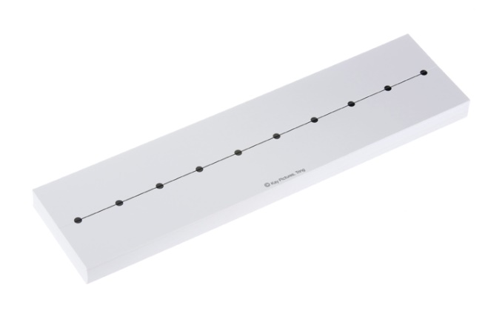

Diagram of a dot card

1. Bend the card slightly lengthways along the central crease, so it forms a wide V shape. Hold one end of the card at the tip of your nose, pointing slightly downwards.

2. Look along the line at the furthest dot and try to make your eyes see this as one dot (singly) by gently using your eye muscles to pull the eyes inwards.

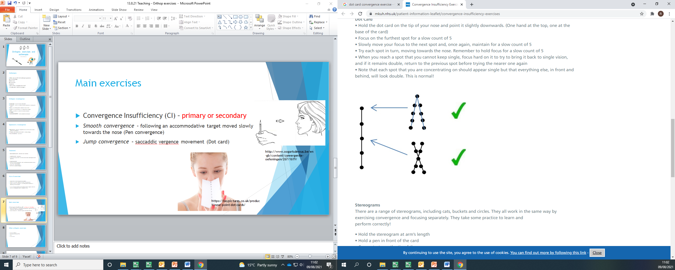3. Once you see the furthest dot singly, the nearer dots should appear double and they will fan out towards you. This is normal.

4. Maintain the furthest dot as one single image for a few seconds then look at the next dot closer to you. Once you see this nearer dot as one single image, hold and maintain for a few seconds.

5. Continue up the line of dots ensuring whichever dot you are focusing on is maintained as a single dot.

6. If you are not able to make the dot single go back to the previous dot and try again.

7. If you can only get a short way down the dot card but no further, keep practising.

**Try this exercise for _____________ minutes at a time,**

**____________________________ times per day.**

**Do not forget to relax your eye muscles afterwards – by looking into the distance for a few minutes.**

Images from:

Eshop.haagstreituk.com

http://www.oogartsderous.be/en-gb/content/ convergentie-oefeningen/267/1619

**Stereograms**

Your stereogram will be provided by your Orthoptist. Stereograms may be used to improve the fine coordination of your eyes. A stereogram has two incomplete images, which when joined will make one complete image. This may be seen in 3D, depending on which stereogram is used. You will usually start with the simplest stereogram, which has two incomplete cats on it. You may progress to more detailed cards once the cat card is easily achieved if necessary.

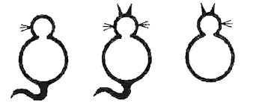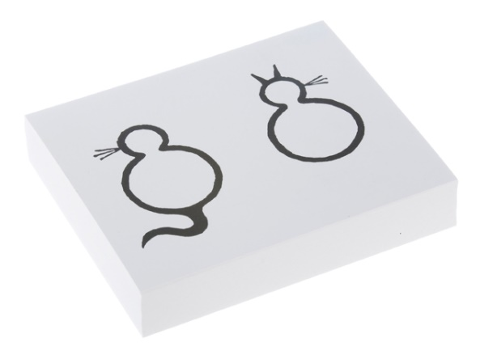

**How to do the Stereogram exercise**

1. Hold the cat card at arms-length on eye level.

2. Then hold a pen halfway between the card and your face.

3. Concentrate on looking at the top of the pen. You must keep the pen as one single image.

4. Slowly move the pen towards you, looking at the pen constantly. Do not look directly at the card or the exercise will not work. You should be aware of both the incomplete cat images becoming double; therefore, you should be aware of four images.

5. Continue to slowly move the pen towards you and the four images should merge into three. The middle image will appear complete if you are using the cat card or becoming 3D with the bucket or ring card. Illustration of three incomplete cats

6. Once the middle image is achieved try to make it as clear as possible. If you become very good at this exercise, you may be asked to do the exercise without using the pen.

7. After doing the exercise it is very important to relax your eyes, by looking into the distance, or by closing your eyes for a minute or so.

**Try this exercise for _____________ minutes at a time,**

**____________________________ times per day.**

**Do not forget to relax your eye muscles afterwards – by looking into the distance for a few minutes.**

Images from:

Eshop.haagstreituk.com

Bmec.sqbh.nhs.uk

**Relaxation**

It is extremely important that you relax your eyes after carrying out the exercises to ensure the muscles are not over worked and do not go into spasm (this is very rare and occurs when the eye muscles are not fully relaxed). Relaxation can be as simple as closing your eyes for one or two minutes or looking out to the far distance to ensure your eye muscles are fully relaxed following the exercises.

It is important not to carry out the exercises for a longer period than specified by your Orthoptist, little and often is advised.

**Appointment attendance**

It is vital that you attend all your appointments. If you are unable to attend your appointment, or if you miss an appointment, please let us know as soon as possible so that an alternative appointment can be arranged. Failure to attend may result in you being discharged; your GP and referrer may be informed. For further information If you have any queries or need further information, please telephone the Ophthalmology Department on: 0151 252 5215

This leaflet only gives general information. You must always discuss your treatment with the appropriate member of staff. Do not rely on this leaflet alone for information about your treatment.

This information can be made available in other languages and formats if requested.

Alder Hey Children’s NHS Foundation Trust Eaton Road, Liverpool. L12 2AP

Tel: 0151 228 4811

www.alderhey.nhs.uk OE/F/1

©Alderhey2017

This information can be made available in other languages and formats if requested.

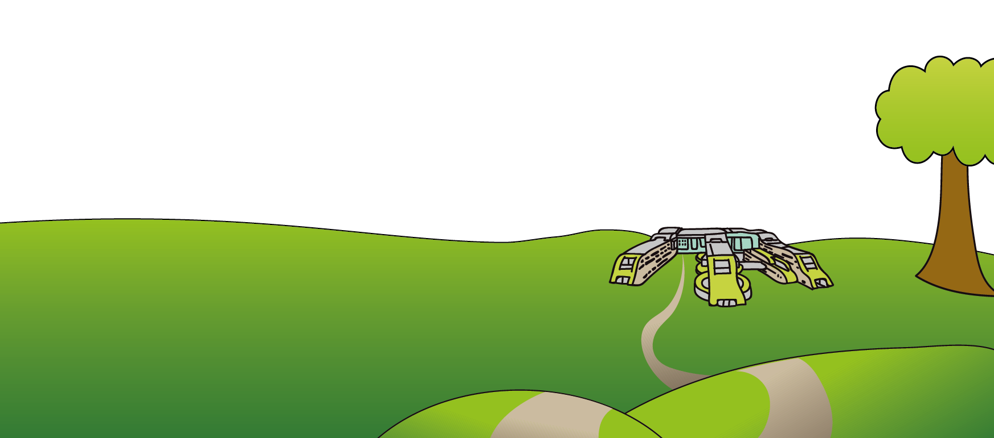Alder Hey Children’s NHS Foundation Trust Alder Hey

Eaton Road

Liverpool

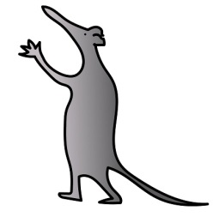L12 2AP

Tel: 0151 228 4811

[www.alderhey.nhs.uk](http://www.alderhey.nhs.uk)

**© Alder Hey Review Date: February 2028 PIAG: 008**