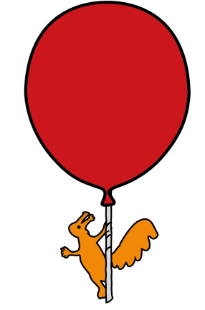


The Roald Dahl Neurophysiology Department
Natural Sleep EEG Test- Infants & Babies
Information for parents and carers

What is an EEG test?

An EEG or Electroencephalogram is a test used to help investigate a number of conditions, most commonly black outs or seizures. The EEG records the activity of the brain via small electrodes which are applied to the scalp with a special paste. Simultaneous video of your child is also recorded

Will this EEG test hurt my child?

No, as it is a painless test and there are no side effects. There is no alternative to this test. If your child does not have this test it may affect the management of their condition.

How long will this procedure take?

The test takes between 30 - 90 minutes, but on average around 45 minutes. It is hoped that your child will fall asleep naturally during this test.

Preparing for the EEG test

If your child is a baby or infant, please bring their bottle and some feeds as feeding often settles them to sleep. You can feed them during electrode application.

For the test, please ensure your child has clean hair which is free from hair gel etc. Make sure your child continues with their regular medication unless advised otherwise by your child’s Consultant.

Natural Sleep recording

A natural sleeping EEG helps to show up brain activity which may not be present in the waking EEG and this information may help your doctor with your child’s diagnosis.

It is hoped that your appointment time coincides with your child’s nap, therefore allowing us to obtain a natural sleep recording. Please ring the department on 0151 252 5375 if you want to re-schedule to a more suitable time to fit around your baby’s nap.

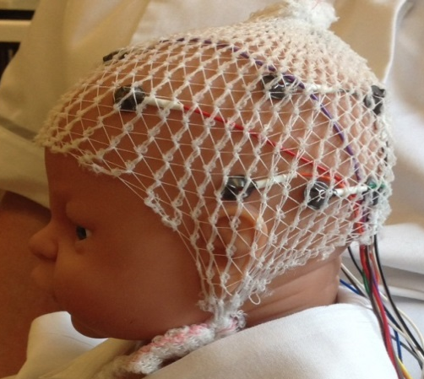
Please do not let your child fall asleep on the journey to the hospital as this will stop them from falling asleep during the test.

What should I expect to happen during this test?
The test is performed by the Clinical Physiologist who will explain all aspects of the test thoroughly.

You will be asked to sign a form to allow for consent for teaching purposes.

Small disc shaped disposable electrodes are applied to your child’s scalp using a water soluble sticky paste. We will not shave / cut their hair.
Doll with electrodes attached

During the test

During the EEG your child’s brain signals appear as wavy lines on a computer screen.
We will record these signals whilst your child is awake and asleep.

Your child may be shown a strobe light to see if their brain is sensitive to flashing lights (only a very small percentage of children are sensitive) – this is called photosensitivity. In some people, strobe lights may trigger an episode or event (again this is rare) but this procedure is an important part of the EEG test. The result of this part of the test will give the doctor more information which may help to make a diagnosis.

At the end of the test

There are no after effects and we remove the electrodes with a little warm water. Your child can then go back to nursery if you wish.

The Clinical Physiologist cannot show you any waveforms or give you the results of the EEG on the day of the test. You will receive the results at your next clinic appointment.

If you require further information about the test please telephone 0151 252 5375

Where is the department located?
Use the blue set of lifts directly next to the Concierge/help desk up to the 4th floor. Upon exiting the lift, turn right.

This leaflet only gives general information. You must always discuss the individual treatment of your child with the appropriate member of staff. Do not rely on this leaflet alone for information about your child’s treatment.
This information can be made available in other languages and formats if requested.

Alder Hey Children’s NHS Foundation Trust
Alder Hey
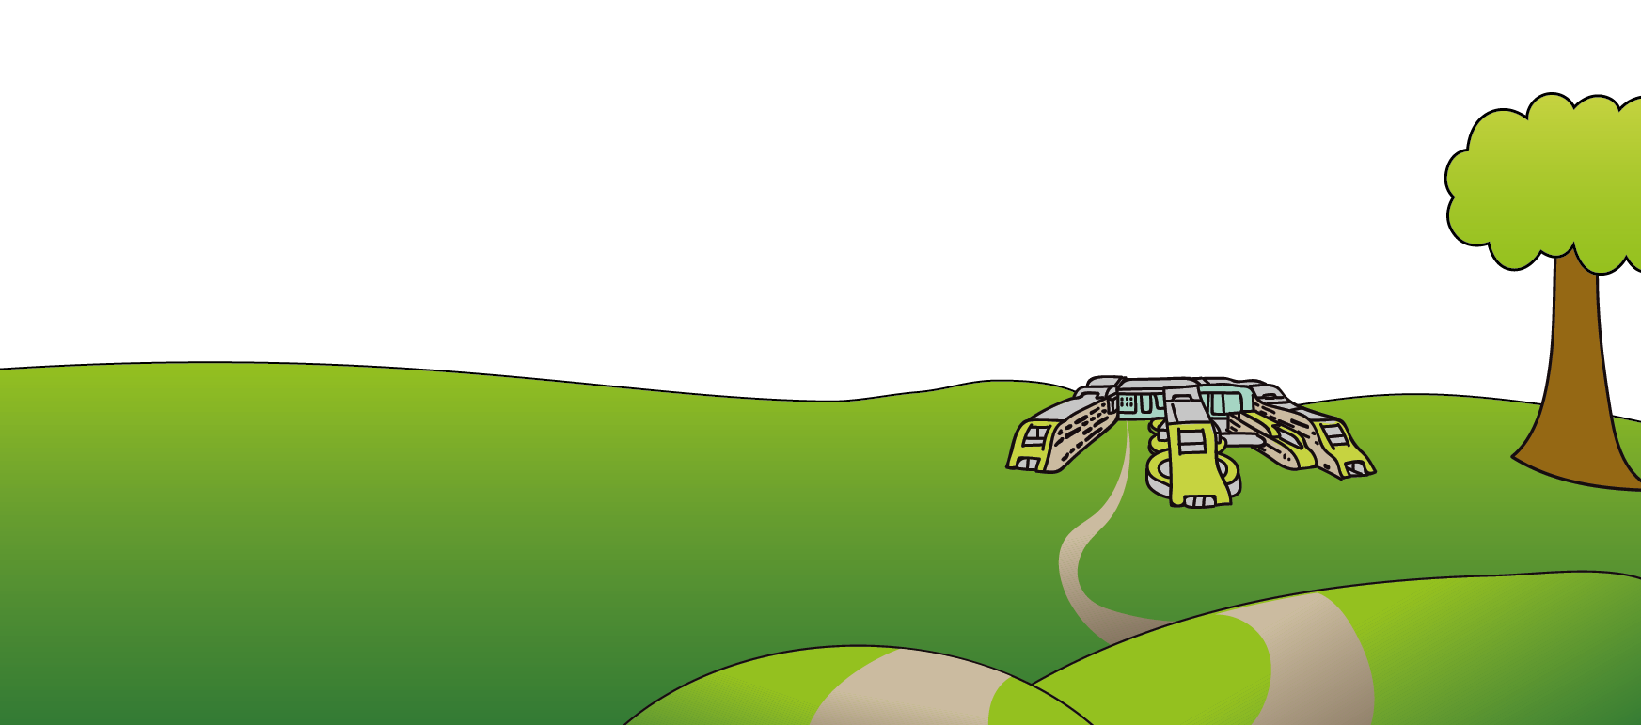
Eaton Road
Liverpool
L12 2AP

Tel: 0151 228 4811
www.alderhey.nhs.uk

© Alder Hey Review Date: January 2027 PIAG: 68

