Is MRI safe?
MRI is a very safe procedure. However we advise that any female who is in the first trimester of pregnancy should not go into the scanner room.

Note for Parents / Carers
Most children manage their scans awake as described in this leaflet. However, if you feel that your child will not be able to do this, please contact us. We will then need to book them for an MRI scan under G.A. (General Anaesthetic).

If for any reason you are not able to attend your appointment, please phone us on 0151 252 5042 as soon as possible.

Missed appointments potentially can cause serious delays in the treatment of other children.

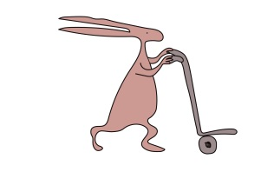
If you have any queries, please feel free to contact us on 0151 252 5042.

This leaflet only gives general information. You must always discuss the individual treatment of your child with the appropriate member of staff. Do not rely on this leaflet alone for information about your child’s treatment.

This information can be made available in other languages and formats if requested.

Alder Hey Children’s NHS Foundation Trust
Alder Hey
Eaton Road
Liverpool
L12 2AP

Tel: 0151 228 4811
www.alderhey.nhs.uk

© Alder Hey
Review Date: March 2029 PIAG: 121
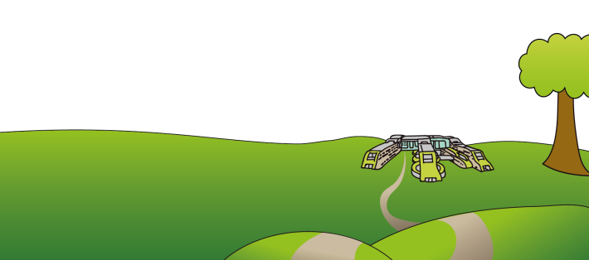



Radiology Department
M.R.I.
(Magnetic Resonance
Imaging)



Information for patients,
parents and carers

Your MRI scan

Welcome to MRI !

Your Doctor has referred you for an MRI scan. An MRI scanner uses a magnetic field rather than X-rays to give us very
detailed pictures of the inside of your body.

When you arrive a member of staff will explain what your test will involve. An MRI safety checklist will need to be completed for any person entering the scan room as MRI scans are not suitable for people with certain metal implants inside them (pacemakers, some surgical clips etc).

You may need to get changed into a
hospital gown depending on which part of you we are scanning or if your clothing has any metal on it.

As some of our MRI scans may involve an injection of dye, you can choose to have the ‘Magic Cream’ to numb your skin before the injection. The cream takes at least 30 minutes to work.


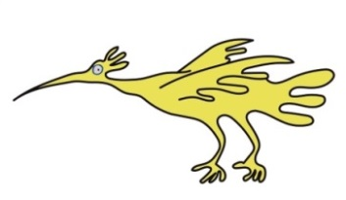

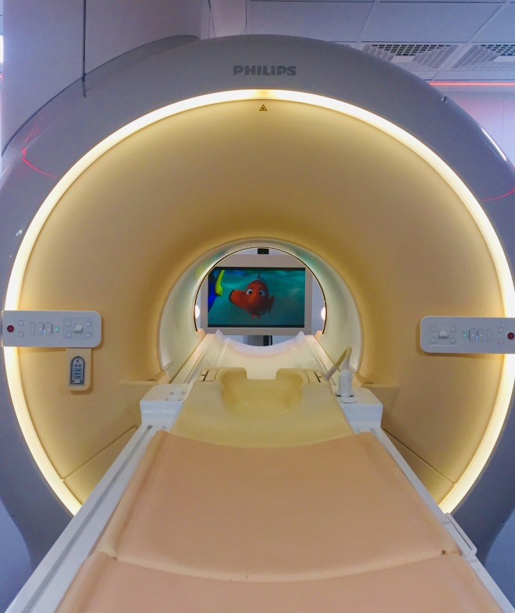

Up to 2 adults can accompany you into the scan room and you will be able to see them whilst you are lying down.
We have a TV in the room and you can choose something to watch. This helps you to stay relaxed, as it is important you lie very still during your scans. You will wear headphones and possibly ear-plugs as the scanner makes lots of different noises. We may need to put a special cover called a coil over part of your body. Sometimes we use a head coil (this will not touch your face). MRI scans take roughly between 15 and 40 minutes.

Scanning babies
We scan babies up to 3 months of age in natural sleep using a “feed and wrap” technique. If possible, try to keep your baby awake until you get to the hospital and time their next feed so that it is due at your appointment time.
On arrival we will move you to a quiet area where you can feed and settle your baby. Please make sure that you bring plenty of feeds with you. To save us disturbing baby too much, try to avoid clothing with metal poppers at the neck or down the front.
If you need any more information on this please contact us on the number overleaf.
Once the scans are completed you can go. The images will be reported by a Radiology Doctor and sent on to the Consultant who referred you.
