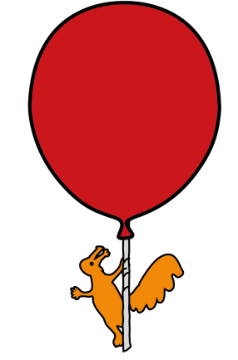


Medicine Division

Lumbar Puncture

Information for parents and carers

What is a lumbar puncture?

A lumbar puncture is when a fine needle is inserted into the fluid within the spinal canal, below the level of the spinal cord, through the small of the back. This procedure is usually undertaken by a doctor.

Why is a lumbar puncture necessary?

A lumbar puncture is most commonly done to diagnose certain diseases, by getting a sample of fluid from the spinal canal (cerebrospinal fluid) for testing in the laboratory. Meningitis is an example of such a disease.

A lumbar puncture can also be done to treat certain diseases. Examples include giving antibiotics, cancer drugs, or painkillers into the spinal canal. Sometimes spinal fluid is removed by lumbar puncture to decrease spinal fluid pressure. Your doctor will explain the reasons in your child’s case.

What is the cerebrospinal fluid?

The cerebrospinal fluid circulates around the brain and spinal cord. It supports and protects the brain from injury and helps nourish the brain.

What diseases are diagnosed by examination of the cerebrospinal fluid?

Spinal fluid obtained from the lumbar puncture can be used to diagnose many important diseases such as bleeding around the brain; increased pressure from hydrocephalus; inflammation such as encephalitis or meningitis; tumours; diseases of the immune system, such as multiple sclerosis.

How is the lumbar puncture performed?

The patient lies down sideways with their knees tucked up towards their chest and with their chin down. In older children, sometimes the procedure is performed while the patient is sitting up
The area of skin that the needle will pass through is first cleaned, and then numbed by a local anaesthetic cream “magic cream” or a local anaesthetic injection. A fine needle is then inserted through the numbed skin and in between two of the individual bones that make up the backbone. The pressure in the spinal fluid can then be measured. Spinal fluid is dripped into special containers and sent to the laboratory for testing.
The needle is in the back of the patient for a few minutes. The skin, where the needle was inserted, is cleaned at the end of the procedure.
The patient then usually lies down to reduce the chance of a headache.

How long does it take?

The whole procedure takes about 30 minutes to perform.

Is it painful?

Your child’s back will feel cold and wet after it has been washed and cleaned. If your child is given a pain numbing medication (anaesthetic) by needle in their back, it will sting them when first given.

Your child will feel hard pressure when the needle is put in and some short-lasting pain that should stop in a few seconds. It can be a little uncomfortable lying in this position, and sometimes as the needle goes in your child can get a twinge of pain.

What are the risks of a lumbar puncture?

Common risks:

Headache: Not usually serious and can be treated by painkillers and bed rest.

Backache: Some mild backache may occur and this can also treated with pain killers.

Rare risks

Catching a spinal nerve: May cause shooting pain and numbness – usually short lasting.

Brain herniation: Very rare but serious. No risk unless a child is very unwell when the lumbar puncture is done.

Bleeding into the spinal fluid: May cause some irritation but is rarely serious to your child.

Infection: Very rare, and can be treated with antibiotics.

What are the benefits of my child having a lumbar puncture?

The benefits of the Lumbar Puncture depend upon the exact situation for which it is performed.

Lumbar Punctures give valuable information to help diagnose, or rule out illnesses, and start the right treatment. The information could save your child's life or prevent significant disability.

A Lumbar Puncture is also a way of giving treatment to your child, for example removing spinal fluid under too much pressure, or certain medications.

What if I do not wish my child to have the procedure?

If, after discussion with your doctor, you do not want your child to have the procedure that the doctor advises, the doctor will record your decision in your child’s medical notes. The doctor will then set about giving the best treatment, but without the information gained from the lumbar puncture. For example, it might mean the doctor having to treat suspected meningitis without knowing the likely bacteria causing it.

Do I have to give my consent for a lumbar puncture?

Currently we do not ask you to fill out a consent form for this procedure because it is part of a group of tests and treatments given to your child, but we would not do it without your verbal consent.

What after care is required at home / on ward?

Your child should lie down for an hour or two and then move around slowly.
Your child should not take part in any vigorous activity for 2 days after the Lumbar Puncture has been performed,
If you need further information before the procedure, please speak to the person who will be undertaking the Lumbar Puncture. If problems occur once your child is back at home, please contact:
--------------------------------------------------------------------------------------------------------------------------------
---------------------------------------------------------------------------------------------------------------------------------
(Person undertaking the procedure to insert name and contact details)

This leaflet only gives general information. You must always discuss the individual treatment of your child with the appropriate member of staff. Do not rely on this leaflet alone for information about your child’s treatment.
This information can be made available in other languages and formats if requested.
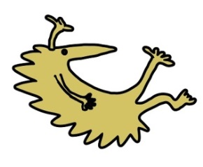
Alder Hey Children’s NHS Foundation Trust
Alder Hey
Eaton Road
Liverpool
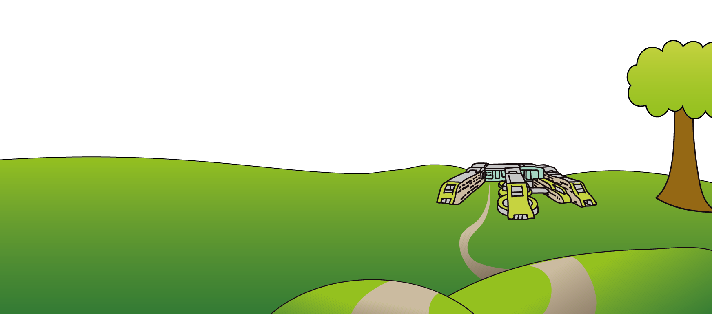
L12 2AP

Tel: 0151 228 4811
www.alderhey.nhs.uk

© Alder Hey Review Date: June 2025 PIAG: 4

