

Urology Service

Looking after your child’s indwelling urethral catheter

Information for parents and carers

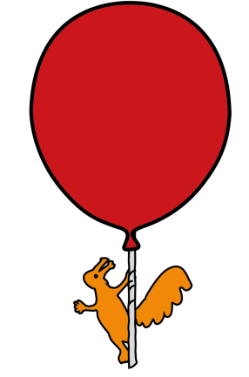
Introduction
Your child’s doctor or nurse has advised you that your child needs to have an indwelling urethral catheter. This leaflet aims to support the discussion you had with the doctor/nurse and to enable you to make an informed decision.
How does the urinary system work?
To understand how a catheter works it is helpful to know what the urinary system is. The urinary system consists of the kidneys, the ureters, the bladder and the urethra. The kidneys filter the blood to remove waste products. This process produces urine (pee). The urine then passes down the ureters to the bladder. During urination (peeing) urine passes from the bladder, through the urethra to outside of the body.
What is a urinary catheter?
A urinary catheter is a hollow, flexible tube inserted into the bladder to drain urine.
There are three methods of catheterisation:
- intermittent catheter – a catheter that is temporarily inserted into the bladder and removed once the bladder is empty. This can be repeated at regular intervals. Another leaflet is available that provides information about this type of catheter,

- indwelling urethral catheter – a catheter that can stay in the bladder for days or weeks. It is held in place by a water-filled balloon. These catheters are sometimes referred to as Foley catheters and are usually attached to a drainage bag.

- Suprapubic catheters - a catheter that is surgically inserted into the bladder through the abdomen (tummy) and can stay in for weeks or months. These catheters are usually used when bladder drainage is needed on a long-term basis. Another leaflet is available that provides information about this type of catheter.

Why does my child need an indwelling urethral catheter?
Your child’s doctor or nurse will explain the reasons why your child needs an indwelling urinary catheter.
These are some of the possible reasons:
- To allow urine to drain if your child has a blockage or narrowing in their urethra.
- To allow your child to empty their bladder if they are unwell and unable to use the toilet.
- To allow your child to empty their bladder if there is nerve damage which is affecting their ability to urinate.
- To drain your child’s bladder after some types of surgery or if they have an epidural.
- To administer medication into your child’s bladder.
- To monitor how much urine your child is making.
- To provide information about your child’s urinary system.
How is an indwelling urinary catheter inserted?
Sometimes catheters are inserted whilst a child is having an operation (when they are asleep). However, urinary catheters are usually inserted whilst a child is awake. If they are old enough (usually over five years), Entonox® can be used for any discomfort they might feel during the procedure. Entonox® is a gas made from oxygen and nitrous oxide that is used for pain relief. Entonox® can also be called ‘gas and air’ or ‘laughing gas’. It works very quickly. It can also help your child to relax, which can help reduce your child’s anxiety about having a catheter. Your child’s nurse will assess whether Entonox® is a suitable option for them.
Sometimes it is also helpful for the child to have distraction from a hospital play specialist. In some circumstances, sedation may be used. Your child’s doctor or nurse will discuss which option is most appropriate for your child. If your child is awake during the procedure, you will be allowed to stay with them. Once the catheter is inserted it should not hurt.
How is an indwelling urinary catheter removed?
The catheter is held in place by a balloon filled with water. Your child’s doctor or nurse will decide when the catheter should be removed. A syringe is attached to the balloon port at the end of the catheter. The water is removed using the syringe. Your child’s doctor or nurse will then gently pull the catheter out. Sometimes a child may complain of some discomfort during catheter removal and when they first pass urine. This should settle and it helps if they drink plenty of water. If they continue to complain of discomfort or have any symptoms of urinary tract infection (see below for list of symptoms) you should seek medical advice.
You should not attempt to remove the catheter yourself.

What are the risks of my child having an Indwelling urinary catheter?
- Urinary tract infection (UTI)
All children who have a catheter in place will have a small amount of bacteria in their urine. Antibiotic treatment is only prescribed if your child becomes unwell with symptoms of urinary tract infection.

Symptoms of urinary tract infection include:
- Offensive smelling urine.
- Cloudy urine.
- Lethargy (tiredness).
- Nausea (feeling sick).
- Loss of appetite.
- High temperature.

If your child has any of these symptoms it is important to seek medical advice as soon as possible. A sample of urine must be taken before antibiotic treatment is started. Encouraging your child to drink lots of fluids can help prevent urinary tract infections, by reducing the amount of bacteria in the urine. Good hygiene, including thorough hand washing before touching catheter, is also important. If your child is using a catheter drainage bag this should be changed every five to seven days according to manufacturers guidelines.
An indwelling urinary catheter is always inserted on temporary basis. It will be removed as soon as possible to avoid risk of infection.

- Bladder spasms
Catheters may irritate the bladder and this may cause spasms. Your child may complain of cramping pains in their tummy or pain in their bottom. They may also complain of the need to pass urine. Medication can be given to help these spasms. Please inform your child’s doctor or nurse if you think your child is having bladder spasms. It is also important to check that the catheter is in the correct position. Spasms can occur when the catheter is too far into the bladder
- The catheter may become blocked or fall out
If your child’s catheter falls out please seek medical advice soon as possible, as it may need replacing. Your child should not do any strenuous activity whilst they have an indwelling urinary catheter in. They can walk short distances but otherwise they should use a wheelchair. They should not sit in a straddle position. If required a wheelchair will be provided on loan before your child’s discharge.
- Blockage of the catheter
Your child’s catheter should drain a small amount of urine continuously. If the catheter stops draining it may be blocked. You should always ensure that the catheter is not allowed to kink or twist. If your child uses a catheter drainage bag this should always be at a position that is below bladder level. Please encourage your child to drink plenty of fluids. If your child’s doctor thinks there is a high risk of the catheter blocking, you will be shown how to flush the catheter. This helps to keep the urine draining and reduces the risk of an infection developing. If the catheter needs to stay in for longer than three months it will need to be changed.
If you’re worried that your child’s catheter is blocked please seek medical advice as soon as possible.
What if I decide I do not want my child to have an indwelling urinary catheter?
You should discuss any concerns you have with your child’s doctor or nurse. There may be suitable alternatives (see below). However, it is important to remember that if the bladder isn’t emptied urine can build up and lead to pressure in the kidneys. This pressure can cause permanent damage to the kidneys.
A suprapubic catheter may be an alternative. This is a tube inserted into your child’s bladder through the abdomen. This procedure requires a general anaesthetic. There are risks associated with this procedure, which your child’s doctor or nurse will explain. This catheter is usually inserted if catheterisation is required on a long-term basis (longer than one to two2 weeks).
Clean intermittent catheterisation may also be an alternative. This type of catheterisation requires inserting a catheter until the bladder is emptied then removing it. This procedure may need to be done every four hours during the day. It is important to consider whether your child will tolerate this.
External catheters, also called sheaths, are a possible alternative for boys. Sheaths look like condoms and cover the head of the penis. A tube leads from the sheath into a drainage bag. These catheters have a lower risk of infection but need to be changed daily. This type of catheter is only suitable for older boys who do not have problems with urinary retention.
Please contact your child’s doctor or nurse if you would like further information regarding the suitability of any of these alternatives.

Caring for an indwelling urinary catheter at home
Before your child is discharged you will be supplied with enough equipment to last for one week. Your child’s urology nurse will arrange home delivery of further equipment if the catheter needs to stay in for longer than a week. The delivery company will contact your GP for a prescription for further supplies. You should contact the delivery company for further supplies approximately one week before you run out. Contact details will be supplied with the first delivery. Some GP’s may prefer that you get further supplies from your local pharmacy.
During the daytime your child may prefer to wear a leg bag. There are various sizes of leg bag that hold from 120mls (for babies) to 500mls of urine. Overnight you should attach the leg bag to a night drainage bag. Night drainage bags hold 2000mls, so you should not need to empty them overnight.
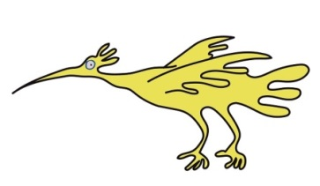
Equipment needed for catheter care at home includes:
- tape to secure catheter,
- urine collection bag,
- flip flow valve,
- alcohol pads,
- gauze,
- saline (sterile salt water) if catheter flushing is required,
- catheter stand,
- 60ml syringe with catheter tip (if catheter flushing if required),
Important points to remember
- Keep the catheter taped securely to your child’s leg so it does not get accidently pulled, kinked or twisted. The tape should be replaced if it becomes loose or dirty. Your child’s nurse will show you how to do this.

- Keep the catheter as straight as possible to prevent kinking and blockage of catheter.

- The catheter drainage bag should be kept below waist level (to encourage drainage) and off the floor (to prevent infection and catheter being accidently being pulled out). Leg bags, which can be secured to leg beneath trousers or skirt, can help.

- Always wash your hands with soap and water and dry them well before and after emptying or changing your child’s catheter bag.

- When emptying the catheter bag try to make sure that the drainage tap does not come into contact with the toilet or any other surface. Always clean the tap with an alcohol pad before and after emptying the catheter drainage bag.

- The drainage bag should only be disconnected from the catheter when absolutely necessary to reduce the risk of introducing infection. It should be changed every five to seven days unless it is damaged then it should be changed immediately.

- It is important to observe for constipation whilst your child has a catheter in. Constipation can prevent the catheter draining well. It can also increase the risk of urinary tract infection and can cause leakage of urine around the catheter. Encouraging your child to eat a healthy balanced diet that includes fruit, vegetables and fibre can help prevent constipation. Sometimes laxatives may be prescribed to help prevent constipation. If your child is toilet trained they can have their bowels open on the toilet. If your child is constipated they may need to push hard. This may cause the catheter to leak (bypass). If you have any concerns please contact your child’s urology nurse. Please ensure your child’s bottom and catheter are cleaned after a bowel movement.

To empty the catheter bag
The bag should be emptied before it is three quarters full or at least four times per day, so you can observe that the catheter is draining. If the bag overfills the catheter will not drain.
You will need: alcohol pads and a clean jug and/or access to a toilet.
- Wash your hands with liquid hand soap and dry on kitchen towel.

- Stand or sit your child near the toilet.

- Clean the tap at the bottom of the drainage bag with alcohol pad.

- Open the tap at the bottom of the bag.

- Drain the urine from the bag into a toilet or clean jug (avoid the tap touching the jug or toilet to reduce the risk of infection).

- When the bag is empty close the tap.

- Clean the tap with an alcohol pad.

- If using a jug dispose of the contents down the toilet then rinse the jug in hot soapy water and allow to dry.

Changing the drainage bag
You should do this once every five to seven days, or if the bag becomes disconnected or is damaged.
You will need:
- New drainage bag (either two litre drainage bag or leg bag).
- Alcohol pads.
- Clean towel.

- Wash your hands with liquid soap and water then dry them on a clean towel or disposable paper towels.

- Prepare a clean surface by cleaning the area with an alcohol pad.

- Open the packet containing the new drainage bag and put it on a surface cleaned with an alcohol pad.

- If applicable, remove tape securing catheter to your child’s body.

- Put a clean towel under the catheter.

- Gently bend the catheter over to stop urine leaking.

- Gently twist the tube of the old drainage bag and remove from the catheter.

- Clean the end of the catheter with an alcohol pad.

- Remove the protective cap from the new drainage bag. Do not touch the sterile connector of the new bag.

- Attach the new drainage bag to the catheter.

- Ensure the drainage tap of the bag is closed.

- Straighten the catheter and re-secure.

- Empty the old drainage bag into the toilet. Then double wrap it in newspaper or plastic bag and dispose of in household waste.

- Wash and dry your hands.
Attaching a night bag onto a leg bag
At night you should attach a large night bag onto your child’s leg bag.
You will need:
- Night drainage bag.
- Alcohol pads.

- Wash your hands with liquid soap and water and dry them with kitchen towel.
- Prepare a clean surface by cleaning the area with an alcohol pad
- Open the packet containing the night bag and put on a surface cleaned with an alcohol pad.
- Clean the tap of the leg bag with an alcohol pad.
- Remove the protective cap from the night bag without touching the sterile connector.
- Attach the night bag to the leg bag tap.
- Open the leg bag tap to allow urine to drain from the leg bag into the night bag.
- Ensure the tap is closed on the night bag.
- Place the night bag on a stand to help with drainage.
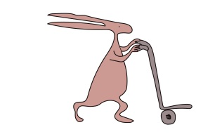
- Wash and dry hands.
Removing a night bag
In the morning you should remove the night bag.
You will need:
- Alcohol pads

- Wash your hands with liquid soap and dry them with kitchen towel

- Close the leg bag tap.

- Disconnect the night bag tube from the leg bag.

- Clean the leg bag tap with an alcohol pad.

- Empty the night bag into the toilet. Double wrap in newspaper or plastic bag and dispose of it in household waste.

- Wash and dry hands
Cleaning around the catheter site
Please clean around your child’s catheter site twice daily with a cloth and mild (non-fragranced) soap and water.
Before your child showers or uses the bath empty the drainage bag, but leave it
connected.

Do not use talc or creams (unless advised by your doctor or nurse) around the catheter entry site.

Flushing the catheter
If your child’s urology nurse or doctor think the catheter may become blocked you will be shown how to flush your child’s catheter before discharge. You should flush the catheter if it is not draining or if it appears to be blocked. You should only flush regularly if you have been trained to do so by your child’s doctor or nurse.
You will need:
- 60ml syringe with catheter tip.
- Alcohol pads.
- Saline (sterile salt water)
- Gallipot.
- Clean towel.

- Wash your hands with liquid soap and dry on kitchen towel.

- Prepare a clean surface by cleaning the area with an alcohol pad

- Remove the gallipot from the package.

- Open the saline packet and empty it into the gallipot.

- Remove the syringe from the packet. Put the packet to one side.

- Use the syringe to draw up the saline. Your child’s nurse will advise you how much to use. It is usually between 10 and 20mls.

- Place the syringe back in the packet to keep it sterile (free from germs). Do not touch the tip of the syringe or let it touch anything else.

- Put a clean towel under the catheter.

- Remove the catheter drainage bag and clean the catheter with an alcohol pad.

- Connect the syringe to the end of the catheter.

- Gently push on the plunger of the syringe. This will insert the saline into the bladder.

- Continue until all the fluid is inserted then remove the syringe.

- Clean the end of the catheter with an alcohol pad and re-attached the drainage bag.

- If the saline won’t go in do not force it. Instead gently try to withdraw fluid from the catheter by pulling the plunger of the syringe with one hand. If there is any resistance stop.
If you can’t remove any fluid or urine from the catheter and the catheter is not draining into the bag contact your doctor or urology nurse as soon as possible.
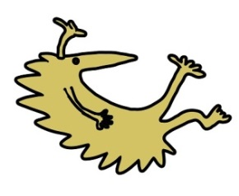
Discharge information
You should seek medical advice if:
- The catheter falls out.

- The catheter becomes blocked and you are unable to unblock the catheter with flushing. If the catheter is blocked no urine or very little urine is draining from the catheter even though your child is drinking and you have emptied their catheter bag.

- Urine leaking around catheter.

- Your child has symptoms of urine infection.

- Your child complains of stomach ache or their bladder feels full or painful.

- Your child has signs of an infection around the site including redness, swelling or discharge.

Please do not remove your child’s catheter under any circumstances.
Further appointment information
Your child will continue to have regular follow up with their Urology Consultant. If there are any problems in the meantime you may contact the Urology Nurses or your local continence nurse.
If you require urgent medical advice please contact your GP, local Walk-in Centre or Emergency Department.
For further information
Please contact the Urology Nurses on: 0151 252 5852
Working hours Monday to Friday 9am until 5pm.
Out of hours contact ward 3A via Alder Hey Hospital switch board 0151 228 4811

This leaflet only gives general information. You must always discuss the individual treatment of your child with the appropriate member of staff. Do not rely on this leaflet alone for information about your child’s treatment.

This information can be made available in other languages and formats if requested.

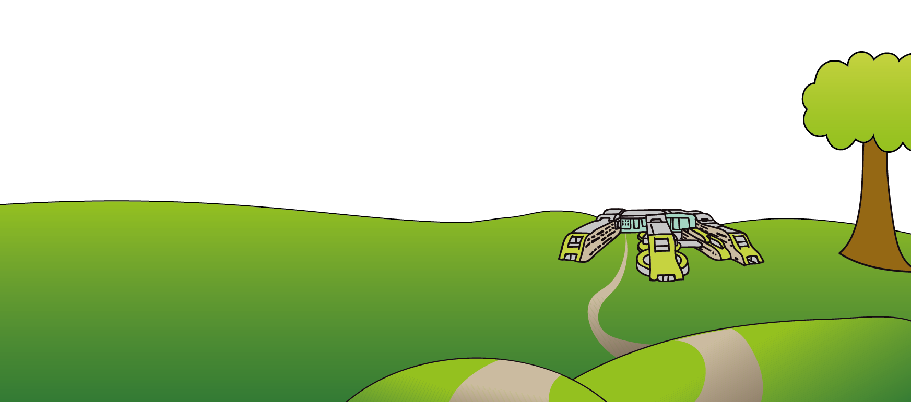
Alder Hey Children’s NHS Foundation Trust
Alder Hey
Eaton Road
Liverpool
L12 2AP

Tel: 0151 228 4811
www.alderhey.nhs.uk

© Alder Hey Review Date: December 2027 PIAG: 005

