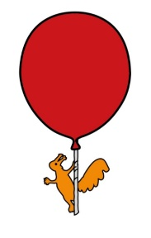

Alder Hey Long Covid Team

**Long Covid**

A resource for young people and their parents

**What is Covid-19, or Coronavirus?**

# The current coronavirus outbreak, or COVID-19 as it’s officially known, was first detected in China in December 2019. Coronavirus has been in the news a lot because there have been cases in lots of different places around the world, including here in the UK, which can make it seem quite scary.

# Coronavirus is a group of infectious diseases that range from a common cold to a more serious illness which affects your lungs and breathing. When people are unwell with Covid 19, they may have symptoms such as a cough, a fever, and/or difficulty breathing.

# You can find out how Alder Hey are managing covid19 on the link below: <https://covid19.alderhey.nhs.uk/faqs/>

# **What is Long Covid?**

The COVID-19 pandemic, caused by severe acute respiratory syndrome coronavirus 2 (SARS-CoV-2), has rapidly spread worldwide. Globally, children and adolescents make up a small proportion of acute severe COVID-19 cases and for the majority the acute illness is mild. There are reports internationally of small numbers of children and adolescents developing a delayed onset illness, Paediatric Inflammatory Multisystem Syndrome, temporally associated with SAR-CoV-2 (PIMS-TS) and also reports that children may be affected by prolonged ill-health as a consequence of Covid-19, known as ‘Long Covid’. This new and emerging condition can have a significant effect on quality of life and be associated with organ damage or impairment.

There is a minimal, although evolving, evidence-base in Long Covid. It is important to recognise that people who had mild acute Covid-19 can develop Long Covid. The most common symptom reported is fatigue, but symptoms across multiple systems are reported and, in some adults, there is evidence of organ damage. There are reports of children having similar prolonged symptom clusters to adults, following suspected or confirmed Covid-19 infection, but further research is needed to establish whether children may also suffer organ impairment. Peri-myocarditis has been reported in one small case series of children with Long Covid symptoms.

It is important that an early, thorough, holistic medical assessment is performed in children with possible Long Covid, to ensure appropriate identification of those with organ impairment requiring further specialist input and management, as well as recognising and offering appropriate support for symptoms which can cause significant morbidity and reduced quality of life.

Definition

NICE (National Institute for Clinical Excellence) produced Covid-19 rapid guideline: managing the long-term effects of Covid-19 for adults and children. This introduced the following clinical definitions for the initial illness and Long Covid at different times:

* Acute COVID-19: signs and symptoms of COVID-19 for up to 4 weeks.
* Ongoing symptomatic COVID-19: signs and symptoms of COVID-19 from 4 to 12 weeks
* Post-COVID-19 syndrome: signs and symptoms which develop during or after an infection consistent with COVID-19, continue for more than 12 weeks and are not explained by an alternative diagnosis. It usually presents with clusters of symptoms, often overlapping, which can fluctuate and change over time and can affect any system in the body. Post-COVID-19 syndrome may be considered before 12 weeks while the possibility of an alternative underlying disease is also being assessed.
* Long COVID: In addition to the clinical case definitions, the term 'long COVID' is commonly used to describe signs and symptoms that continue or develop after acute COVID-19. It includes both ongoing symptomatic COVID-19 (from 4 to 12 weeks) and post-COVID-19 syndrome (12 weeks or more).

It is not necessary for the patient to have had a positive test for COVID when they were acutely ill to meet this definition.

The Office for National Statistics (April 21) suggests that around 7.4% of children aged 2 to 11 years and 8.2% of children aged 12-16 years had persistent symptoms at 12 weeks. Data for longer intervals is not yet available. Another study, using the Zoe Symptom Tracker App, reported 13% of those who had COVID-19 had persisting symptoms at 28 days.

# **How might I feel if I have Long Covid?**

Everyone is different, and lots of people might have different symptoms, or have different symptoms at different times. We know that it is not unusual to feel, or to experience, any of the below....

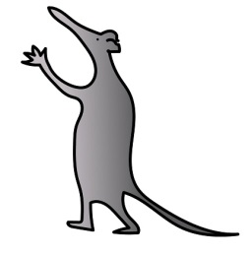Symptoms:

* Respiratory symptoms: breathlessness, cough
* Cardiovascular symptoms: chest tightness, chest pain, palpitations
* Generalised symptoms: Fatigue, fever, Pain, hair loss
* Skin rash
* Neurological symptoms: cognitive impairment (brain fog), sleep disturbances, peripheral neuropathy
* Gastrointestinal symptoms: abdominal pain, nausea, diarrhoea
* ENT symptoms: Tinnitus, earache, sore throat, loss of taste/altered taste, loss or altered smell
* Autonomic symptoms: dizziness, vertigo
* Musculoskeletal symptoms: non-specific joint pains, muscle pain
* Psychological symptoms: mood changes, anxiety, low mood

**Differential diagnoses:**

The spectrum of symptoms for children and adults with Long Covid is broad and therefore the differential diagnosis for children presenting with the features of Long Covid is wide-ranging.  It is important to consider a differential diagnosis and investigate appropriately for other causes for the presenting symptoms.

Dependent on symptom presentation the differential might include:

* Rheumatological conditions e.g. JIA, SLE, Dermatomyositis
* Inflammatory conditions e.g. IBD
* Chronic infections, including reactivation (eg TB, HSV, EBV)
* Malignancy – for example leukaemia, lymphoma
* Autoimmune – Coeliac disease, Thyroid disorders
* Adrenal insufficiency
* Organ impairment – renal, liver, pancreatic, cardiac, respiratory
* Neurological conditions – Venous sinus thrombosis, malignancy, stroke, neuromuscular conditions
* Mental health difficulties including low mood, chronic fatigue

# **Managing Long Covid**

We know that having long covid can be difficult. By reading the information in this resource, we hope that this may help you to find ways of being able to better manage living your life, whilst long covid is around.

We will share ideas which involve managing your daily activity levels.

We will talk about ways to strengthen your body and improve your stamina. We will talk about sleep, as well as exploring some of the ways which you might be feeling emotionally at this time.

What is Pacing?

________________________________________________________________________________

Pacing is about balancing activities throughout the day to help to manage symptoms of pain and fatigue, which can often be experienced because of Long Covid. It’s about finding a level of daily activity which can be managed and achieved, no matter how you are feeling that day.

________________________________________________________________________________

Everyone is different and their activity levels will also be different. This can vary depending on a number of things, including what is going on in your life and how you feel both physically and emotionally.

When people experience pain or tiredness, a natural reaction is for their level of activity to drop. It is the body’s way of protecting itself.

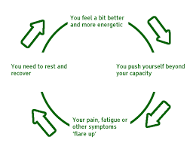When activity levels stay low for a while, fitness and motivation to do things decreases and our mood can also be affected. This can lead to reduced confidence and can change how you feel about yourself. You might start to find you are missing out on things you used to do, and we understand that this can feel tough.

Young people often describe that they have good and bad days. On a good day, they might try to ‘catch up’, and try to return to a previous activity level. They might find that due to reduced fitness and weaker muscles, that this brings an increase in pain and/or tiredness and are then unable to keep up with these activity levels.

People may describe that they ‘pay for it’ over the next few days, when everything feels worse, and they can even have lower activity levels than before. We call this cycle “boom and bust”, with a rollercoaster pattern of over and under activity.

Pacing is the opposite to boom and bust, and means starting off lower, and gradually building up activity levels over time, in small gradual steps. Spreading your activities and energy levels across the day or week. when you start pacing, you may experience an increase in symptoms, and you may feel your activity levels may drop. However, by continuing to pace you are unlikely to drop to previous low levels and should be able to do more by spreading your activities out. Applying the skills you have learned will help you bounce back quicker!

# **What is Boom and Bust?**

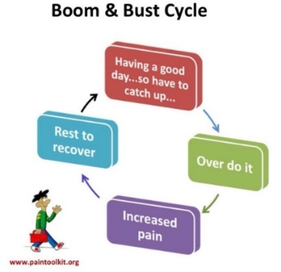The boom and bust cycle below help to illustrate how pacing is important to maintain consistent energy levels.

The ‘boom and bust’ cycle occurs when we feel we have more energy than at other times in the day (boom) and as a result we can use up all our energy, leading to exhaustion and long periods of ‘recharge’ (bust).

When our energy levels are higher, we want to do as much as possible. However, this can lead to periods of fatigue and enforced rest, overall reducing the amount of activities we can take part in.

The boom and bust cycle are managed by strategies such as pacing.

We understand that pacing may not seem very appealing at first; it may feel that you can’t do what you want to do when you want to do it. It might be annoying or frustrating, or make you feel sad.

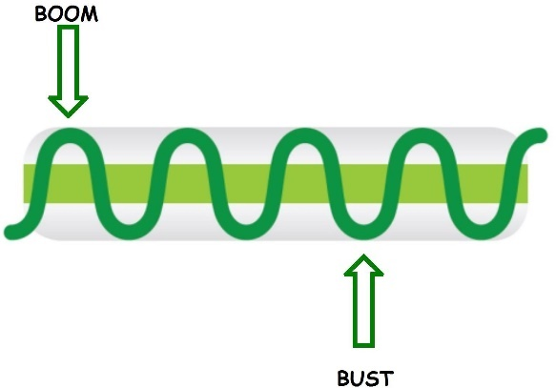Maybe you’re having a good day, and you feel tempted to do lots more...we aim to help you to appreciate that there might be some disadvantages to this.

The more you use pacing, the more beneficial it can become. Avoiding that rollercoaster of over and under activity, to give you back control, having strategies to manage the impact of long covid.

# How do I pace?

The same way you climb a mountain……one step at a time :)

* 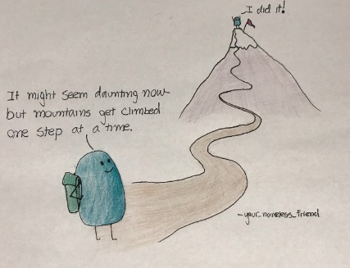Prioritise and spread out activities over the week/day. Think about things you must do and things you want to do over the week. We need to get a balance between school, home life and leisure/social.
* Break down activities into smaller steps where you can
* Set baselines – what level of activity can you manage every day without causing an increase in symptoms? Can you do this consistently?
* Consistency means doing the same levels of activity every day – this doesn’t have to always be the same activity
* Plan, this will help you avoid over and under activity.... consider what is coming up later in the day or week.

What strategies can you plan to use to manage an activity?

* Balance different activities and think about what is involved in the activity, the physical, cognitive and social aspects
* Breaks & Rest, it’s important to change what you might be doing after a while. This doesn’t always have to mean stopping and sitting...a restful activity might include reading, tv, a walk, being by yourself, a bath, creative activities, music, mindfulness
* Progression - gradually increase your activity level in a graded way
* Managing challenges – using relaxation, breathing techniques and body scan techniques to help manage any tricky thoughts and feelings which might show up
* Goal setting...knowing what you want to work towards achieving will help you to keep going with your pacing

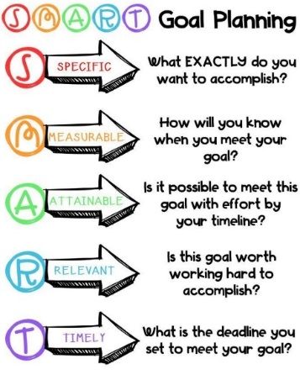

## 

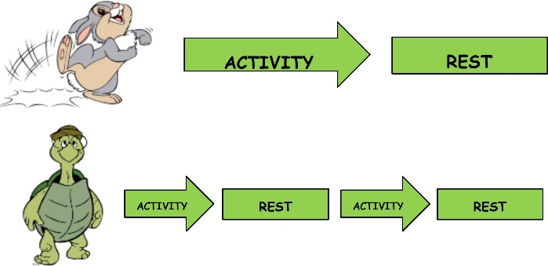**The hare and the tortoise;** Over time, the more we pace ourselves during activity, the more beneficial it will become. By avoiding periods of over and under activity like the tortoise, we are in control of our energy levels by using useful strategies to manage symptoms. If pacing isn’t used, as shown by the hare, exhaustion and prolonged rest periods may occur which can prevent us from participating in activities and tasks we want and need to do.

# **Getting active again...**

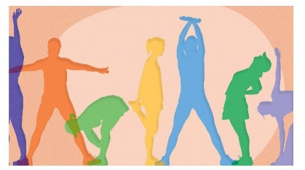The benefits of exercise;

• Keeps you supple

• Endorphin release

• Increase energy levels

• Helps with sleep

• Improves strength and stamina

Exercise helps to keeps you moving, it keeps you supple, and it keeps your joints as they should be, preventing them from becoming out of condition.

Exercise releases endorphins, your happy hormone, and can therefore make a difference to your moods and feelings.

Exercise increases your energy levels – this may sound a little strange at first when you’re tired and in pain, but after doing some physical activity, as long as you do this in a paced and graded way, exercise can give you more energy.

Exercise can also help with sleep. It can help to regulate your body’s day and night patterns, improving the quality of sleep at night due to how you’ve been making energy during the day.

**Fatigue**

# **What is fatigue?**

________________________________________________________________________________

Fatigue is very common in long covid, for children and young people as well as adults. Fatigue can be hard to manage and can cause us to feel tired and exhausted all or most of the time. Our muscles can start to feel weak when we become fatigued, meaning we struggle to do all the things we want to on a daily basis. Our reaction times can become slower, meaning we might find it difficult to play games or take part in PE.

The more fatigued we become, our brains can become fuzzy and we might find it difficult to concentrate. This may affect us in school and when doing work as we aren’t able to work as quickly.  Fatigue can also affect our ability to care for ourselves and can contribute to losing interest in our hobbies, favourite activities, and our friends. This can lead us to feel even more tired.

_______________________________________________________________________________

*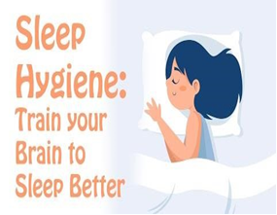***Sleep**

Due to how you have been feeling, you might have noticed that your sleep has been affected, and you might not feel as refreshed in a morning as you used to do. This is normal in children and young people experiencing long covid.

What can I do to help to improve my sleep?

• Stay active using a pacing approach

* Eat well
* Stick to regular routines
* Remember that bedrooms are for sleeping, try avoiding overusing your bedroom in the day/early evening
* Create a comfortable space, low lighting, not too much clutter
* Breathing techniques can help to calm the mind
* Progressive Muscle Relaxation can help to let go of tension
* Imaging a safe or calming place, can help you drift off as you relax
* Meditation / Mindfulness can help to bring your mind back to the present moment

# **Breathing Techniques**

Breathing techniques can help at any time of day, as well as to help prepare the body for sleep. They can help;

• Calm the nervous system

• Quieten the mind

It can be useful to practice these during the day, and also when you are winding down for bed. There are many different techniques such as:

[In stressful times you can use the power of your breath to help calm feelings of stress or anxiety.

Box breathing is a simple relaxation technique that can help you ‘reset your breath’ and return it to its normal rhythm.

This video demonstrates box breathing and highlights its benefits.

In short, it involves:

- Imagining breathing around a box
- Inhaling as you visualize going up one side of the box, pausing and then exhaling as you picture going down the other side of the box.

In moments of stress and anxiety, box breathing is an easy way to slow down and help calm your body and mind.

Many thanks to Dr. Joanna Mansfield, psychiatrist at Sunnybrook’s Women’s Mood and Anxiety Clinic, and Cognitive Behavioural Therapy Clinic for her expertise and voicing this box breathing video.

Video produced by Brent Creelman and Jennifer Palisoc in Communications & Stakeholder Relations at Sunnybrook.

For more mental health resources, visit: http://sunnybrook.ca/Psychiatry

If you need help in an emergency, please call 911 or visit your local emergency department. If you feel like you're in a crisis or need somebody to talk to, please know that help is available.
Find a local crisis resource: http://sunnybrook.ca/GetHelp](https://youtu.be/tEmt1Znux58)

**1. Box breathing/Square breathing**  <https://www.youtube.com/watch?v=tEmt1Znux58>

**2. Circle breathing;** <https://www.youtube.com/watch?v=aNXKjGFUlMs>

[Did you know that extending your exhales so that they are a little longer than your inhales can help you relax? Try it and let us know how it goes for you. 

The breathe bubble above was designed with the following counts in mind:
Inhale for 3 counts
Rest for 2 count 
Exhale for 5 counts 
Rest for 2 counts

Tips:
Experiment with different counts that feel nourishing for you. 
↓Go down by a count of one in each part if you’re feeling any stress or strain.
↑ If it feels easy, you can try increasing each section by a count of one.
☺️ Bringing a hint of a smile to your lips helps to relax your jaw.

✷ More free resources to help you breathe: https://www.calm.com/blog/take-a-deep-breath](https://youtu.be/aNXKjGFUlMs)

**[No child is born knowing how to self-soothe and calm down when upset. As they grow, kids learn to calm down through being soothed by their caregivers, watching the example of others, and discovering what works for them. However, for many children (and adults) calming down when upset continues to be a difficult skill to master.
 
This lack of mastery shows up in angry kids with explosive tempers, anxious children who can’t seem to face their fears or calm their racing thoughts, and impulsive or hyper kids who can’t seem to settle down.
 
Fortunately, there are many strategies and tools that kids can learn in order to better relax.
 
This is the first in a series of posts to help parents, teachers, and others learn some of these strategies to pass them on to kids that need them.
 
Strategy #1 – Balloon Breathing (or Belly Breathing)
 
Slow, deep breaths are one of the best ways to calm an anxious child.
 
An anxious or angry child is in flight-or-fight mode with their body primed to handle a perceived threat. This usually leads to fast, shallow breathing, rapid heartbeat, and tense muscles. Practicing slow, deep breathing tells your body that it can calm down, and as the physical arousal decreases, the emotional feeling of anxiety or anger will too.
 
Here’s a sample of how I talk to kids about deep breathing for relaxation:
 
“When we get scared or worried or angry, we usually take quick shallow breaths that stay at the top of our chest. (I put my hand on the top of my chest to give a focal point and demonstrate what this looks like.) When we want to calm down, we need to take slow belly breaths instead. Imagine that there is a balloon in your belly. When you breathe in, you want to push all the air down and fill up the balloon so that your belly puffs out. (I put my hand on my belly and demonstrate this.) Then, you breathe out slowly and your belly gets smaller as the balloon deflates.”
 
Sometimes it’s easier to practice belly breaths if you lay down. I’ll have the child lay on the couch and we’ll put a small stuffed animal (or balloon) on their stomach. I’ll remind them that when they breathe in, the stuffed animal should rise, and when they breathe out, it should go down. We’ll practice this until they seem to understand how to do the belly breaths.

Follow us:
Fablefy.com
facebook.com/fablefy
Twitter: @fablefy](https://youtu.be/sn_2GY1gTyo)3. Three-minute belly breathing**;

<https://www.youtube.com/watch?v=sn_2GY1gTyo>

# **Progressive Muscle Relaxation**

* Muscle tension is a common response to physical or emotional difficulties
* Tense muscles feel more pain and can become more tired
* [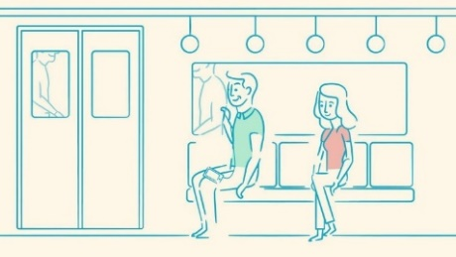](https://youtu.be/JPrKsWgI66g)Progressive Muscle Relaxation, can help relieve stress, anxiety and symptoms of pain
* This involves a technique of squeezing muscles and then relaxing

<https://www.youtube.com/watch?v=JPrKsWgI66g>

# **Imagery**

****There are different ways to engage in imagery, and did you know that this is also a relaxation technique?! We’d like to tell you about ways you can use your imagination to help bring about a sense of stillness, and of calm.

Imagery works best when you use all of your senses, to create a picture in your mind's eye - imagining in your chosen place, what you can see, hear, touch, smell and even taste.

* Start by getting comfortable in a quiet place where you won't be disturbed, and take a couple of moments to focus on your breathing, close your eyes if you wish, and just notice what’s going on in your body....become aware of any tension in your body, and let that tension float away each time you breath out.
* Imagine a place where you feel calm, peaceful and safe. It may be a place you've been to before, somewhere you've dreamed about going to, somewhere you've seen a picture of, or just a peaceful place you can create in your mind’s eye.
* Look around you in that place, notice the colours and shapes. What else do you see, what else do you notice?
* Now notice the sounds that are around you, or perhaps notice the silence. Notice any sounds far away, notice any nearer to you.
* Think about any smells you notice...maybe you smell grass, the sea, anything at all where you are.
* Now focus on anything you can feel, that you imagine touching....maybe the earth beneath you, the chair you imagine sitting on, how does the temperature feel, can you feel a breeze?
* Notice the pleasant, physical sensations in your body, whilst you enjoy just being here, in this safe place.
* Now whilst you're in your peaceful and safe place, you might choose to give it a name, whether one word or a phrase that you can use to bring that image back, anytime you need to.
* You can choose to linger there a while, just enjoying the peacefulness and calmness. You can leave whenever you want to, just by opening your eyes and being aware of where you are now and bringing yourself back to alertness in the 'here and now'.
* Remember, this is a special place, a place that lives within you, a place you can visit any time you choose.

# C:\Users\JMCHUGH\Desktop\headspace.png C:\Users\JMCHUGH\Desktop\insight timer.png**Mindfulness**

Mindfulness is a way of training our awareness to come back to the present moment, when maybe it has wandered off to the past, or wandered away to the future. This is not done by trying to turn off thoughts and feelings, or get rid of them, but instead by learning to observe them without judgement, much like you might notice cars passing on the street, or clouds moving through the sky. Focusing on your breath and using your senses to tune into the present moment.

You could think of it like anchoring yourself, holding yourself steady whilst tricky thoughts and felling pass by. There are several apps and websites which have helpful exercises you could try, including:

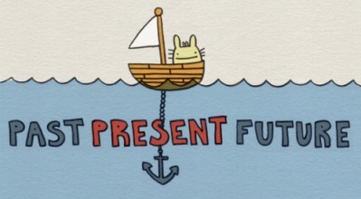

[Learning how to meditate means accepting that our minds won’t go quiet the moment we sit and close our eyes. So if we can’t just clear the mind on-demand, how are we ever going to relax? In this animation Headspace co-founder, Andy Puddicombe likens the practice of meditation to sitting by the side of a road, with instructions to watch the traffic. How do we stop ourselves getting caught up with the thoughts? It’s a question of perspective.

If you enjoy this animation, and you'd like to learn how to meditate, you can get started for free, by downloading the Headspace app.

http://hdspce.co/2BuYMFp

Learn to meditate in a few minutes a day with the Headspace app. It delivers guided meditations based on teachings that Andy Puddicombe, Co-founder of Headspace, learned during the ten years he spent studying meditation and mindfulness in monasteries across Asia.

The first series, Basics, is completely free. As the name suggests, it will teach you the basics of meditation and mindfulness. After that, via subscription, Headspace offers hundreds of hours of guided meditations on subjects ranging from Stress to Sleep. Themed meditation packs are supported by a host of animations. 

Along with daily meditations, Headspace also offers On-The-Go exercises for users short on time and SOS sessions to support subscribers in those meltdown moments.

Follow Us:
Facebook - https://www.facebook.com/Headspace
Twitter - https://twitter.com/Headspace
Instagram - https://www.instagram.com/headspace/](https://youtu.be/iN6g2mr0p3Q)A video about the idea of training the mind; <https://www.youtube.com/watch?v=iN6g2mr0p3Q>

# **Managing tricky thoughts and feelings**

Thoughts and feelings can at times be tricky to have around. They can show up when you don’t want them to, and sometimes they stick around, no matter what you do. Have you ever tried hard to stop thinking about something? To just get rid of it from your mind? Maybe try this.... don’t think about a blue elephant.... whatever you do don’t think about it.... how did you get on? It’s not easy is it! I wonder as you carry on reading this resource, how many times a blue elephant will pop into your mind? Chances are, you’ll think about it more, now that you’re trying not to.

Thoughts are very powerful, and they can have an impact on the way we feel and the things we do. We have thousands of thoughts each day. Most come and go before we even notice, but others can stick around in our minds for a long time.

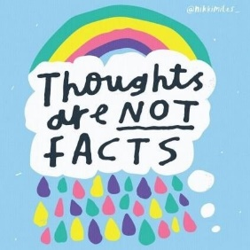If you use all your energy trying to push away and ignore difficult thoughts and feelings, you might find that you have less time, or find it harder, to focus on what really matters to you. It’s ok to not want worry, or sadness to be around. To not want to be thinking some of those unhelpful thoughts that keep popping into your mind. However, by acknowledging that they are there, and dropping the struggle you might be having with them, you might find they lose some of their power.

It is normal for us all to experience difficult thoughts, as well as tricky feelings. This is just how we have evolved. If you feel that you sometimes get stuck in a cycle of struggling with difficulties...try to pause for a moment...notice what is going on for you...and try to remember....... thoughts are not facts.

[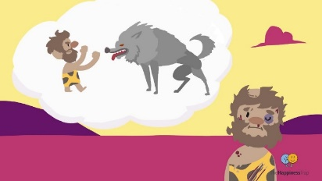](https://youtu.be/kv6HkipQcfA)Just because you have thought, it doesn’t mean that it is true. Our minds can be great story tellers, but whilst your mind thinks it’s helping you out by thinking and over thinking, remember, not everything that your mind says, is necessarily true.

A video about how we have inherited a caveman mind; <https://www.youtube.com/watch?v=kv6HkipQcfA>

[This video explains some of the things you can try when you feel overwhelmed by your thoughts. After the video, take a few moments to observe your thoughts with curiosity, paying attention to how each one makes you feel. Paying attention to your thoughts and sorting through them takes practice and patience.

For more information, visit: https://teens.aboutkidshealth.ca/mentalhealth

Subscribe to the AboutKidsHealth YouTube channel: http://ow.ly/CzrN50ClHN3

This video is provided for general information only. It does not replace a diagnosis or medical advice from a healthcare professional who has examined your child and understands their unique needs. Please speak with your doctor to check if the content is suitable for your situation.

#MentalHealth
#PositiveThinking
#Mindfulness

Follow us on: 
Facebook: http://www.facebook.com/aboutkidshealth 
Twitter: http://www.twitter.com/aboutkidshealth
Pinterest: http://www.pinterest.com/aboutkidshealth

TRANSCRIPT
Every day, we have thousands of thoughts, emotions, urges, memories and feelings. From the time we wake up in the morning, all throughout the day, to when we lay down to sleep at night. No matter who we are, we all have thoughts swirling around in our heads. We even think and feel in our dreams.
Often, we don’t realize how many thoughts we are having, and we get lost in them. Sometimes, we’re not even aware that we’re thinking. We seem to be swimming in a sea of our own thoughts. When we are surrounded by our thoughts, it’s easy to get caught up in them and react automatically, sometimes in ways we don’t even mean to react. We might hold onto some thoughts, even when we don’t want to, and it can feel like our thoughts are overwhelming. But thoughts are not facts, and they are not always true, even if they seem to be. Next time you feel caught up in your thoughts, try paying attention to them with curiosity, and not judgment. 
It doesn’t matter if they are true or false, right or wrong; just notice them. How fast or slow are they? Are they are all very different from each other? Or perhaps you are having the same ones over and over again.
Maybe they’re even focused on one theme. Some of these thoughts may be unwanted. But instead of reacting to them, notice what happens to your body sensations and your emotions when you have these thoughts. Perhaps you will notice if they are bringing you closer to or further away from what is important to you or the goals you have for yourself. Observing your thoughts
is a skill that takes practice, like playing an instrument. Sometimes it'll be easy for you to be able to notice and respond to your thoughts. Other times, you might have to work really hard to get some distance from them.
You might even have to keep letting go of the same unwanted thought over and over again.

But don’t give up. Keep trying. Like waves in the ocean, thoughts are always passing through our minds, and can affect how we feel and what we do.
But they are not “us”, and we are not our thoughts. Learning to be aware of our thoughts can allow us to respond with more choice instead of reacting in ways we may regret. Observing our thoughts gives us some distance to see how our thoughts make us feel. We can then choose to act in ways that bring us closer to the things and the people that are important to us. Remember, you are not your thoughts. Try observing your thoughts with curiosity. Try it right now.](https://youtu.be/0QXmmP4psbA)

A video about how you are not your thoughts; <https://www.youtube.com/watch?v=0QXmmP4psbA>

# **Thoughts, Feelings & Behaviour**

As we’ve read, all day long thoughts run through our minds, coming and going. Every time we face a situation, our mind has a thought about it....I wonder what thoughts have gone through your mind whilst you’ve been reading this resource?

Maybe thoughts such as...

* Pacing makes sense, I’ll try that
* This is interesting
* I’m glad I read this
* This doesn’t apply to me
* 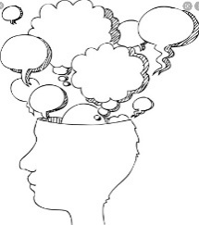Nothing’s going to work
* I hate long covid
* Where’s my phone gone?
* What’s for tea?
* Ooh that new films on tonight....

Thoughts can be linked to the situation we are in, thoughts can be in the form of judgements, thoughts can be critical or supportive, and at times they can be just random!

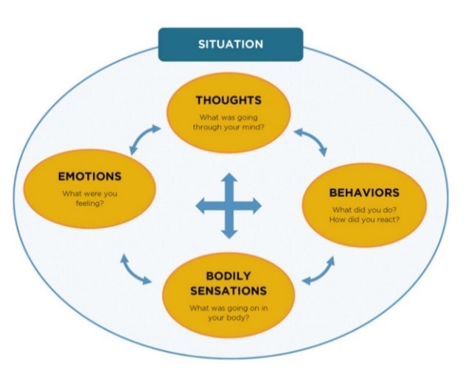

The diagram above, shows that how we think, how we feel, how we behave, and what goes on inside our bodies, are all connected.

It’s how we make sense of the way that people can be in the same situation as each other but can have very different responses. Imagine putting a group of people into a theme park.... some people will be excited going on rides, some people will be scared, some people will be bored, some people might even get angry. Why? The way people perceive a situation, what they think of it, what it means to them, can have an impact on how they behave, what happens to their moods and feelings, and how their bodies react.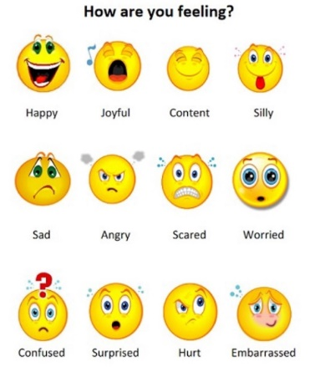 I wonder which feelings you might have experienced? The next time you notice a feeling showing up, pause for a moment, and notice what thoughts might be around.

Ask yourself...is there another way of looking at this situation?

What might a friend, or family member say, if they knew what I was thinking?

See how your hot cross bun looks and see what happens if you can challenge any thoughts which are around.

Remember that our behaviour also impacts how we think and feel. Take notice of your behaviours when certain feelings show up and ask yourself if there are any other ways of responding right now.

# **‘Brain Fog’**

Sometimes children and young people who have long covid can experience ‘brain fog’. This just means that sometimes you might feel a bit more forgetful, you might struggle to concentrate, or just feel that things are a bit muddled up. If you have any difficulties with remembering information, concentrating or making sense of things, here are some strategies you might find helpful;

* Rehearse and repeat information you hear
* 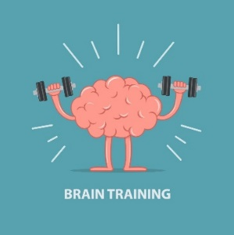Chunking; break information down into smaller chunks
* Write it down; post it notes can be really helpful
* Use rhyming to remember things
* Take breaks
* Ask for help
* Sometimes having a short ‘time out’ from class can help
* Remember your breathing and mindfulness techniques

***We hope that you have found reading this resource helpful. We appreciate that there isn't a 'quick fix' to long covid, however we hope to reassure you that by trying out the advice and strategies here, that this may support you to get back to living the kind of life which matters to you.***

**With best wishes,**

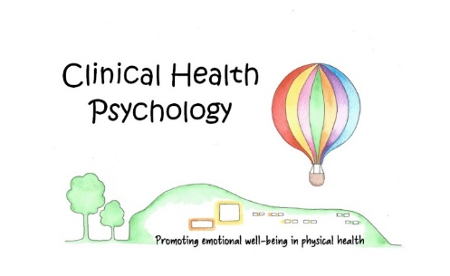**The Alder Hey Long Covid team**

***Dr Theo Anbu (Consultant Paediatrician)***

***Lindsey Clarke (Occupational Therapist)***

***Sharon Atherton (Physiotherapist)***

***Carol Lydon (Clinical Nurse Specialist)***

Alder Hey Children's NHS Foundation Trust is neither liable for the contents of any external internet site listed, nor does it endorse any commercial product or service mentioned or advised on any of these sites.

This leaflet only gives general information. You must always discuss your individual treatment with the appropriate member of staff. Do not rely on this leaflet alone for information about your treatment.

This information can be made available in other languages and formats if requested.

Alder Hey Children’s NHS Foundation Trust,

Alder Hey

Eaton Road,

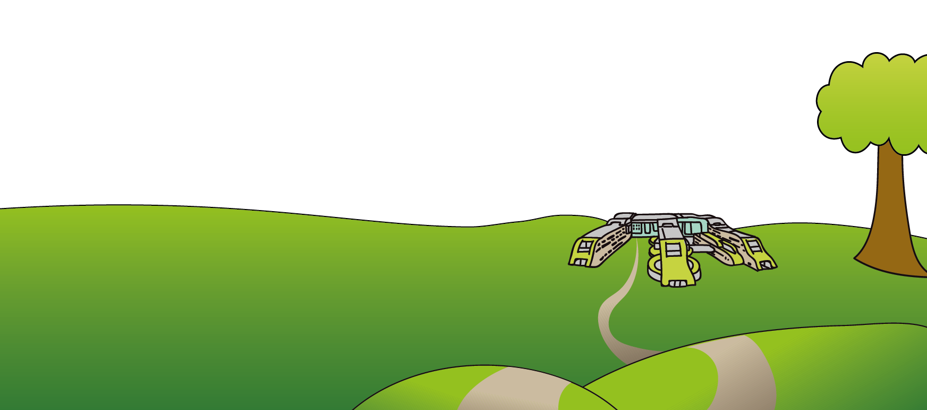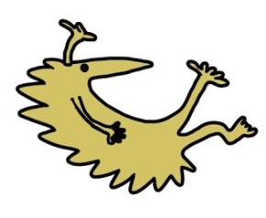Liverpool,

L12 2AP

Tel: 0151 228 4811

[www.alderhey.nhs.uk](http://www.alderhey.nhs.uk)

**© Alder Hey Review date: June 2028 PIAG: 378**