Post-test dose
A post test dose assessment will be
carried out by the same physio who did the pre op assessment. The amount of spasticity will be assessed and you will be asked about any changes you have noticed when caring for your child. Your child may also have a functional assessment if this is the purpose of the test dose. Your community physio may also attend to assist in assessment.
Once enough information has been gathered, the catheter will be removed and you will be discharged.
Follow up will take place in the outpatient department with the team. The test dose response will be discussed and potential treatment options.
Frequently asked questions
What are the possible complications of ITB test dose?
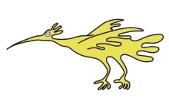
• Low pressure symptoms causing headache, nausea or vomiting
• Overdose of baclofen
• Infection of catheter or wound
• Catheter kink preventing the flow of baclofen
• Catheter breakage, causing leak of baclofen.
What are the signs of baclofen overdose?
Slow shallow breathing, drowsiness, light headedness, seizures, loss of consciousness.
Should you have any further questions please contact the Specialist Nurse on 0151 228 4811 Ext 4349
Email: Deborah.quirk@alderhey.nhs.uk

This leaflet only gives general information. You must always discuss the individual treatment of your child with the appropriate member of staff. Do not rely on this leaflet alone for information about your child’s treatment.
This information can be made available in other languages and formats if requested.

Alder Hey Children’s NHS Foundation Trust
Alder Hey
Eaton Road
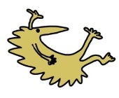
Liverpool
L12 2AP

Tel: 0151 228 4811
www.alderhey.nhs.uk
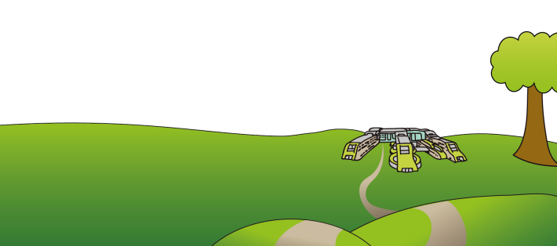
© Alder Hey
Review Date: September 2028 PIAG: 206

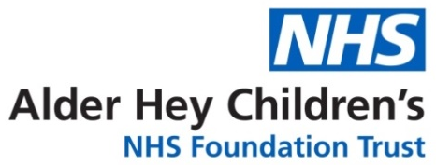

Spasticity Service
Intrathecal Baclofen (ITB) Test dose for SDR & Pump Insertion
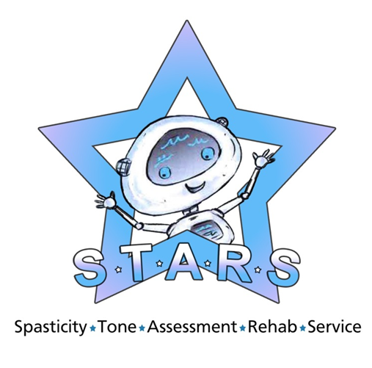

Information for patients,
parents and carers

Spasticity is a condition that affects muscles, making them more stiff and rigid than usual, and it may be accompanied by other problems such as uncontrolled movements, also known as dystonia.

Treatment options for spasticity management
Baclofen is a muscle relaxant and antispasmodic agent administered orally to manage spasticity. Other drugs may also be used. Some patients respond to oral medication, however others may experience side effects such as drowsiness, dizziness, weakness and nausea. Other patients may fail to get adequate control of their spasticity regardless of the dose.
Intrathecal Baclofen is a neurosurgical technique used to treat spasticity and dystonia. It involves the long term delivery of baclofen directly into the intrathecal space surrounding the spinal cord, via a pump (Medtronic Syncromed Infusion System). This is surgically implanted under the skin in the
abdomen, with a catheter connected to the pump and secured in the intrathecal space.
ITB therapy delivers a special form of the drug Baclofen directly into the fluid around the spinal cord via an internal catheter. The pump is programmed to release prescribed amounts of baclofen according to the instructions provided by the programmer. Usually this means that a continuous dose of medication is given over 24hrs.

What are the aims of this surgery?
Specific aims for your child will be discussed, but may include:

• Reduce pain
• Reduce spasm
• Increase mobility
• Increase functional ability
• Reduce care givers time
• Ease rehab procedures
• Delay / Optimise Orthopaedic Surgery
• Facilitate hygiene cares
• Increase range of motion
How will I know if this is the correct procedure for my child?
You and your child will be seen in a multi-disciplinary clinic by the spasticity team, which includes a Neurosurgeon, a Neurologist, a Physiotherapist and a Nurse. We will discuss all aspects of ITB. If we think your child may be suitable for ITB, we will carry out a baseline assessment and ‘Test Dose’, to decide if ITB would be effective.
This involves your child coming into to hospital and having a catheter inserted into the space surrounding the spinal cord when sedated. The medical team can then administer a small dose of Baclofen into this space, and changes in your child’s spasticity can be assessed.
There is opportunity to speak with another family whose child has an ITB pump should you wish to.

Test dose process
Prior to admission, a detailed pre-test assessment is carried out by a physiotherapist.
This will include:
- Gathering information about your child’s functional abilities, nutrition, sleep pattern,
equipment needs, current medications and details of other professionals involved.
- A physical examination looking at the amount of spasticity.
- Completing standardised assessments about your child’s care needs and pain.

- Discussing concerns and expectations and setting goals for the intervention.
On the day of the test dose, the physical exam is completed once your child has gone to sleep, to determine the amount of muscle contracture and joint limitation without the influence of spasticity.
Once recovered from the anaesthetic, a small amount of Baclofen is delivered into the intrathecal space, via the intrathecal catheter and your child is carefully monitored to assess the quality and degree of tone reduction.
Infusion test dosing can take place for up to 6 days, with assessments following each dose adjustment.

