If you have any questions, you can
contact:
Monday-Friday 8:30am to 4:30pm
Advanced Nurse Practitioner in
Neurosurgery: Dawn Hennigan
0151 282 4579
Spasticity Nurse Specialist
Deborah Quirk
0151 228 4811 ext 4349
Email:Deborah.quirk@alderhey.nhs.uk
Clinical Specialist Physiotherapist
Beata Migas : 0151 252 5660
Out of hours (evenings and weekends)
Contact Ward 4A
0151 282 4492 or 0151 282 4489
Email us with non-urgent queries:
spasticityservice@alderhey.nhs.uk
IN AN EMERGENCY
CALL 999
DO NOT DELAY EMERGENCY TREATMENT IN ORDER TO
CONTACT THE WARD OR YOUR GP

This leaflet only gives general information. You must always discuss the individual treatment of your child with the appropriate member of staff. Do not rely on this leaflet alone for information about your child’s treatment.
This information can be made available in other languages and formats if requested.

Your child has attended today and the following procedures have taken place:

Pump refill
Drug Dose Change
New dose:
………………….mcg/day
Drug Concentration Change
New concentration:
………………….mcg/ml
Your next refill date is:
…………………………………….
This is the date you should attend clinic.
Your pump alarm date is:
…………………………………….
This is the date the pump will alarm if you miss this appointment. This tells you the pump is running low on drug.
You need to access the ITB team
immediately.
Alder Hey Children’s NHS Foundation Trust
Alder Hey

Eaton Road

Liverpool
L12 2AP

Tel: 0151 228 4811
www.alderhey.nhs.uk

© Alder Hey
Review Date: September 2028
PIAG: 207



Spasticity Service
Intrathecal Baclofen (ITB)
Pump Refill
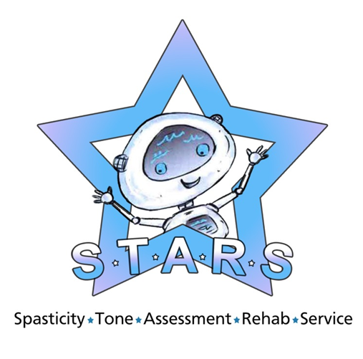

Information for patients,
parents and carers

This leaflet provides you with advice on how to care for your child following refill of your intrathecal baclofen pump.
There should be no adverse effects following today’s clinic appointment, however you should always observe your child closely for signs of Baclofen under / over dosage. Some examples are listed below, but please note these are a guide and are not exclusively related to Baclofen.
Should your child’s condition or behaviour concern you in any way, please do not hesitate to seek medical advice.
Signs of under dosage (sometimes called withdrawal)
• Increase in spasticity of the
muscles, starting in the lower limbs first
• Itching Skin (Pruritus)
• Seizures - Collapsing or passing out with shaking of arms and/or legs
• Irritable, unusual behaviour such as not knowing who or where they are, saying inappropriate things, getting things mixed up or appearing to see things that aren't there.
• Increased body temperature

Signs of over dosage
• Excessive weakness of muscles
beginning in the lower limbs first

• Sedation and excessive
sleepiness
• Nausea and Vomiting
• Dizziness
• Severe overdose can require
Intensive care and ventilation
The puncture site from the refill should also be observed for any signs of redness, swelling, heat, pain or leak,
Please ensure that your child’s school and carers are aware of the information above

Please be advised that pumps and catheters can very occasionally malfunction, therefore you should be mindful of this if your child presents with any of the previously mentioned signs and symptoms at any time.
If you are unsure, you can contact us on the numbers provided overleaf, or take your child to a medical practitioner for advice without delay.
The pump does contain an alarm. Should you ever hear this alarm, you must contact us immediately.

In the event of this being overnight or at the weekend, take your child to your local hospital, and they will contact our out of hours team for advice. The pump will continue to alarm until it is reset by the programmer.
This is a medical emergency
Medtronic © are the company that have developed and supplied your pump to us.
There is further information available in the Medtronic information booklet you received at the time of pump
Implantation titled ‘Intrathecal
Baclofen Therapy for Cerebral Palsy – Information for you and your
family’.
You can also obtain further information from www.medtronic.com or by contacting Medtronic by telephone 01923 212213

