Clinic Follow Up
This takes place in the outpatients
department, with the physiotherapist and nurse practitioner who you and your child will have met before during your inpatient stay. If necessary, your child may also be seen by the neurosurgeon or neurologist. Further assessment may be needed to decide if a dose change is required, but we will be also be helped by the information that you and your community physiotherapist give us about any changes.
Dose adjustment is an ongoing process with frequent changes required especially in the first few months after implantation. The nurse will interrogate the pump using the programmer and this will give information about pump function and check the battery. Alterations to the amount of drug delivered can be made using the programmer.
Pump refills may not be necessary every time you attend clinic, and will usual take place every 3-6 months. This involves removing the old drug with a needle, through the skin, directly into the pump reservoir, via the refill port. This is replaced with fresh baclofen. The
procedure lasts a few minutes and dose not require ametop as it is usually well tolerated.
Following each clinic, you will be given a detailed advice sheet regarding signs of under/over dose. You will be advised of the alarm date for the pump, and your next refill appointment.

Should you have any further questions please contact the Neurosurgical Specialist Nursing team on:
0151 282 4489 ext 4349
Email: Deborah.quirk@alderhey.nhs.uk

This leaflet only gives general information. You must always discuss the individual treatment of your child with the appropriate member of staff. Do not rely on this leaflet alone for information about your child’s treatment.
This information can be made available in other languages and formats if requested.

Alder Hey Children’s NHS Foundation Trust
Alder Hey
Eaton Road

Liverpool
L12 2AP

Tel: 0151 228 4811
www.alderhey.nhs.uk


© Alder Hey
Review Date: September 2028 PIAG: 208

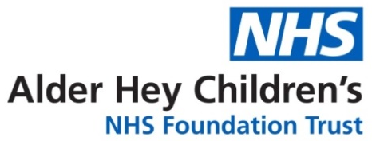

Spasticity Service
Intrathecal Baclofen (ITB)
Pump Implantation
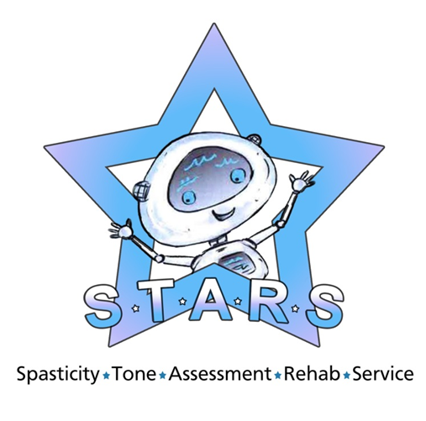

Information for patients,
parents and carers

Spasticity is a condition that affects muscles, making them more stiff and rigid than usual, and it may be accompanied by other problems such as uncontrolled movements, also known as dystonia.
Treatment options for spasticity management
Baclofen is a muscle relaxant and antispasmodic agent administered orally to manage spasticity. Other drugs may also be used. Some patients respond to oral medication, however others may experience side effects such as drowsiness, dizziness, weakness and nausea. Other patients may fail to get adequate control of their spasticity regardless of the dose.
Intrathecal Baclofen is a neurosurgical technique used to treat spasticity and dystonia. It involves the long term delivery of baclofen directly into the intrathecal space surrounding the spinal cord, via a pump (Medtronic Syncromed Infusion System).
This is surgically implanted under the skin in the abdomen, with a catheter connected to the pump and secured in the intrathecal space.
ITB therapy delivers a special form of the drug Baclofen directly into the fluid around the spinal cord via an internal catheter. The pump is programmed to release prescribed amounts of baclofen according to the instructions provided by the programmer. Usually this means that a continuous dose of medication is given over 24hrs.

What are the aims of this surgery?
Specific aims for your child will be
discussed, but may include

• Reduce pain
• Reduce spasm
• Increase mobility
• Increase functional ability
• Reduce care givers time
• Ease rehab procedures
• Delay/Optimise Orthopaedic Surgery
• Facilitate hygiene cares
• Increase range of motion
How will I know if this is the correct procedure for my child?
You and your child will be seen in a multi-disciplinary clinic by the spasticity team, which includes a Neurosurgeon, a Neurologist, a Physiotherapist and a Nurse. We will discuss all aspects of ITB. If we think your child may be suitable for ITB, we will carry out a baseline assessment and ‘Test Dose’, to decide if ITB would be effective. This involves your child coming into the hospital and having a catheter inserted into the space surrounding the spinal cord when sedated. The medical team can then administer a small dose of Baclofen into this space, and changes in your child’s spasticity can be assessed.
There is opportunity to speak with another family whose child has an ITB pump should you wish to.

Pump Implantation
Your child will be provided with a pre op
wash / nasal cream (mupirocin and octenisan wash) commenced for decolonisation of MRSA / MSSA. This should be used for 5 days prior to admission.
On admission, a further assessment of your child by a physiotherapist may be needed if it has been a long time between your child having the test dose and pump implantation.
After the pump has been implanted, your child will be assessed 24 hours later to see if there has been any change in their spasticity. The results of the assessment will help the team to decide of the dose setting of the pump. Several doses changes may be made before discharge.
Before your child is discharged, we will demonstrate 2 safety alarms.
These are a Critical Alarm (Two Tone) or
Non-Critical (Single Tone).
If you hear the critical alarm, your must bring your child to hospital immediately.
If you hear the Non Critical alarm, you should
contact Ward 4A (0151 282 4489).
On discharge, your community physio will be contacted and arrangements made for follow up in the community.

