Radiation Safety
(A Note for Parents)
Any Interventional Radiological Procedure does involve a dose of radiation.
There is no upper limit for the amount of radiation required to undertake any interventional procedure, as the benefits of the procedure outweigh the risks of the radiation dose received.
Every patient of childbearing age and gender undergoing any interventional procedure will have a Pregnancy test prior to the procedure being undertaken.
This is to avoid any unnecessary radiation dose being given to a developing foetus.
Please do not take offence, as this is Trust policy.

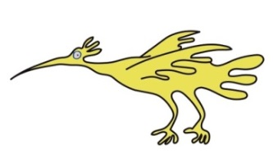

If you have any queries, please feel free to contact us on: 0151 252 5332.

This leaflet only gives general information. You must always discuss the individual examinations of your child with the appropriate member of staff. Do not rely on this leaflet alone for information about your child’s examinations.
This information can be made available in other languages and formats if requested.

Alder Hey Children’s NHS Foundation Trust
Alder Hey
Eaton Road
Liverpool
L12 2AP
Tel: 0151 228 4811
www.alderhey.nhs.uk

© Alder Hey
Review Date: May 2026
PIAG: 104




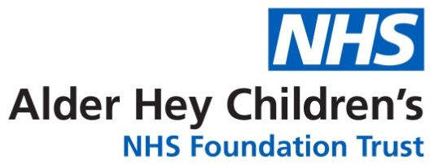

Radiology Department
Interventional
Radiology



Information for patients,
parents and carers

Here is some information about your Interventional X-Ray Procedure
Your Interventional Team are based in Theatre 12 (I.R. Suite).
The team consists of:
Interventional Radiologist
Anaesthetist
Operating Department Practitioner (O.D.P.)
Theatre Nurses
Interventional Radiographer



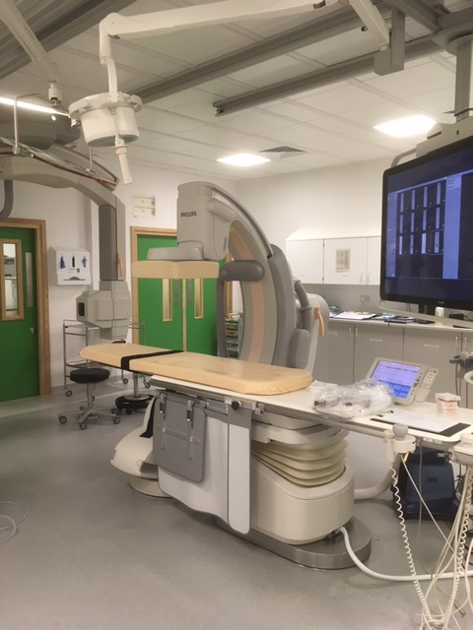
The Interventional procedure can take quite a while to do, so you will need to be asleep for your pictures.
The Anaesthetist will help you go to sleep with a General Anaesthetic.
We perform special dynamic (moving)
x-ray pictures with a special “dye” called contrast agent (Angiography).

These pictures assist the Radiologist perform the procedure.

To take the pictures we use a special
x-ray machine called an image intensifier.
This allows us to take pictures from above and at the side of you at the same time.

.

Here is our image intensifier
Photo taken in Theatre 12.



