Radiation Safety
(A Note for Parents)
An Orthopaedic Theatre Procedure does involve a dose of radiation.
There is no upper limit for the amount of radiation required to undertake any Orthopaedic Surgical procedure, as the benefits of the procedure outweigh the risks of the radiation dose received.
Every patient of child-bearing age and gender undergoing any Orthopaedic Surgical Procedure will have a Pregnancy test prior to the procedure being undertaken.
This is to avoid any unnecessary radiation dose being given to a developing foetus.
Please do not take offence, as this is Trust policy.

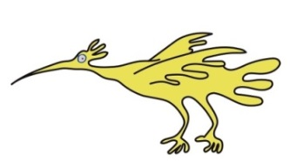

If you have any queries, please feel free to contact us on: 0151 252 5332.

This leaflet only gives general information. You must always discuss the individual examinations of your child with the appropriate member of staff. Do not rely on this leaflet alone for information about your child’s examinations.
This information can be made available in other languages and formats if requested.

Alder Hey Children’s NHS Foundation Trust
Alder Hey
Eaton Road
Liverpool
L12 2AP

Tel: 0151 228 4811
www.alderhey.nhs.uk

© Alder Hey
Review Date: May 2026 PIAG: 105






Radiology / Orthopaedic
Department
Imaging in
Theatre



Information for patients,
parents and carers

Here is some information about your Imaging in Theatre

Your Orthopaedic Theatre Team
The team consists of:
Orthopaedic Surgeon
Anaesthetist
Operating Department Practitioner (O.D.P.)
Orthopaedic Theatre Nurses
Radiographer



The Orthopaedic Theatre procedure can take quite a while to do, so you will need to be asleep for your pictures.
The Anaesthetist will help you go to sleep with a General Anaesthetic.
Radiographers perform special dynamic (moving) x-ray pictures in theatre to assist the Orthopaedic surgeon (Fluoroscopy).

To take the pictures we use a special
x-ray machine called an image intensifier.
Sometimes we need to take CT – like images and use the O-arm.
CT is short for Computerised Tomography. This uses special x-rays sent from different directions at the same time to get more detailed pictures.

.


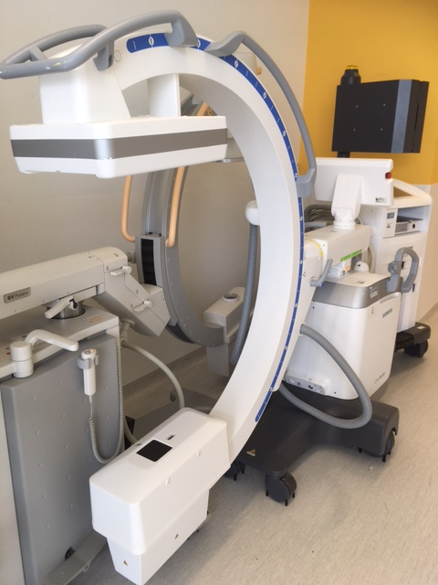

This is an image intensifier that the radiographer’s use to make the moving pictures for the Surgeon.

Here is the O arm.

