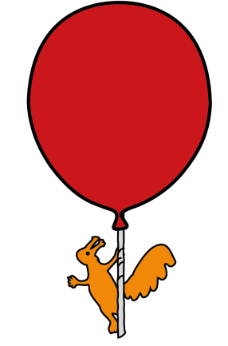
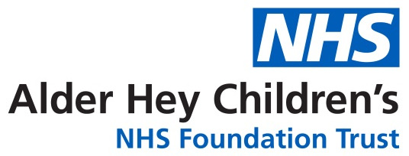

Community Speech and Language Therapy

Ideas to encourage turn taking

Information for families and settings about encouraging turn taking

Introduction

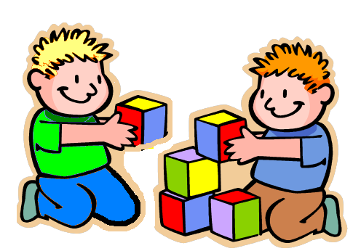
Turn taking skills are really important and one of the foundations for successful communication. Young children typically respond to what another person does or says – this may be by looking, reaching or making a sound etc. Turn taking helps your child to be aware of other people and is the start of two way communication.

Ways to develop early turn taking skills;

- When playing with your child, make sure you pause and wait to give them an opportunity to respond to you.

- Games that involve passing a toy to each other help to develop turn taking, e.g. rolling a ball forwards and backwards, pushing a car to each other etc. You can model language too, “my turn, your turn”.

- Try to involve yourself in your child’s play, for example if your child is playing with blocks you could get your own blocks and play alongside them. If they are ready you can take a turn to put a block on their tower.

- Play any games without toys your child enjoys, for example peekaboo, tickles, blowing raspberries, chase. Pause and wait for your child to take their turn, remember their turn might be a look, a smile, a movement or a sound. When they respond then take your next turn.

Childrensslt@alderhey.nhs.uk

Sefton: 0151 282 4973 Liverpool: 0151 295 3990

Speech and language therapy - Alder Hey Children's Hospital Trust
(click this link or type into search engine)

This leaflet only gives general information. You must always discuss the individual treatment of your child with the appropriate member of staff. Do not rely on this leaflet alone for information about your child’s treatment.
This information can be made available in other languages and formats if requested.

Alder Hey Children’s NHS Foundation Trust
Alder Hey
Eaton Road
Liverpool
L12 2AP
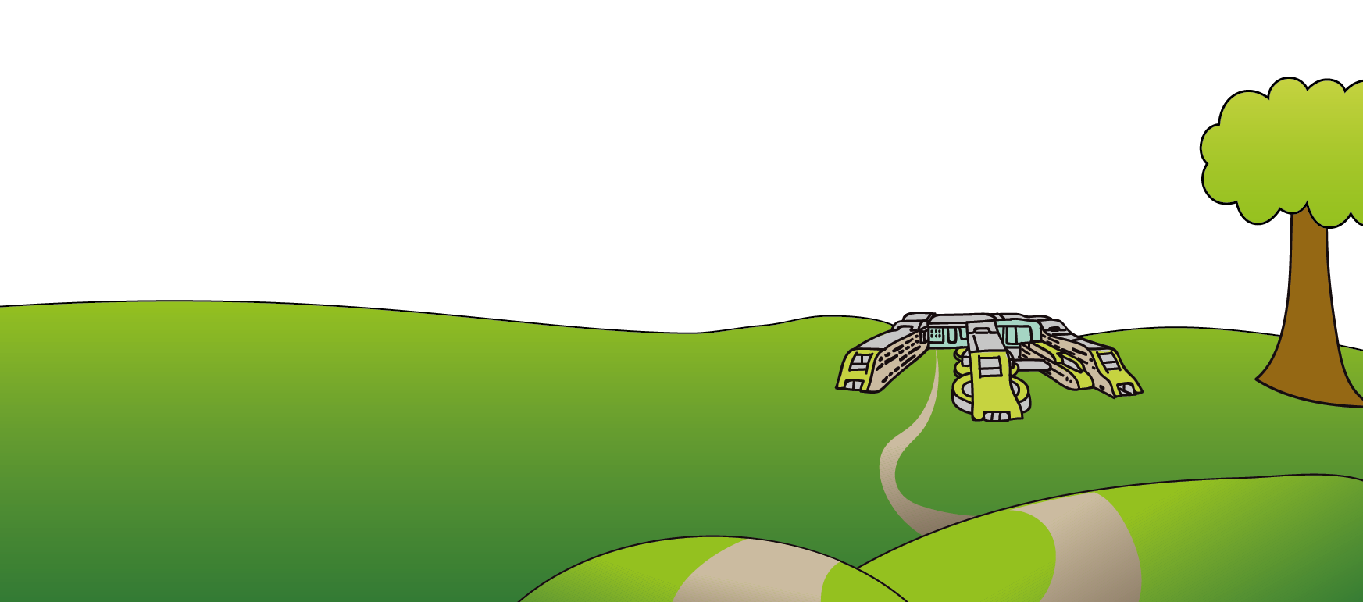
Tel: 0151 228 4811
www.alderhey.nhs.uk

© Alder Hey Review Date: December 2027 PIAG: 0091

