Urology Department

Hypospadias Repair

Information for parents and carers

What is Hypospadias?

Hypospadias means “short urethra ”. The urethra is the tube that urine (wee) goes through from the bladder to the opening in the penis (willy). Some boys are born with the wee hole somewhere on the underside of the penis. The exact position of the hole can vary from boy to boy.

Hypospadias repair involves moving the wee hole to the end of the penis. The repair uses the foreskin to make a new tube inside the penis. This will enable your son to pass urine standing up.

Hypospadias can be accompanied by Chordee. This causes the penis to have a downward curve, and makes the penis appear shorter. Chordee is caused by a tight band of fibrous tissue which pulls the penis out of shape. This will be corrected as part of the Hypospadias repair surgery.

When will we come to hospital?

Your son will be admitted on the date of his operation and will be seen by a doctor and anaesthetist before he goes to theatre. Your admission letter will tell you the time your son can have his last food and drink before going for surgery.

On the ward

If your son is admitted for Day Case Surgery he may be admitted to our Day Surgery Ward, or to one of our surgical wards. All in-patients will be admitted to a surgical ward, and your son can either stay in a bed or a cot. It is a good idea to bring in any favourite toys or DVDs for your child. Every ward has a play specialist but resources are limited. There are facilities for one parent to stay by your child’s bed at night-time. If there are any problems with this, please speak to your named nurse when you are admitted.

The hospital has a restaurant and a shop, and washing facilities are available.

Going to theatre

If you have any specific concerns about the anaesthetic, please speak to the anaesthetist who will see you before the operation.

Your son will need to have medicine through cannula to put him to sleep for the operation. A cannula is a flexible tube inserted into a blood vessel in the lower arm or hand. He will have “magic cream” (a local anaesthetic gel) put on the back of his hands to numb the area where the cannula will go in.

Your son can go to theatre in cotton pyjamas or a hospital gown. Only one parent is allowed in the anaesthetic room, but the parent who goes can stay until your son is fast asleep.

Sometimes the anaesthetist may have to use gas to help your son go to sleep. This smells funny, but does work quite quickly.

Going to the theatre and coming back to the ward

One parent is allowed to go to the recovery room to collect your son after his surgery. He will be given lots of pain relief whilst asleep and should not be sore. He will return to the ward once awake and comfortable.
When he is back on the ward and is fully awake, he will be allowed a drink of juice. If he has had a drink and is feeling alright, he will be allowed home (after Day Case Surgery) or can have some toast or cereal if he is staying as an in-patient.

If your son likes particular foods or drinks, you are allowed to bring these with you.

After surgery

Your son will have a stent (small soft tube) placed in his urethra to hold it open, or a catheter inserted into his bladder during the operation. This drains urine so that the new urethra inside his penis can heal.

He will have a dressing on after surgery to protect his penis while it heals.

The stent or catheter will come through the dressing and is held in place by it. A stent will drip continuously into a nappy, or drain into a catheter bag if your son is older.

Your son may have a drip in place when he returns to the ward. If so, this is just to give him fluids until he is drinking normally.

What care will my son need after his operation?

It is important that your son restricts his activity whilst the dressing is in place. He can mobilise (move about) but should avoid vigorous activity or play.

It is important that your son has lots of drinks while he has a stent or catheter in place. This makes sure there is a good flow of urine through the stent / catheter.

Nurses will be able to give your son pain relief whilst he is in hospital. Pain relief will also be given to you to take home.

Will he need any medicine in hospital and when at home?

Your son will need to take an antibiotic whilst he has a stent or catheter in place. This protects him from any infection. He may need a medicine to try to minimise any bladder spasms he may experience from having a catheter in place.

Most children do not need this medicine, but if your son seems to have spasms, you will be given medicine to take home. If your son has any problems with spasms following discharge please contact the ward or Urology Nurses.

It is important to monitor how often your son opens his bowels (has a poo). A side effect of the medicine for bladder spasms is constipation, and straining to open his bowels may make his penis more uncomfortable.

Going home Day Case Hypospadias Repair

If your son is well and you and the doctors are happy, you can be discharged one hour after surgery. Your son will go home with a dripping stent in place, which will drain into double nappies. The nurses will tell you how to look after this at home.

In-patient Hypospadias Repair (usually 1st stage repair or older boys)
If your son is well and you and the doctors are happy, you can be discharged 24-48 hours after surgery. Your son will go home with the catheter in place and you will be shown how to care for it.
When at home
You are welcome to contact the hospital at any time if you are concerned and staff will do their best to help you.
You can ring:
Ward 3A on 0151 252 5416

The Urology Nurses can be contacted on 0151 252 5852 or via the hospital switchboard 0151 228 4811.

What will happen when we come back to Alder Hey?

You will be given an appointment to return to the hospital for the removal of the dressing and stent / catheter.

Your child’s doctor may arrange for the dressing to be removed in theatre.
If your son has a stent, we can remove the dressing and stent in the Urology Clinic. The play specialist or nurse will use distraction and play to help him sit still while the dressing and stent are removed.
Please can you make sure your son has had his pain relief before you bring him back to the hospital.

Your son’s penis will look swollen, red and bruised when his dressing is removed, but this will get better over the next six weeks.

He will have to stay in the hospital until he has passed urine through his penis. This can sometimes take several hours, but having lots to drink can speed things up a bit.

Your son may find the first time he passes urine a little uncomfortable, but this should improve as he continues to pass urine.

What happens next?
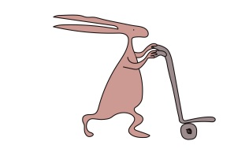
If the nurse may feel it is important for your son’s repair to be reviewed in out-patient clinic this will be explained to you.

An appointment with the Urology Team will also be booked for about six months’ time.

Appointments will be posted to your home address after your son is discharged.

What can go wrong?

Complications can happen. An opening can re-occur at the site of the hypospadias repair. This is called a fistula and urine may leak from this opening, as well as passing through the tip of your son’s penis.

There is also a possibility of developing a stricture. This is a narrowing of the urethra which can occur somewhere along the repair. This can result in your son having difficulty passing urine.
If these complications occur, your son may need further surgery to correct them.

This leaflet only gives general information. You must always discuss the individual treatment of your child with the appropriate member of staff. Do not rely on this leaflet alone for information about your child’s treatment.
This information can be made available in other languages and formats if requested.

Alder Hey Children’s NHS Foundation Trust
Alder Hey
Eaton Road
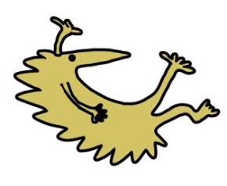
Liverpool
L12 2AP
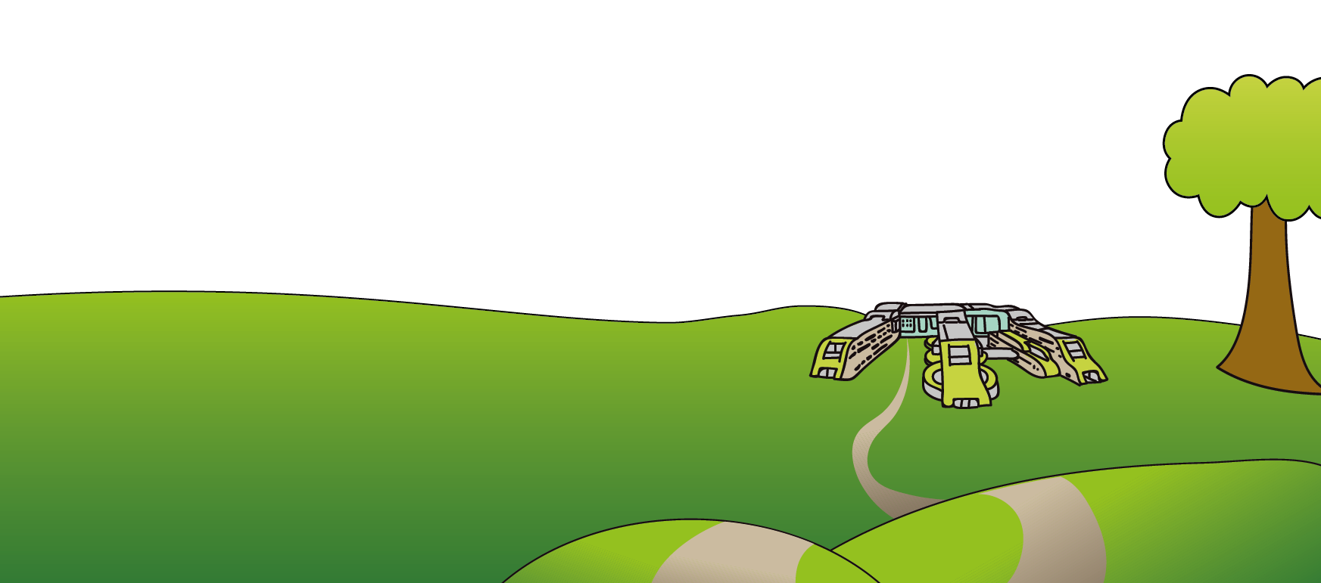
Tel: 0151 228 4811
www.alderhey.nhs.uk

© Alder Hey Review Date: September 2024 PIAG: 92

