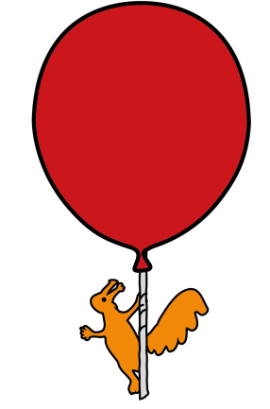


Occupational Therapy Department

Hypermobility

Information for parents, carers and schools

Introduction

All joints have varying ranges of movement. Ligaments and muscles provide a joint with stability and allow movement. Children who are hypermobile have some joints that are more flexible than their peers. The looseness of the supporting structures may cause joints to be unstable. Excess movement may cause brief discomfort, pain and swelling. A growth spurt, lack of exercise or an accident can increase symptoms.

If there is an underlying reason for joint hypermobility, this will be investigated by the doctors. Therapy advice will remain the same, regardless of the reason for the hypermobility.

Many people with Hypermobile joints do not get any symptoms and may not even realise they are Hypermobile. Being Hypermobile can be an advantage for some people when playing sports, such as dancing, gymnastics or when playing musical instruments.

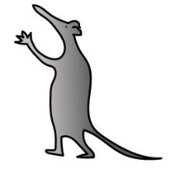
Possible symptoms

- Fatigue. Children may experience two types of fatigue:

  - specific joint or muscle fatigue because joints and muscles are working extra hard

  - general overall fatigue due to increased effort to perform activities

- Pain. Increased range of movement can contribute to joint and muscle pain.

- Co-ordination. The receptors in our joints tell us the position of our bodies in the environment when we can’t see; for example if you close your eyes and hold out your hand, your body knows where your hand is in front of you. When there is too much movement around the joints the receptors don’t get the same messages as when there is less movement. These symptoms may lead to poor co-ordination and difficulties with daily activities such as handwriting, holding cutlery and getting dressed.

As children grow and develop, the majority of them will become less flexible as they get older. and becomes more active, hypermobile joints often / generally become stronger and pain subsides. Co-ordination may improve and your child should be less tired.

Management strategies for parents and carers

Good body mechanics:

The way that your child carries their body largely affects how much strain they put on their joints. Considering posture and movement allows your child to use their body more efficiently and conserve energy.

- When sitting at a desk your child’s feet should be flat on the floor. Their thighs and forearms should be horizontal and the desk just below elbow height.

- When your child is using a keyboard for long periods consider using a chair with arms or wrist or forearm supports.

- A sloped work surface is easier on the neck position. You could try using an angled board or a lever arch file when writing.

- When standing the work surface height should enable your child to work comfortably without stooping.

- Increase the height of the chair to reduce stress on the hips and knees as your child gets up.

- When picking up items from the floor your child should bend from the hips and knees or sit in a chair to reach down.

- Carry heavy objects close to the chest.

- Use a backpack with padded straps for carrying school books, worn symmetrically to distribute weight evenly. Pack heavier items closest to the back of the bag.

Use the strongest joint available for the job:

Throughout the day your child should use large joints for as many tasks as possible. They should save their weaker / more mobile joints for specific jobs that only they can do. For example they should:

- Carry objects with their palms open distributing the weight evenly over their forearm.

- Slide objects along a work surface rather than lifting them.

- When opening cabinets, use a loop that can be pulled with the wrist or forearm to reduce stress on the fingers.

Avoid keeping joints in the same position for a prolonged period of time:

Don’t give your child’s joints a chance to become stiff, this can cause more discomfort - keep them moving. For example:

- Gentle exercise and movement throughout the day, even if your child is in pain it will help.

- Regular movement breaks will help relieve any symptoms from keeping joints in one position for any length of time

- When writing they should release their grip every 5-10 minutes.

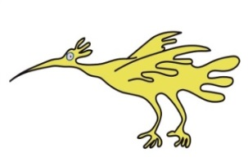
- On long car journeys get out of the car, get your child to stretch and move around at least every hour.

- Whilst watching TV your child should get up and move around every half hour.

- Discourage your child from resting their head on their hands when sitting at the desk.

Protecting joints:

- Encourage your child to move each joint at least once a day. This will help maintain freedom of movement in the joints. They should keep movements slow and gentle; sudden jerking or bouncing can hurt joints.

- Both you and your child should try to understand and respect any pain. Understand the difference between general discomfort and the pain from over using a joint. By noting the activity that stressed a joint, you can help your child to learn to avoid repeating that movement.

- Encourage your child to be careful how they use their hands. Fingers are used in many day-to-day activities. Stressful positions and techniques may increase the stress on joints and most tasks can be performed in easier ways. Ask your occupational therapist for further advice.

- Avoid your child making a tight fist. Try to use larger handled objects rather than narrow ones, which will increase the tension through the hands and stress through the joints. For instance hair brushes, chunky pencils, fatter-handled cutlery and an electric rather than standard toothbrush.

- Try to get your child to not pinch items between their thumb and fingers. They should hold a book, plate or mug in the palms of their hands. If your child is reading for long periods use a book holder.

- If your child is carrying items, encourage them to make several small trips rather than carrying one very heavy item.

- Avoid your child demonstrating the ‘party trick’ of over stretching their joints – don’t encourage them to ‘pop’ their fingers or knees! Ask your occupational therapist for further advice.
Strategies
Strengthen:

- Encourage your child to take part in regular low impact strengthening activities such as swimming, cycling, children’s yoga/pilates or walking. These are all helpful to improve joint strength. They should avoid inactivity.

Pain management:
- Heat or ice: warm baths, hot water bottles or heat packs can help relax your child’s muscles. Ice can reduce swelling. Protect your childs skin from heat or ice burns by placing the heat pack in a dry cloth, use a damp cloth when using an ice pack.

- Distraction techniques: focusing on pain will make it feel worse. Help your child to keep their mind busy with activities to distract them.

- You should take your child to their GP if the pain isn’t manageable
Sleep:

- Maintain a healthy sleep pattern for your child with set bed time and wake up time routines

- Your child should avoid watching TV and playing on electronic gadgets before to going to bed.

Eating:

- Encourage your child to eat a healthy balanced diet, as being overweight can put extra stress on their joints.

Pacing:

- Plan your activities through the week / day to avoid getting tired and avoid over working your child’s joints

- Pre-plan your child’s work and rest periods before they become tired and sore

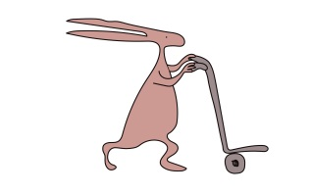
- Spread heavy and light tasks throughout the day. Try to get your child to work at a steady moderate pace.

- Work out what’s important and eliminate unnecessary tasks for your child.

Self-care:

- If children are struggling with dressing, fastenings or holding cutlery, there are many adaptive strategies that may assist them such as Velcro or elastic laces. Building up the grips on handles can help with grip. For further information, refer to our other advice sheets on these areas.
Advice for Schools

- When the child is at their desk ensure that feet are flat on the floor, thighs and forearms are horizontal and the desk is just below elbow height.

- Using a desk slope can further improve wrist position for writing. If children appear to be slumping in their chair a foam wedge cushion may improve this. Encourage children to sit straighter as although it is hard work, slumping may cause pain.

- Sitting on the carpet with crossed legs is hard work. Allow children to sit on a chair or bench. Discourage children sitting in a ‘w sit’ position,(Sitting on their bottom with their knees bent and their feet outside their hips).

- Children may need to move around a lot rather than sitting still and may need to fidget. This will help to reduce stiffness and should be allowed.

- Writing may be hard work for children with hypermobile joints. Increasing the diameter of the pen / pencil by using a pen grip or chunky pens may help. Regular rest breaks are useful to reduce pain. Completing hand warm ups before handwriting may also help.

- Consider having a plan to allow children to rest if they get over tired at school or are in pain.
PE:

- Unless told otherwise, children should participate as much as they can in PE (the curriculum may need to be differentiated).

- This will help keep muscles strong to reduce pain

- Make sure they always wear supportive sports shoes such as trainers rather than bare feet or pumps.

- Avoid unnecessary high impact or contact sports if a child is experiencing discomfort.

If you have any queries

Please contact the Therapy Department on 0151 252 5171 between 8.30 am and 4.30 pm - Monday to Friday.

There will probably be a Disabled Living Centre or mobility shop in your area that would also be able to help. There is a wide range of companies who deal in specialist advice and equipment.
Below are just a few websites where these things are available:
- DISABLED LIVING FOUNDATION: www.dlf.org.uk
- OT STORES: www.otstores.co.uk
- HOMECARE: www.homecare-products.co.uk
- POSTURITE: www.posturite.co.uk
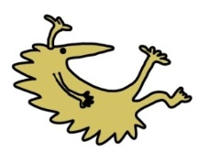
- SPECIAL DIRECT: www.specialdirect.com
- BACK IN ACTION: www.backinaction.co.uk
- TASKMASTER: www.taskmasteronline.co.uk
- PETA(UK)LTD: www.peta-uk.com
- ESSENTIAL AIDS: www.essentialaids.com
- ABILITY STORE: www.abilitystore.co.uk
- HOMECRAFT: www.homecraft-rolyan.com
- NRS HEALTHCARE: www.nrs-uk.co.uk
- BETTER LIFE FROM LLOYDS PHARMACY: www.betterlifehealthcare.com
- GREEPER LACES: www.greeper.com

Alder Hey Children's NHS Foundation Trust is neither liable for the contents of any external internet site listed, nor does it endorse any commercial product or service mentioned or advised on any of the sites.

This leaflet only gives general information. You must always discuss the individual treatment of your child with the appropriate member of staff. Do not rely on this leaflet alone for information about your child’s treatment.
This information can be made available in other languages and formats if requested.

Alder Hey Children’s NHS Foundation Trust
Alder Hey
Eaton Road
Liverpool
L12 2AP

Tel: 0151 228 4811
www.alderhey.nhs.uk

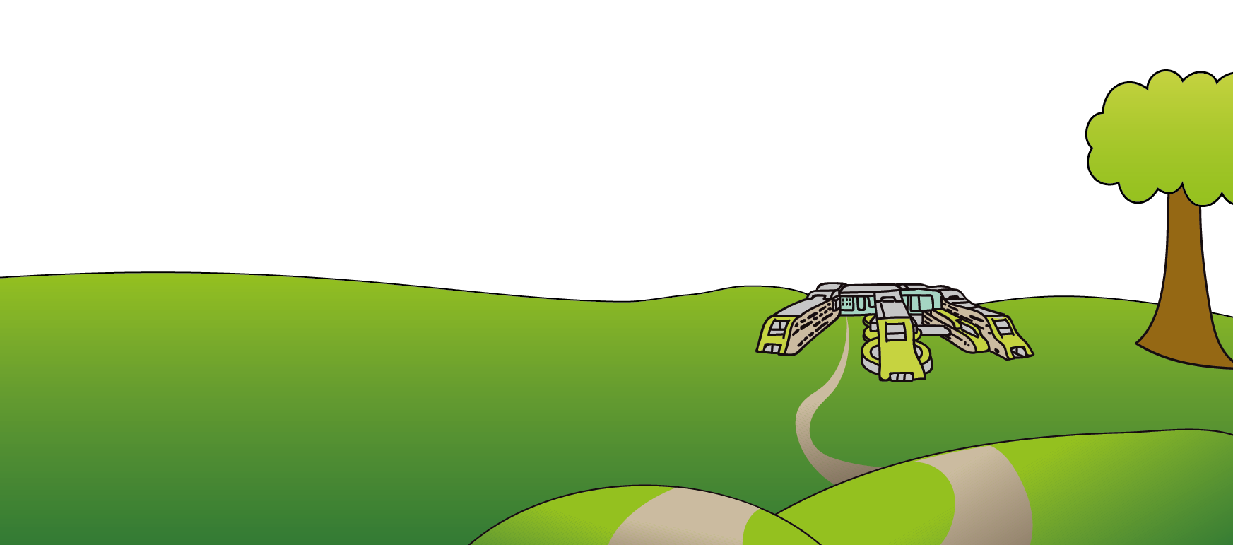
© Alder Hey Review Date: June 2027 PIAG: 085

