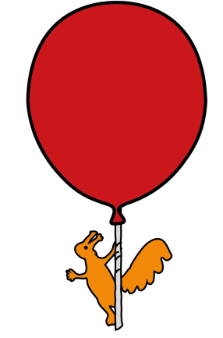


Pharmacy Department

How to Prepare (Reconstitute) an Antibiotic Powder

for Oral Solution

Information for patients, parents and carers

Introduction

The preparation of an oral antibiotic liquid from the dry powder is called “reconstitution”.
This leaflet explains how to do this.

- Wash your hands before handling any medication.

- Check the “expiry” or “use before” date on the original container to ensure the oral antibiotic powder is in date.


- There should be instructions printed on the label attached by the Pharmacy and/or the original container of your child’s medication telling you how much water is needed to reconstitute the oral antibiotic powder.

- The measuring cylinder provided by Pharmacy should also be marked with the correct volume of water needed to reconstitute the oral antibiotic powder.

- Ensure that the product has not already been reconstituted and it is in a dry powder form.

- Using tap water and the measuring cylinder provided, measure out the required volume of water to reconstitute the oral antibiotic powder.

- Once the correct volume of water is measured, pour it slowly into the medicine bottle containing the oral antibiotic powder.

- Place the lid back on the bottle securely and shake thoroughly to ensure proper mixing.

- Once you are happy that your medication has been mixed properly, you will need to put a “do not use after” date on the label as the original expiry will be shortened. This date will depend on how stable the medication is following reconstitution. Usually it will be an expiry date of 7 days or 14 days after reconstitution.

- Ensure the medication is stored properly i.e. IN THE FRIDGE or at ROOM TEMPERATURE. This will be stated on the label.


- The correct dose of the reconstituted oral antibiotic solution for your child will be stated on the dispensing label.

Please ensure that you shake the bottle well before each use.

General advice about medicines

- Never give medicines prescribed for your child to anyone else, even if their condition appears to be the same, as this could do harm.

- If you think someone else may have taken the medicine by accident, contact your doctor straight away.

- Make sure that you always have enough medicine. Order a new prescription at least 2 weeks before you will run out.

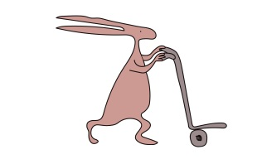
- Make sure that the medicine you have at home has not reached the ‘best before’ or ‘use by’ date on the packaging. Give old medicines to your Pharmacist to dispose of.

- This leaflet should be read with any manufacturers’ patient information. You must always discuss individual treatment with the appropriate member of staff.

Who to contact for further details

If you have any questions about your medication whilst you are in hospital, please do not hesitate to ask one of the Pharmacy team, alternatively you can telephone us on (0151) 252 5311.

This leaflet only gives general information. You must always discuss the individual treatment of your child with the appropriate member of staff. Do not rely on this leaflet alone for information about your child’s treatment.

This information can be made available in other languages and formats if requested.

Alder Hey Children’s NHS Foundation Trust
Alder Hey
Eaton Road
Liverpool
L12 2AP
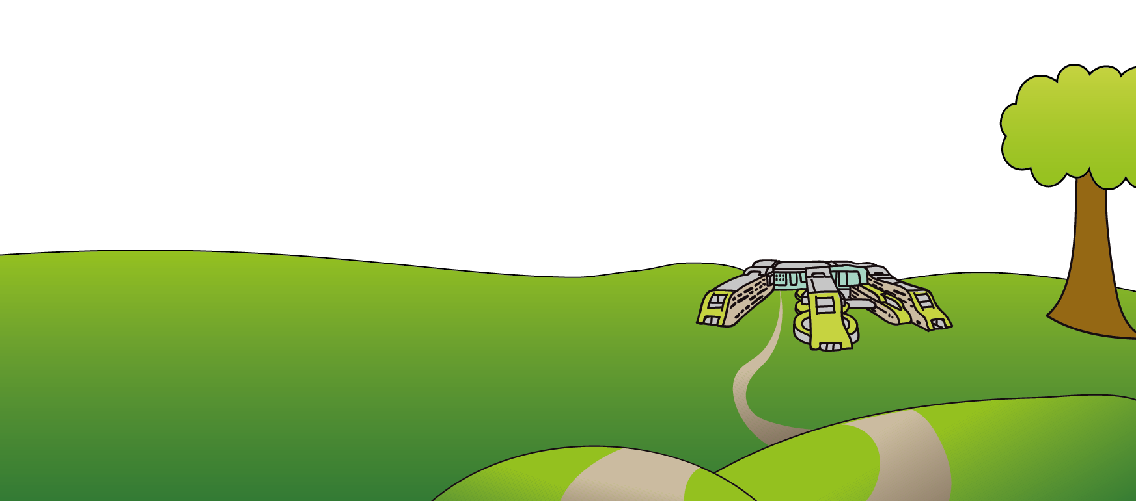
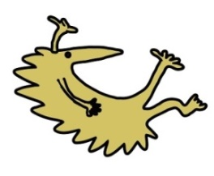
Tel: 0151 228 4811
www.alderhey.nhs.uk

© Alder Hey Review Date: May 2027 PIAG: M34

