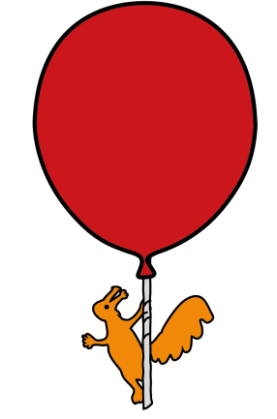
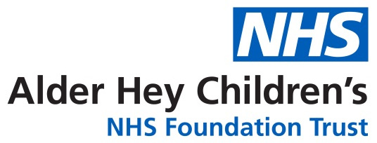

Pharmany Department

How to Use Your Child’s Nasal Spray

Information for parents and carers

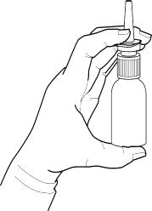
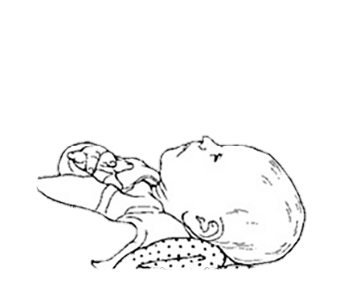
- Read the instructions on the label.

- Wash your hands.

- Wipe your child’s nose and ask him or her to blow their nose if possible.

- Ask your child to lie down or sit with his or her head tilted back.

- Shake the spray

- Ask your child to breathe through the mouth, and squirt the recommended number of sprays into your child’s nostril(s).

- Keep your child’s head back so the medicine can spread through the nose.

- Replace the top of the bottle after using. Try not to touch applicator tip with anything, including your fingers.

- Your child may be able to taste the medicine. This is normal – do not worry.

- Use the spray as directed and do not continue to use for longer than your doctor has recommended.

- Once opened, sprays should not be used for longer than instructed on the label.

General advice about medicines
• Never give medicines prescribed for your child it to anyone else, even if their condition appears to be the same, as this could do harm.
• If you think someone else may have taken the medicine by accident, contact your doctor straight away.
• Make sure that you always have enough medicine. Order a new prescription at least 2 weeks before you will run out.
• Make sure that the medicine you have at home has not reached the ‘best before’ or ‘use by’ date on the packaging. Give old medicines to your pharmacist to dispose of.
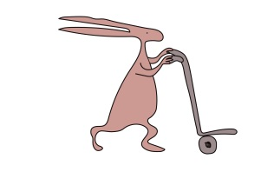
• This leaflet should be read with any manufacturers’ patient information.
You must always discuss individual treatment with the appropriate member of staff.

Who to contact for further details
If you have any questions about your medication whilst you are in hospital, please do not hesitate to ask one of the Pharmacy team, alternatively you can telephone us on 0151 252 5311.

This leaflet only gives general information. You must always discuss the individual treatment of your child with the appropriate member of staff. Do not rely on this leaflet alone for information about your child’s treatment.
This information can be made available in other languages and formats if requested.

Alder Hey Children’s NHS Foundation Trust
Alder Hey
Eaton Road
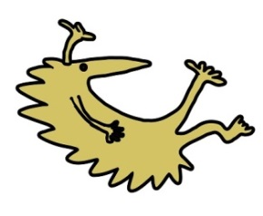
Liverpool
L12 2AP

Tel: 0151 228 4811
www.alderhey.nhs.uk

© Alder Hey Review Date: May 2027 PIAG: M18

