This leaflet only gives general information. You must always discuss the individual treatment of your child with the appropriate member of staff. Do not rely on this leaflet alone for information about your child’s treatment.
This information can be made available in other languages and formats if requested

Alder Hey Children’s NHS Foundation Trust
Eaton Road

Liverpool
L12 2AP

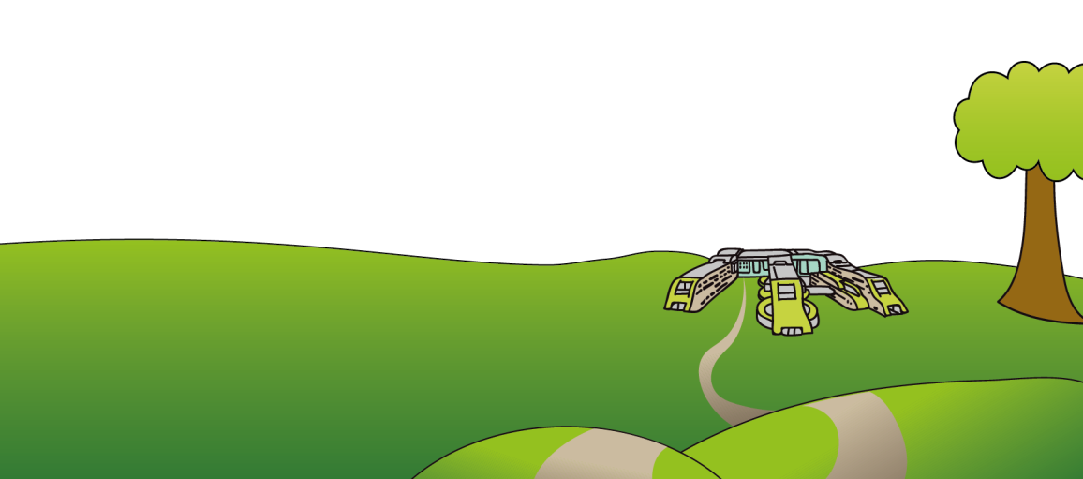
Tel: 0151 228 4811
www.alderhey.nhs.uk

© Alder Hey Review Date: 21/10/2028 PIAG: 084



Clinical Health Psychology

How do I feel about my Craniofacial Condition?

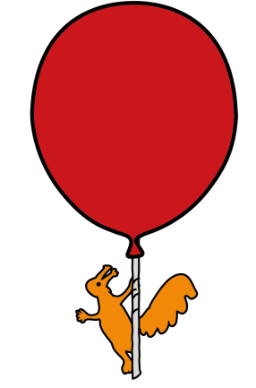

Information for patients,

parents and carers

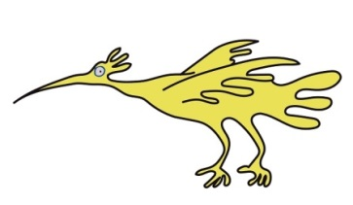
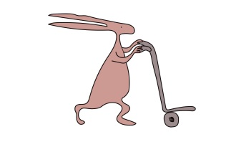

Learning about your Craniofacial Condition
It is important to learn about your craniofacial condition and what it means to you. This enables you to understand and discuss how your condition affects you now, in the future and when you were younger. This might help you feel more confident when talking to other people about it. You can also become more involved in making any decisions about any treatment you might need or choose to have in the future.
You may already know lots about your craniofacial condition. However, there may be information you cannot remember, or that you don’t understand.
You may want to talk to your parent, carers, GP or the craniofacial team if you have any questions. You may want to know:
- Is there a specific name for my craniofacial condition?
- How does my craniofacial condition affect me and my body?
- Will my craniofacial condition change as I get older? Will it get better or worse?
- What treatment have I had?
- What treatment am I still to have, and when will I have it?
- What difference will the treatment make? What won’t change?
- Is there optional treatment that I might choose to have (or not) in the future?
- Is there anything else I might want to know?
You may want to ask to see photographs of yourself when you were a baby or around the time of any treatment(s) you have had. You can record this information in our treatment record.
Talking to others confidently about your craniofacial condition
If you look or sound different because of your craniofacial condition, it is natural that other people might be curious about you. Their questions looks or comments might make you feel self-conscious or uncomfortable.
The first step to feeling confident talking to others is to understand as much as you can about your craniofacial condition. You can decide what phrases or words you might want to use when talking to others. There are lots of different ways that you might choose to talk about your craniofacial condition.
The Changing Faces website has some helpful tips about how you might like to do this:
- Explain: to help them understand.
- Reassure: give information to explain that it’s OK.
- Distract: talk about something else if you’d prefer.
- Humour: your sense of humour might lighten the situation.
- Assertiveness: take control of the situation.
Trying out new strategies takes practise before it feels easy to you.
You might choose to talk to your parents or carers, friends, teachers and other people you trust for support and advice about this.
The Clinical Psychologist in our team can offer advice or support about how it feels talking with others about your craniofacial condition. They can also support you in practicing techniques for talking and feeling confident about your craniofacial condition.
Bullying – What is bullying?
Bullying is when the same person or group of people do things to deliberately upset, humiliate or hurt you. It can include saying unkind words, doing hurtful things or being left out.
Bullying can happen anywhere: at home, school, in public places, on your phone, computer or social networking sites.
Some young people tell us that they experience bullying about their craniofacial condition. It is important to remember that bullying is not your fault. If you are being bullied, it is normal to feel very upset, worried, angry, embarrassed, humiliated or sad about it. You might not be sure what to do or who to tell about it.
If you are being bullied
You MUST tell someone about it. This might be one of your friends, parents or carers, teachers or other people you trust for support or advice.
You can also speak to the Clinical Psychologist in our team. They can offer support about how bullying is affecting your feelings. You can also think about ways to manage bullying.
10 Top Tips
- TELL SOMEONE.
- Remember it’s not your fault.
- Ask them to stop.
- Keep calm – do not get angry or hit back.
- Walk away
- Get support from your friends.
- Keep safe.
- Make a record of when it happens.
- Report it to the school.
- Report it to the police.

Websites for more information
https://www.changingfaces.org.uk/
https://www.headlines.org.uk/
www.bullying.co.uk
www.kidscape.org.uk
www.nhs.uk/livewell/bullying/pages/
www.nhs.uk/livewell/bullying/
www.nhs.uk/livewell/bullying/pages/antibullyinghelp.aspx

Deciding and coping with treatment
You may already have had treatment for your craniofacial condition when you were younger. Now you are older, you may have a choice about whether to have future treatment. These decisions can be easy or more difficult.
Some young people find it very easy to cope with treatments, but others find it more difficult. It can be worrying to have treatment and it is important that you have all your questions answered and get all the support you need.
If you are making decisions about treatment you will be offered an appointment with our Clinical Psychologist. This it to make sure that you have all the support you need to make the right decision for you.
We want you to have the best outcome and the best experience of treatment as possible.

