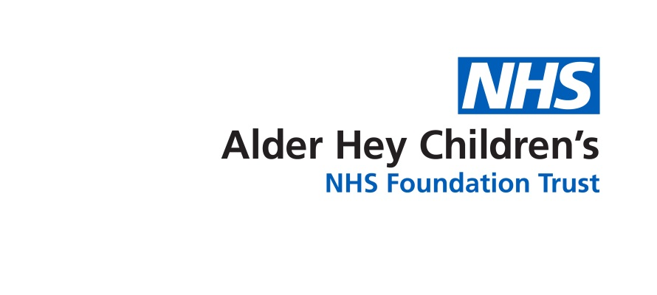

Inherited Bleeding Disorders Team

**Health Promotion**

Information for Parents and Carers

**Health promotion**

Health promotion is the process of enabling people to increase control over, and to improve their health.

Sometimes a hospital appointment for ourself or our children leads us to think about other aspects of our own or our children’s health, well-being and life style.

We have found a wide range of health and well-being information available through the NHS Live Well website <https://www.nhs.uk/live-well/>

**Useful information can be found through the following links**

Alcohol misuse <https://www.nhs.uk/conditions/alcohol-misuse/>

Dental health <https://www.nhs.uk/common-health-questions/dental-health/>

Exercise <https://haemophilia.org.uk/support/day-day-living/healthy-living/>

Healthy eating <https://www.nhs.uk/live-well/eat-well/>

Sexual health <https://www.nhs.uk/common-health-questions/sexual-health/>

Weight management

<https://www.nhs.uk/live-well/healthy-weight/start-the-nhs-weight-loss-plan/>

Mental wellbeing

<https://www.nhs.uk/conditions/stress-anxiety-depression/improve-mental-wellbeing/>

Smoking cessation

<https://www.nhs.uk/live-well/quit-smoking/nhs-stop-smoking-services-help-you-quit/>

Sexual and Reproductive Health Services

<https://haemophilia.org.uk/resources/publications/booklets/sex-and-bleeding-disorders>

**Reference**

**The Haemophilia Society 2021**

[**https://haemophilia.org.uk/**](https://haemophilia.org.uk/)

This leaflet only gives general information. You must always discuss the individual treatment of your child with the appropriate member of staff. Do not rely on this leaflet alone for information about your child’s treatment.

This information can be made available in other languages and formats if requested.

Alder Hey Children’s NHS Foundation Trust

Alder Hey

Eaton Road

****Liverpool

L12 2AP



Tel: 0151 228 4811

[www.alderhey.nhs.uk](http://www.alderhey.nhs.uk)

**© Alder Hey Review Date: 01/02/2028 PIAG: 187**