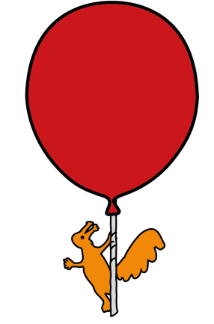


The Roald Dahl Neurophysiology Department

Electroencephalogram (EEG) Test

Information for parents and carers

What is Electroencephalogram (EEG)?

An EEG or Electroencephalogram is a test which records the activity of the brain through small electrodes which are applied to the scalp with a special paste. During the EEG your child’s brain signals appear as wavy lines on a computer screen. Simultaneous video will also be recorded.

Where is the department located?
Use the blue set of lifts directly next to the Concierge/help desk up to the 4th floor. Upon exiting the lift, turn right.

Who will carry out the EEG test ?

The test is performed by the Clinical Physiologist who will explain all aspects of the test to you.

What are the benefits of my child having an EEG?

It is used to help investigate a number of conditions, most commonly black outs or seizures

What are the risks of my child having an EEG

Very rare risk: A patient may be asked to breathe deeply for a short time, which may, in one or two situations, provoke a typical episode or event. In a very small number of patients, strobe lights may trigger an episode or event.

Will the EEG test hurt my child?

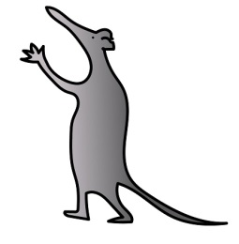
No it is a painless and there are no side effects

What will happen if I decide that my child will not have the EEG test?

It may affect the management of your child’s condition.

Are there any alternatives to this procedure?

There are no alternative procedures.

Is there anything I should do before the EEG test?

Please ensure your child has clean hair which is free from hair gel etc.

Make sure your child continues with their regular medication unless advised otherwise by your child’s Consultant

What happens during the EEG test?

The test is performed by the Clinical Physiologist who will explain all aspects of the test thoroughly.

You will be asked to sign a form to allow for consent for teaching purposes.

Small disc shaped disposable electrodes are applied to your child’s scalp using a water soluble sticky paste. We do not shave / cut their hair.

If your child is able to co-operate, or is old enough to understand, they will be asked to open and close their eyes during the test.

Picture of a patient having EEG test Close up of a patients head with electrodes attached

Your child will be shown a strobe light to see if their brain is sensitive to flashing lights (only a very small percentage of children are sensitive) – this is called photosensitivity. This procedure is an important part of the EEG test. The result of this part of the test will give the doctor more information which may help to make a diagnosis

How long will the EEG test take?

The test takes between 30 to 90 minutes, but on average around 60 minutes.

Your child can watch a DVD during electrode application, which takes around 10 minutes and they can bring in their favourite DVD or a small hand held toy if you prefer. Toddlers are encouraged to co-operate during the test by watching DVD’s / playing with toys etc. If your child is a baby or infant, please bring a bottle with you in case they want a feed.

Are there any after effects from EEG test?

There are no after effects and we remove the electrodes with a little warm water.

When can my child return to school?

After the EEG test your child can go back to school or nursery if you so wish.

When will I receive EEG test results?

The Clinical Physiologist cannot show you any waveforms or give you the results of the EEG on the day of the test. The results are reported to the Consultant and you will receive the results at your next clinic appointment.

For further information

Please telephone 0151 252 5375.
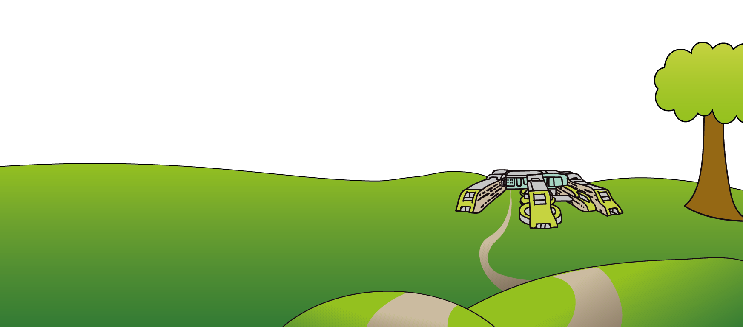
This leaflet only gives general information. You must always discuss the individual treatment of your child with the appropriate member of staff. Do not rely on this leaflet alone for information about your child’s treatment. This information can be made available in other languages and formats if requested.
Alder Hey Children’s NHS Foundation Trust
Alder Hey
Eaton Road
Liverpool
L12 2AP
Tel: 0151 228 4811
www.alderhey.nhs.uk

© Alder Hey Review Date: January 2027 PIAG: 69

