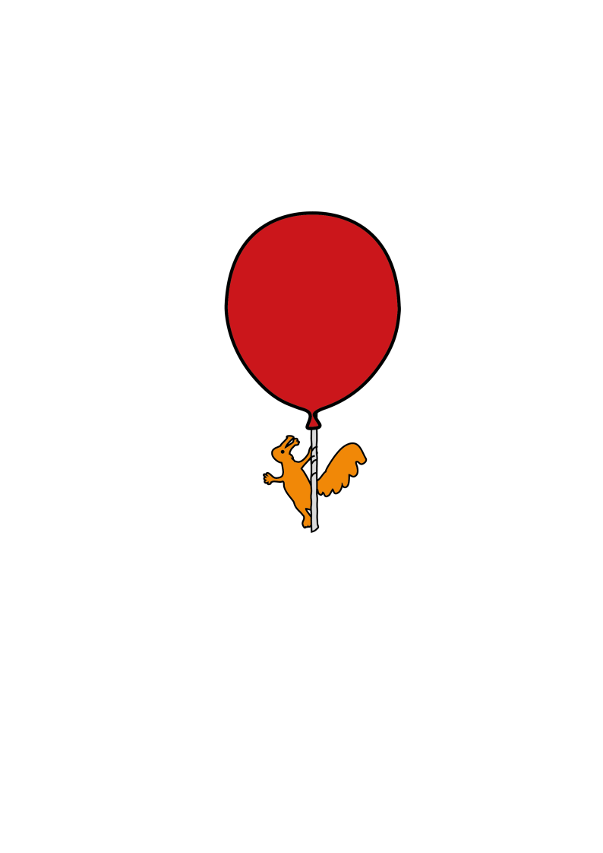

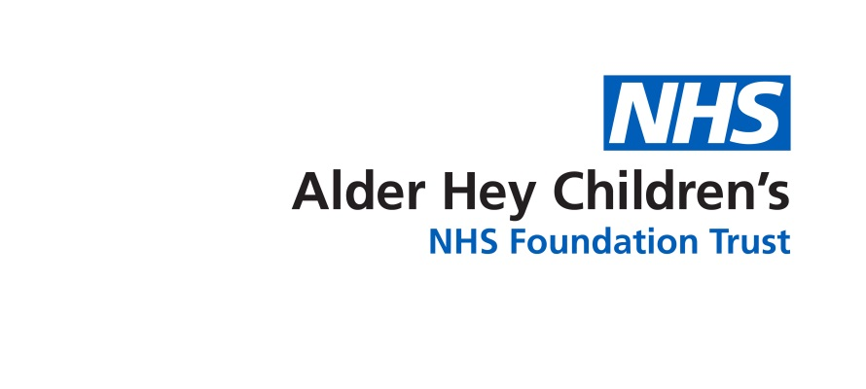

Cleft Lip and Palate Unit

**Information following a Pharyngoplasty**

Discharge information for Parents & Carers

**What to do when your child goes home**

**Care of the palate**

Your child’s palate will look different and may be initially swollen with white patches on. This will settle down. The stitches are dissolvable and can take up to six weeks to fully dissolve. Your child’s speech may sound different, but the full effect of the surgery may not be evident for a few months. Your child will have a speech assessment at the next outpatient appointment

**Diet**

By the time of discharge your child should be taking enough diet and fluids, although this may be less than their usual intake. Please avoid using a straw to drink which may accidently damage the palate.

Please give your child a soft diet for three weeks following surgery. It is important to avoid sharp foods such as toast, crisps, biscuits, chips, or any vegetables with shells i.e. peas, beans etc. Ideal foods included porridge, custards, soft pasta, stews / casseroles, hot dog sausages, mashed food etc. Avoid chocolate and dry bread as this may stick to the suture line.

A drink of water should be given after each meal or snack to help keep the palate clean, followed by some live / probiotic yoghurt. This will reduce the risk of infection and keep the palate clean.

**Teeth**

It is important that teeth are brushed as normal twice a day. This will not harm the palate repair but will help to reduce the risk of infection

**School**

Your child may return to school after one week, if a soft diet can still be given at meal and snack times.

**Pain Relief**

For the first 3-4 days after discharge continue to give your child regular pain relief.

Follow the instructions on the bottle carefully and do not exceed the prescribed dose.

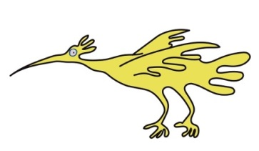This will help them to eat, drink and sleep more easily. After this they may require pain relief occasionally, especially when waking or before bed.

**Things to look out for**

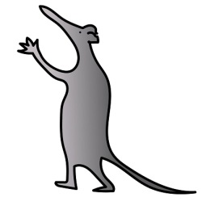The following may be signs of infection:

* Irritability
* increased temperature
* loss of appetite.
* Foul smell in the mouth

Due to the swelling your child may now snore. Please observe for any breathing difficulties during the first week or so at home. If these occur please contact Ward 3A immediately

If any fresh bleeding occurs from the mouth or nose, please contact the ward directly.

An outpatient appointment will be sent through the post for you to be seen by the cleft team

If you are worried about your child please do not hesitate to contact

Ward 3A 0151 252 5416

Cleft Palate Unit 0151 252 5209

Louise Hall 07817127187

Kay Ralston 07484087759

Kathryn Wolstencroft 07973893933

Maria Smith 07929718361

This leaflet only gives general information. You must always discuss the individual treatment of your child with the appropriate member of staff. Do not rely on this leaflet alone for information about your child’s treatment.

This information can be made available in other languages and formats if requested.

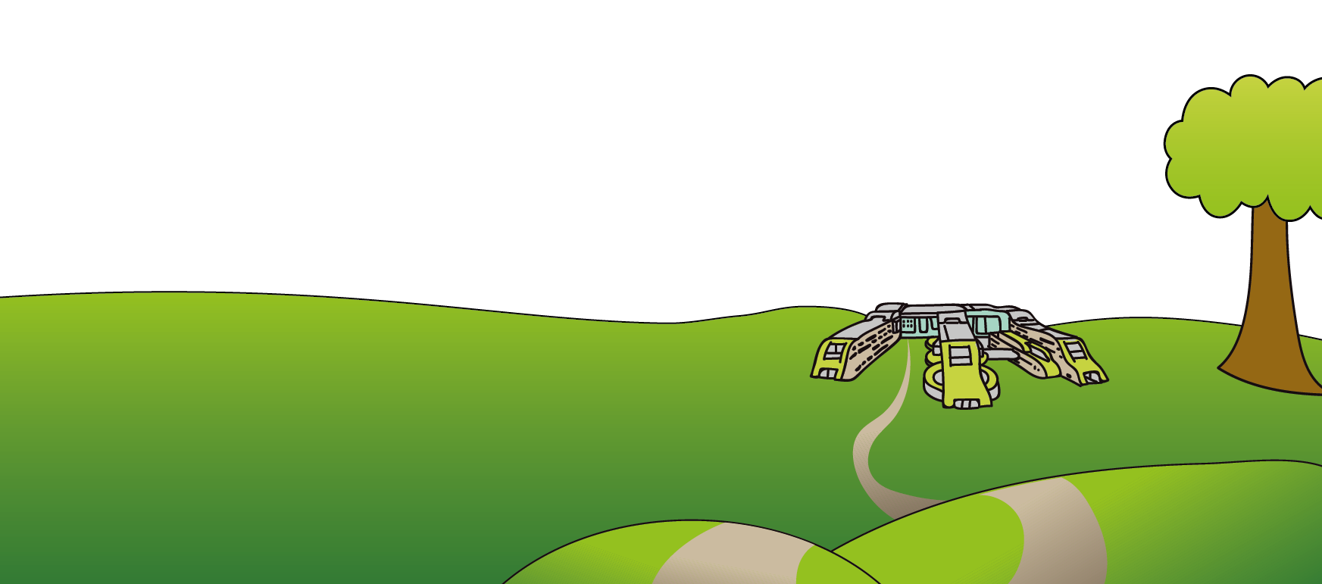Alder Hey Children’s NHS Foundation Trust

Alder Hey

Eaton Road

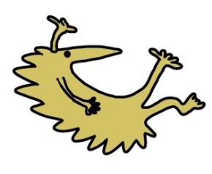Liverpool

L12 2AP

Tel: 0151 228 4811

[www.alderhey.nhs.uk](http://www.alderhey.nhs.uk)

**© Alder Hey Review Date: MAY 2028 PIAG: 366**