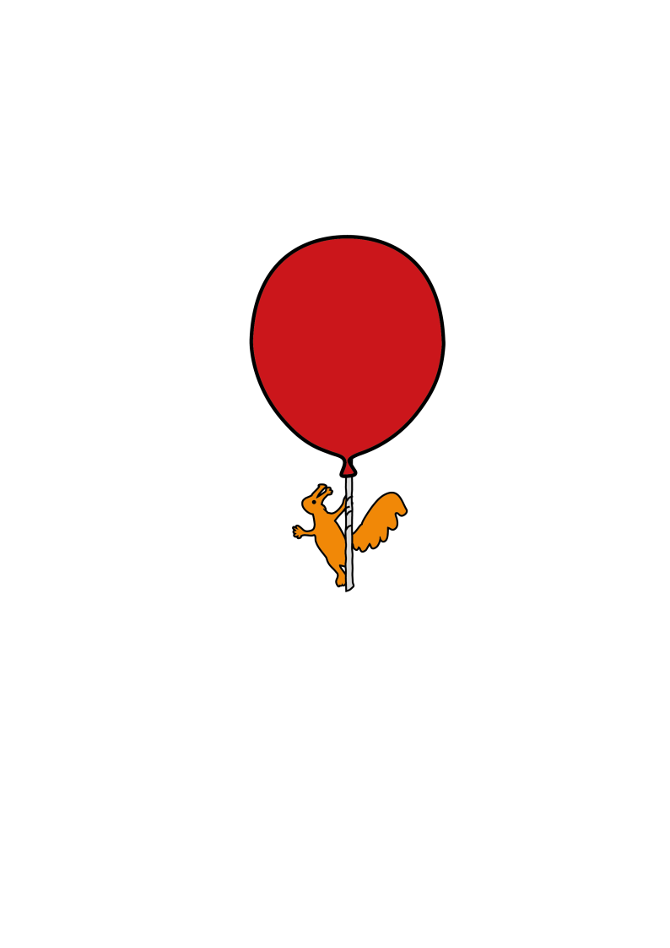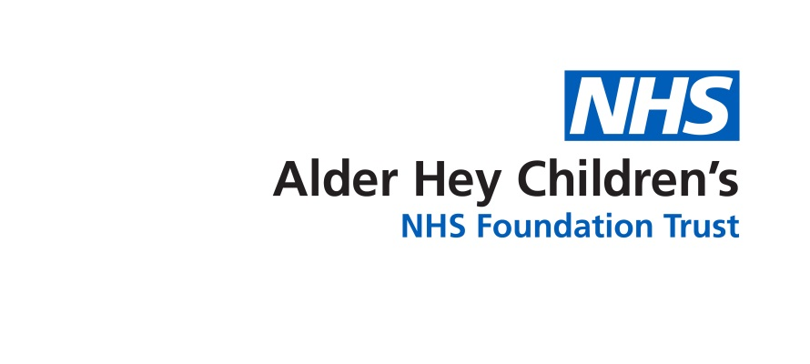

Ward 3A - Cleft Lip and Palate Unit

**Following Cleft Lip Repair**

Discharge information for Parents & Carers

**What to do when your child goes home**

**Feeding**

By the time of discharge your baby should be taking enough milk, although this may be less than their usual intake. It can take up to two weeks to get back to their normal pattern of feeding from the bottle or breast.

**Care of the lip**

* Clean and dry the suture line after each feed with cooled boiled water and a clean cotton bud.
* After cleaning apply the ointment provided on discharge.
* The sutures should start to dissolve after five days but may take 2-3 weeks for them to fully disappear.

It is common for the scar to look red and raised for the first six months and may also shorten and lift the lip slightly. This will gradually become flatter, paler and softer. The nurse specialist may advise applying silicone gel to the lip and will discuss this with you if required.

Placing socks or mittens on your child’s hands should prevent them from putting their fingers, toys etc. into their mouth.

**Pain Relief**

For the first 48-72 hours after discharge continue to give your child regular pain relief. Follow the instructions on the bottle / package carefully and do not exceed the prescribed dose. After this time, they may require pain relief occasionally, especially when waking or before bed.

**Sun Protection**

Please note that direct sunlight can irritate a new scar. You must keep the new scar protected from the sun for the first year following surgery and in the future.. We advise the use of a high protection (factor 50) sun cream and that your child also wears a hat or cap.

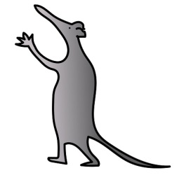**Teeth**

If your child has any teeth, it is important that they are brushed as normal twice a day.

This will not harm the lip repair

**Things to look out for**

The following may be signs of infection:

* swollen, red suture line
* oozing from suture line
* irritability
* increased temperature
* increased pain
* loss of appetite

If you are worried about possible infection, call your nurse specialist, Ward 3A or your GP for advice.

Your clinical nurse specialist will arrange to visit within the first week after surgery

If you have any concerns about your child following discharge, please contact your nurse specialist for advice.

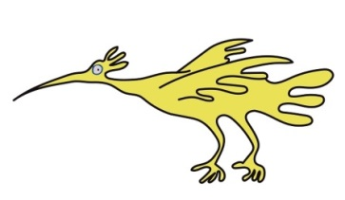Ward 3A 0151 252 5416

Cleft Lip and Palate Unit 0151 252 5209

Louise Hall 07817127187

Kay Ralston 07484087759

Kathryn Wolstencroft 07973893933

Maria Smith 07585138735

This leaflet only gives general information. You must always discuss the individual treatment of your child with the appropriate member of staff. Do not rely on this leaflet alone for information about your child’s treatment.

This information can be made available in other languages and formats if requested.

Alder Hey Children’s NHS Foundation Trust

Alder Hey

Eaton Road

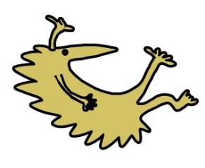Liverpool

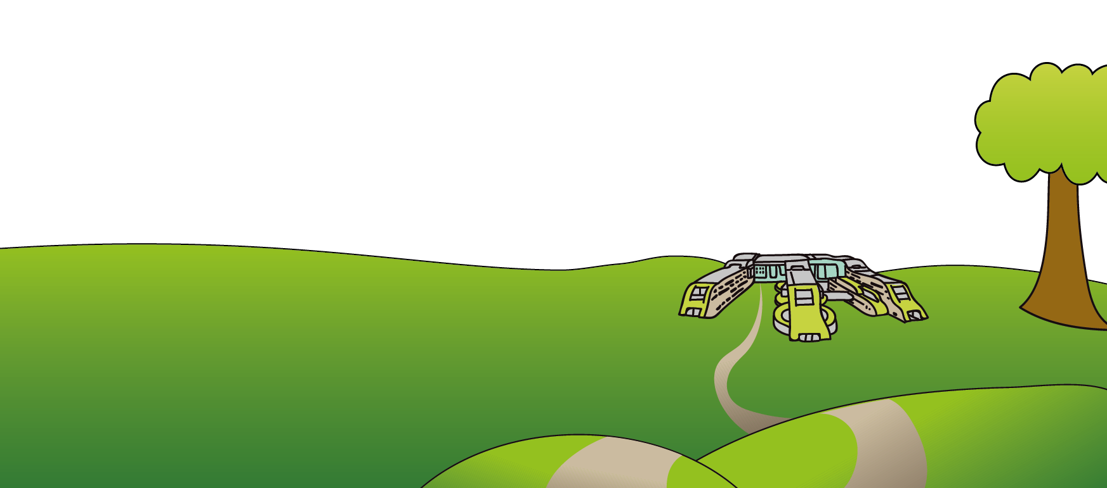L12 2AP

Tel: 0151 228 4811

[www.alderhey.nhs.uk](http://www.alderhey.nhs.uk)

**© Alder Hey Review Date: May 2028 PIAG: 163**