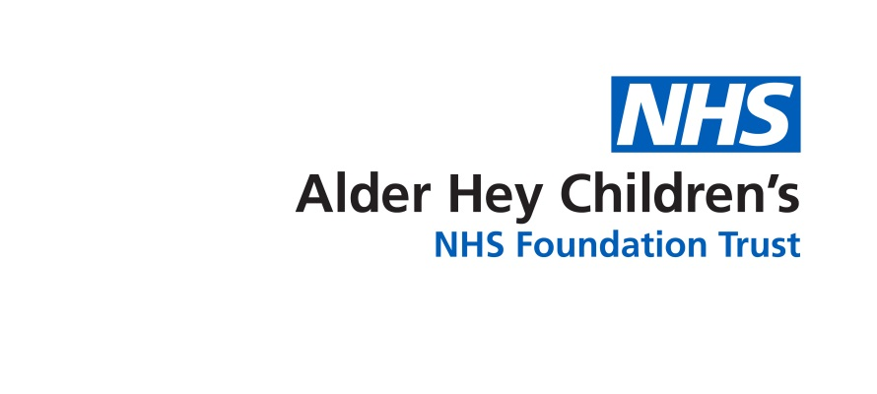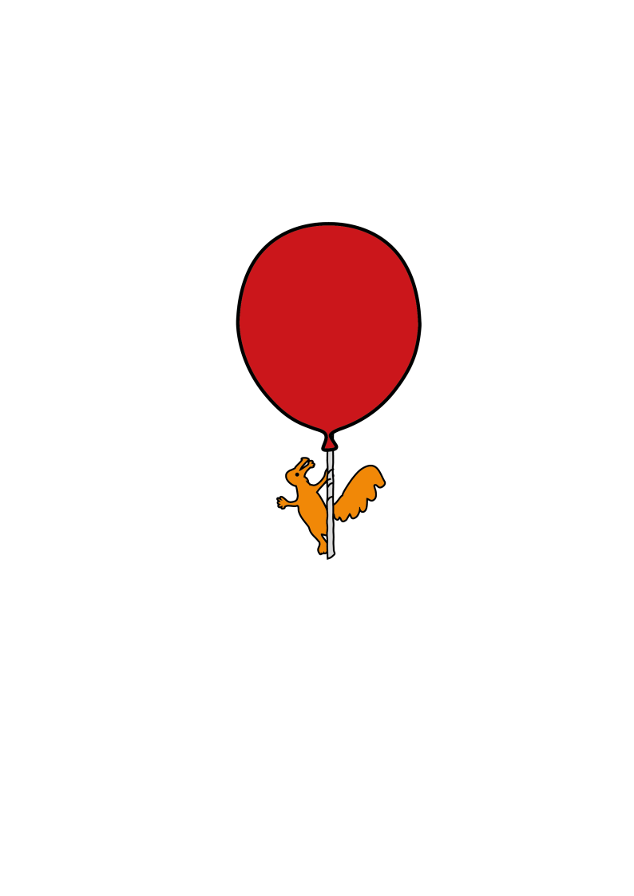

Cleft Lip and Palate Unit

**Information following an Alveolar Bone Graft**

Discharge information for Parents & Carers

**What to do when your child goes home**

**Teeth**

Your child will be given a mouthwash to use at home for the first ten days. Use this as directed as it is important to keep the surgery area clean. Your child should be encouraged to clean their teeth as normal, taking care with gentle brushing around the surgery area for the first two weeks. After two weeks your child should be able to return to more vigorous brushing.

**Braces**

If your child has an orthodontic brace and there are difficulties post operatively, please contact their orthodontist in the usual way.

**Diet**

Give your child a soft diet for two weeks following surgery. Most soft foods may be given, if your child does not bite directly on the surgical area.

A drink of water should be given after each meal. This will help to keep the mouth clean.

Your child’s mouth and face will still be a little swollen, but this should settle down over the next week or two.

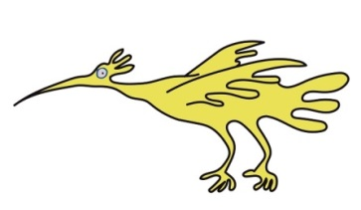

**Pain Relief**

If your child has any discomfort you may give them the prescribed pain killers.

Follow the instructions on the bottle carefully and do not exceed the prescribed dose.

**Hip**

The dressing on your child’s hip should have been changed prior to discharge. There should be no further significant blood-stained discharge on the dressing. If this occurs, please contact Ward 3A. Your child may remove the dressing one week after their surgery, by soaking it in the bath.

Your child’s hip may cause some mild discomfort for a few days, but they should try to mobilise as normal.

It is advised that your child does not participate in sports for 4-6 weeks to allow the hip bone to stabilise.

**School**

Your child may return to school after one week, if a soft diet can still be given at meal and snack times, and your child can mobilise safely.

**Things to look out for**

The following may be signs of infection:

* Irritability
* Increased temperature
* Loss of appetite
* Foul smell from the mouth
* Excessive swelling to the site that occurs after discharge.
* If any fresh bleeding occurs from the mouth or nose please contact the ward directly.

An outpatient appointment will be sent through the post for your child to be seen by the cleft team

If you are worried about your child, please do not hesitate to contact

Ward 3A 0151 252 5416

Cleft Palate Unit 0151 252 5209 (Monday – Friday)

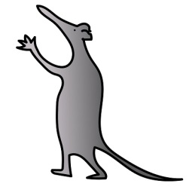

Louise Hall 07817127187

Kay Ralston 07484087759



Kathryn Wolstencroft 07973893933

Maria Smith 07929718361

This leaflet only gives general information. You must always discuss the individual treatment of your child with the appropriate member of staff. Do not rely on this leaflet alone for information about your child’s treatment. This information can be made available in other languages and formats if requested.

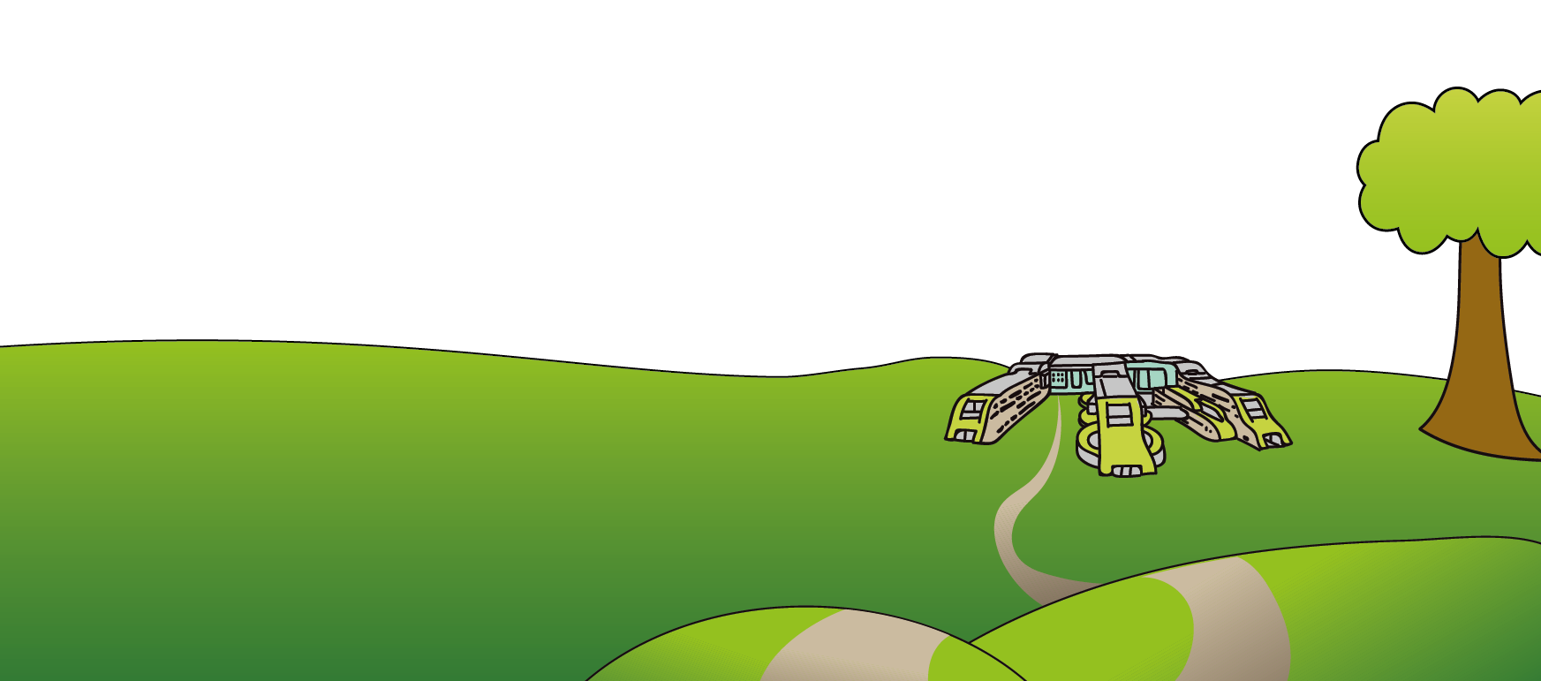

Alder Hey Children’s NHS Foundation Trust

Eaton Road

Liverpool

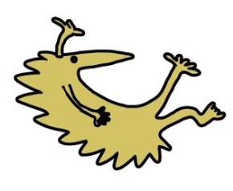

L12 2AP

Tel: 0151 228 4811

[www.alderhey.nhs.uk](http://www.alderhey.nhs.uk)

**© Alder Hey Review Date: May 2028 PIAG: 165**