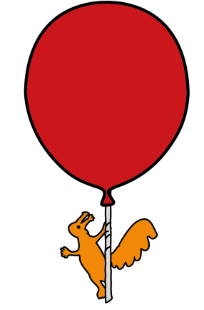


Ophthalmology Department
Cyclopentolate Hydrochloride Eye Drops
Information for Parents and Carers

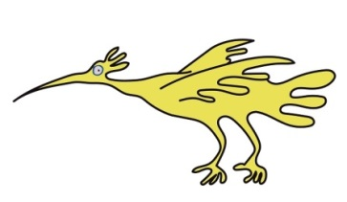
Introduction
This leaflet is to provide you with information about Cyclopentolate eye drops.

What do the eye drops do?

- Cyclopentolate eye drops are used in clinic when we need to assess the health of your child’s eyes (fundus check) and when a refraction assessment (need for glasses) is required.

- Cyclopentolate eye drops are used to dilate pupils and to relax the focusing of the eyes to enable an accurate test to be performed. Different strengths of cyclopentolate are available (0.5% or 1%). The strength used will be dependent upon your child's age and upon any health issues that your child may have.

How long do the effects of Cyclopentolate eye drops last?
Recovery from the effects of the drops usually takes six to eight hours, but this can vary.
In some children the pupils may take up to 24 to 36 hours to return to normal.

Are there any risks?
It is advisable to monitor your child whilst in clinic, after the drops are instilled.
Occasionally, there may be a slight localized flushing of the face shortly after the drops have been instilled.

Following instillation of drops

Your child may notice a stinging sensation when the drops are instilled. This is normal and will quickly resolve.

Your child’s pupils will increase in size about 20-30 minutes after the drops are instilled. As the pupils are enlarged temporarily, your child may be sensitive to sunlight. If this happens it is advisable to give your child a hat/cap or sunglasses to wear outside if it is a sunny day.

Your child may notice blurring of vision for reading or near tasks.
Rarely, use of the drops may reveal an underlying, but previously hidden squint (turn in eye).

How long will the effects last?

The focusing ability of the eyes should return within 4-6 hours but some children may complain of difficulty reading for up to 24 hours due to blurred near vision.

Recovery from light sensitivity and the enlarged pupil may take up to 24 – 48 hours

Rare side effects and Adverse Reactions

Swelling of eyelids
Painful eye (more than the stinging that occurs when drops go into eye)
Excessive watering of eyes
Fast heartbeat

If your child experiences any of the following symptoms; swelling and/or redness of eyelids, excessive pain or excessive watering of the eyes, gritty or foreign body sensation or fast heartbeat, they should be examined by a medical professional: Ophthalmologist/Optometrist or GP/Paediatrician/Nurse.

What to do if you have any concerns
If you are concerned about your child at all whilst you are in the clinic, please speak with a member of staff.
If you have any concerns after you have left the clinic, please contact our Ophthalmology Department or your child’s GP.

Who you should tell that your child has had the eye drops
If your child has an assessment with another Health Professional e.g. GP, immediately after this appointment, make sure you tell them your child has recently had dilating eye drops.

Going back to school
Your child can return to school following eye drops but may have difficulty focussing on small detailed close work. It is advisable to inform your child’s teacher.

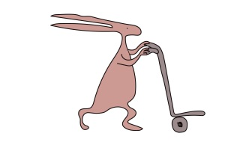
For further information
If you have any queries or need further information, please telephone
Ophthalmology Department on 0151 252 5215

This leaflet only gives general information. You must always discuss the individual treatment of your child with the appropriate member of staff. Do not rely on this leaflet alone for information about your child’s treatment.
This information can be made available in other languages and formats if requested.

Alder Hey Children’s NHS Foundation Trust
Alder Hey
Eaton Road
Liverpool
L12 2AP

Tel: 0151 228 4811 www.alderhey.nhs.uk

© Alder Hey Review Date: November 2027 PIAG: 007

