**Craniofacial Team**

Information for young people



**Clinical Nurse Specialist:**

The role of the clinical nurse specialist is to be directly involved with craniofacial patients and their families from the first clinic visit admission, through surgery to discharge. The nurse acts as a link between patients, parents and the multidisciplinary craniofacial team.

**Speech and Language Therapist:**

The role of the speech and language therapist is to assess and manage speech, language and feeding difficulties that are related to the craniofacial condition.

**Clinical Geneticist:**

The clinical geneticist is part of the team because some craniofacial conditions are caused by changes in genes and some may run through the family.

**Ear, Nose and Throat surgeon (ENT):**

The ENT surgeon will assess and manage your child’s airway, breathing and surgical management of any hearing loss.

**Clinical Psychologist:**

The clinical psychologist’s role within the team is to offer assessments and support to children, young people and families in relation to a variety of issues, such as development, appearance concerns, bullying and teasing, making decisions about treatment and surgery and preparation and support pre and post- surgery.

**Ophthalmological Surgeon:**

The ophthalmological surgeon assesses and treats any eye problems relating to the craniofacial conditions. Where appropriate, the team may also liaise with local services that may be the most appropriate for overseeing and providing the on-going care of your child.



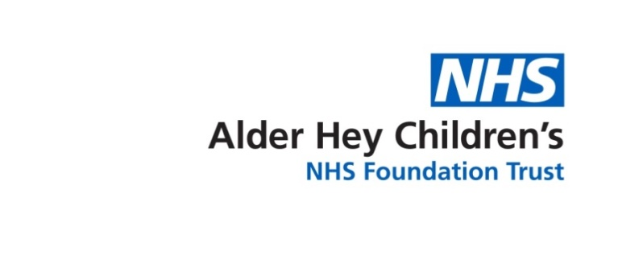

**Respiratory Team:**

The respiratory team assesses and investigates your child’s sleep pattern and breathing.

**Orthodontics:**

The orthodontics will assess and manage the way the teeth and jaw grow.

**Neurosurgeon:**

The Neurosurgeon is involved in the treatment of Craniofacial conditions that may or may not affect the growth of the brain.

**Plastic Surgeon:**

Plastic surgery aims to correct complex cosmetic and functional abnormalities of both soft tissue and bone using a wide range of reconstructive techniques.

This leaflet only gives general information. You must always discuss your individual treatment with the appropriate member of staff. Do not rely on this leaflet alone for information about your treatment.

This information can be made available in other languages and formats if requested.

Alder Hey Children’s NHS Foundation Trust

Alder Hey

Eaton Road

Liverpool

L12 2AP

Tel: 0151 228 4811

[www.alderhey.nhs.uk](http://www.alderhey.nhs.uk)

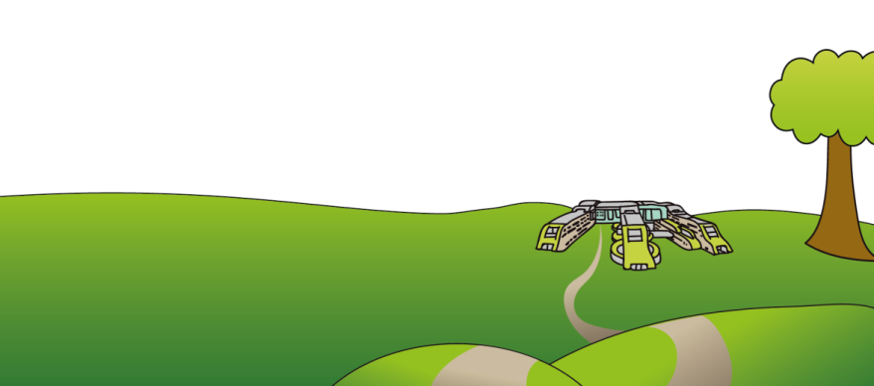**© Alder Hey**

**Review Date: May 2028**

**PIAG: 162**