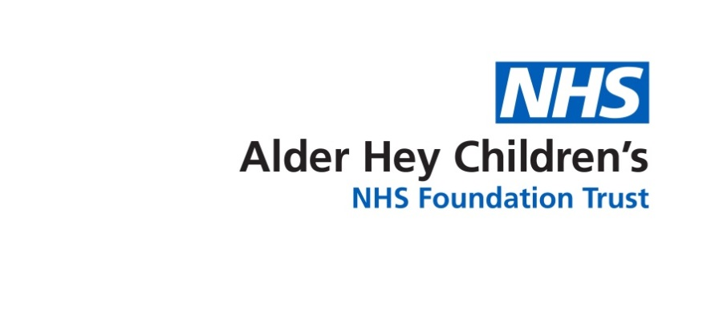

**Craniofacial Team**



**Information for young people**

Digitalt sample text

In hospitals, transition is the preparing, planning and moving of young people from children’s to adult’s health care. In the craniofacial service, lots of young people are discharged from the service between the ages of 15 and 21 years. However, if you require ongoing treatment for your craniofacial condition you will be transferred to adult’s healthcare.

This includes attending clinics and any surgery treatment. In the craniofacial service, some aspects of your treatment (such as Orthodontics) may remain at Alder Hey but your team will talk to you about this.

During this time we also think that is it is important for you to develop the skills to take an independent role in your healthcare. The transition process allows time for you and your family to get ready for this.

Digitalt sample text

Transition is a gradual process and you can move at your own pace. At your clinic appointment when you are 11 years old, the Craniofacial Nurse Specialists will discuss transition with you.

When you feel ready and comfortable, we can start working towards you being seen in some craniofacial appointments without your parents if you wish. This could start by you being seen alone for just some of each appointment.

It’s important to remember that your family still has an important part to play in your care during transition and so it might be helpful to talk to them about how you feel about it. They may also be able to help you understand some of the main processes involved in your healthcare.

During your transition journey you will learn some useful information which will help you feel more comfortable living with your craniofacial condition as you get older. This will be part of an on-going ‘transition plan’ that we will make with you to guide you



through your healthcare needs as you get older. This may include:

* Who you might meet in the Craniofacial Team and their role.

* How to talk to others about your craniofacial condition and how to cope with changes such as moving school.
* Helpful groups and websitesspecifically for people with a craniofacial condition.
* Keeping a record of all your treatment to date, as well as any other treatment you may have in the future.
* Thinking about future treatment you may want and when and where this might happen.
* Understanding the genetics of your craniofacial condition and what this might mean for you as you grow older.
* Making sure you understand the importance of a healthy lifestyle.

Any questions you or your family have about transition, please feel free to contact a member of the Craniofacial Team at any time.

This leaflet only gives general information. You must always discuss your individual treatment with the appropriate member of staff. Do not rely on this leaflet alone for information about your treatment.

This information can be made available in other languages and formats if requested.

Alder Hey Children’s NHS Foundation Trust

Alder Hey

Eaton Road

Liverpool

L12 2AP

Tel: 0151 228 4811

[www.alderhey.nhs.uk](http://www.alderhey.nhs.uk)

**© Alder Hey**

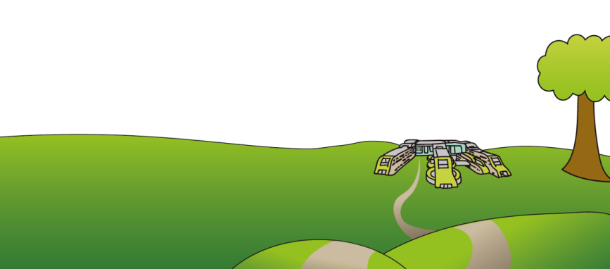**Review Date: May 2028**

**PIAG: 131**