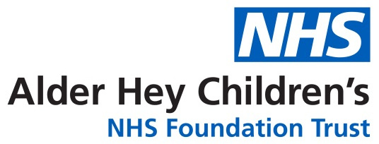
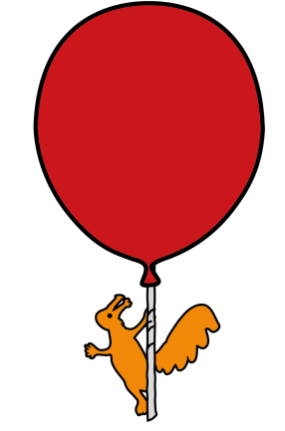

Department of Pharmacy

Chlorhexidine Mouthwash

Information for parents and carers

What is Chlorhexidine and what is it used for?
Chlorhexidine is an antibacterial that can come in many different formulations to help to reduce and prevent bacterial growth.

Chlorhexidine mouthwash can be used for many different reasons, for example before and after surgery or as part of a mouth care routine.

Why is it important for my child to use this mouthwash?

Chlorhexidine mouthwash will help to reduce the likelihood that your child develops an infection.

How much should I give?

Always follow the instructions on the label on the bottle. The instructions will tell you how much mouthwash to use and how often.

How should I give it?

Chlorhexidine mouthwash can be affected by some toothpaste brands due to an ingredient they contain¹.

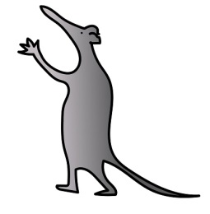
It is recommended your child:

- Brushes their teeth as normal
- Rinses their mouth with water
- Waits for five minutes before using the chlorhexidine mouthwash.

The mouthwash should not be swallowed.

What if I forget to give it?

Use the chlorhexidine mouthwash when you remember and then follow the instructions on the label.

Are there any possible side effects?

- Reversible staining of the tongue and teeth can occur. This can be removed with general teeth cleaning or via the child’s dentist / hygienist.

- There may be an unpleasant taste or slight burning sensation when you first use the product. This will often go away with repeated use.

- Chlorhexidine in some cases can lead to peeling of the skin inside the mouth¹. If this happens consult your dentist, GP or pharmacist as the mouthwash may need to be diluted before use.

- If swallowed the mouthwash can lead to stomach irritation.

Is there anything else I need to know about this medicine?

Some people can experience an allergic reaction to chlorhexidine mouthwash. This can in some cases present as a serious reaction, with symptoms including; swelling of the face and tongue, wheezing and breathing difficulties and unconsciousness¹.

If your child experiences any of the above please contact a doctor urgently.

General advice about medicines

• Only give this medicine to your child. Never give it to anyone else, even if their condition appears to be the same, as this could do harm.

• If you think someone else may have taken the medicine by accident, contact your doctor straight away.

• Make sure that you always have enough medicine. Order a new prescription at least two weeks before you will run out.

• Make sure that the medicine you have at home has not reached the ‘best before’ or ‘use by’ date on the packaging. Give old medicines to your pharmacist to dispose of.

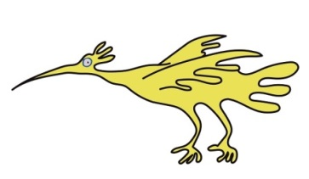
• This leaflet should be read with any manufacturers’ patient information. You must always discuss individual treatment with the appropriate member of staff.

How do I get further supplies of Chlorhexidine mouthwash?

If the mouthwash is required for long periods of time you should be able to obtain further supplies from your GP.

Who to contact for further details

If you have any questions about your child’s medication whilst they are in hospital, please do not hesitate to ask one of the Pharmacy team (on the ward or at the Outpatient Dispensary). Alternatively you can telephone The Pharmacy Department on 0151 252 4811.

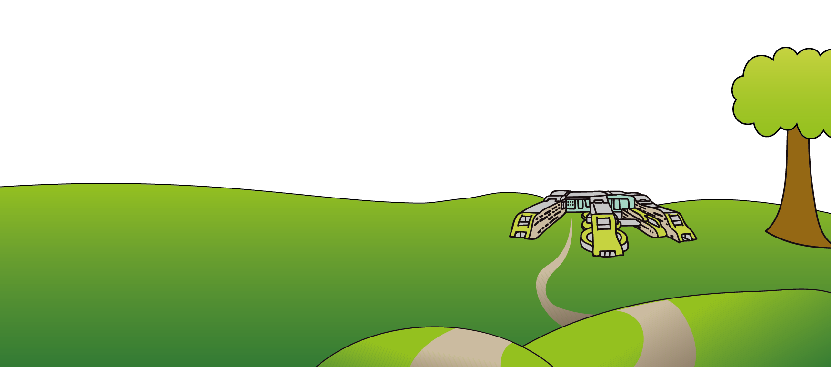
This leaflet only gives general information. You must always discuss the individual treatment of your child with the appropriate member of staff. Do not rely on this leaflet alone for information about your child’s treatment.

This information can be made available in other languages and formats if requested.

Alder Hey Children’s NHS Foundation Trust
Alder Hey
Eaton Road
Liverpool
L12 2AP

Tel: 0151 228 4811
www.alderhey.nhs.uk
© Alder Hey Review Date: May 2027 PIAG: M16

