Contact us  Address: Alder Hey Children’s Hospital, Eaton Prescot Rd., Liverpool L14 5AB  Phone: 0151 252 5933 / 0151 252 5943  Email: Audiologymail@alderhey.nhs.uk  Website: www.alderhey.nhs.uk  Twitter: @AHAudiology  This leaflet only gives general information. You must always discuss the individual treatment of your child with the appropriate member of staff. Do not rely on this leaflet alone for information about your child’s treatment.  This information can be made available in other languages and formats if requested.  
    - ALDER HEY CHILDREN’S HOSPITAL
    - LIVERPOOL
  
  CHILDREN’S AUDIOLOGY DEPARTMENT

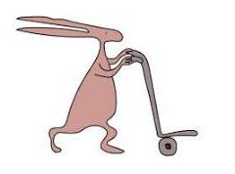
© Alder Hey Review Date: June 2027 PIAG: 410

FOR PARENTS/CARERS
Table of contents  About us 1  Our services 2  Our commitment 3  Hearing aid repairs/ earmold service 4  Local contacts 5  Useful websites 6  Communication skills 7  Noise sensitivity 8  Softening ear wax 9  Contact us 10 |  | Softening ear wax  Wax in the ear is natural and should never be removed by anyone other than a trained health care professional.  Never put anything into your child’s ears.  Cotton buds must NOT be used!
 |  |  | 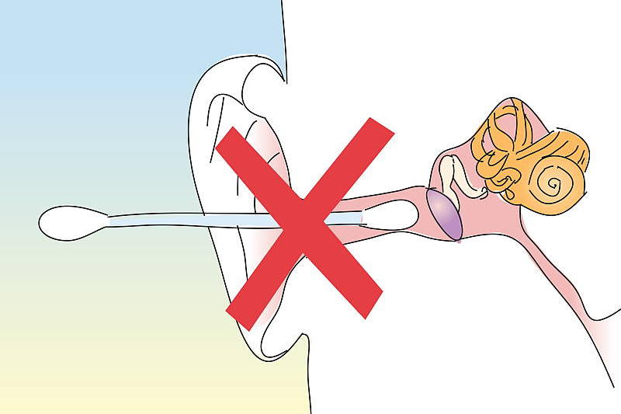
Olive oil drops can be used to help soften any ear wax.
You will need to have some ordinary olive oil (at room temperature, do not heat up) and a teaspoon or a dropper.
Once a day, for two weeks, insert 2-3 drops of olive oil into the ear/s which needs to have the wax removed.

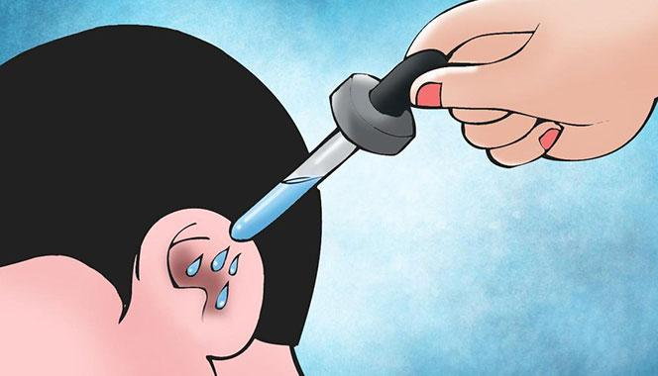
For full instructions, please refer to our website at https://alderhey.nhs.uk/services/audiology
5
9
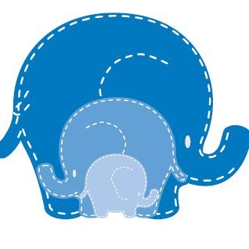
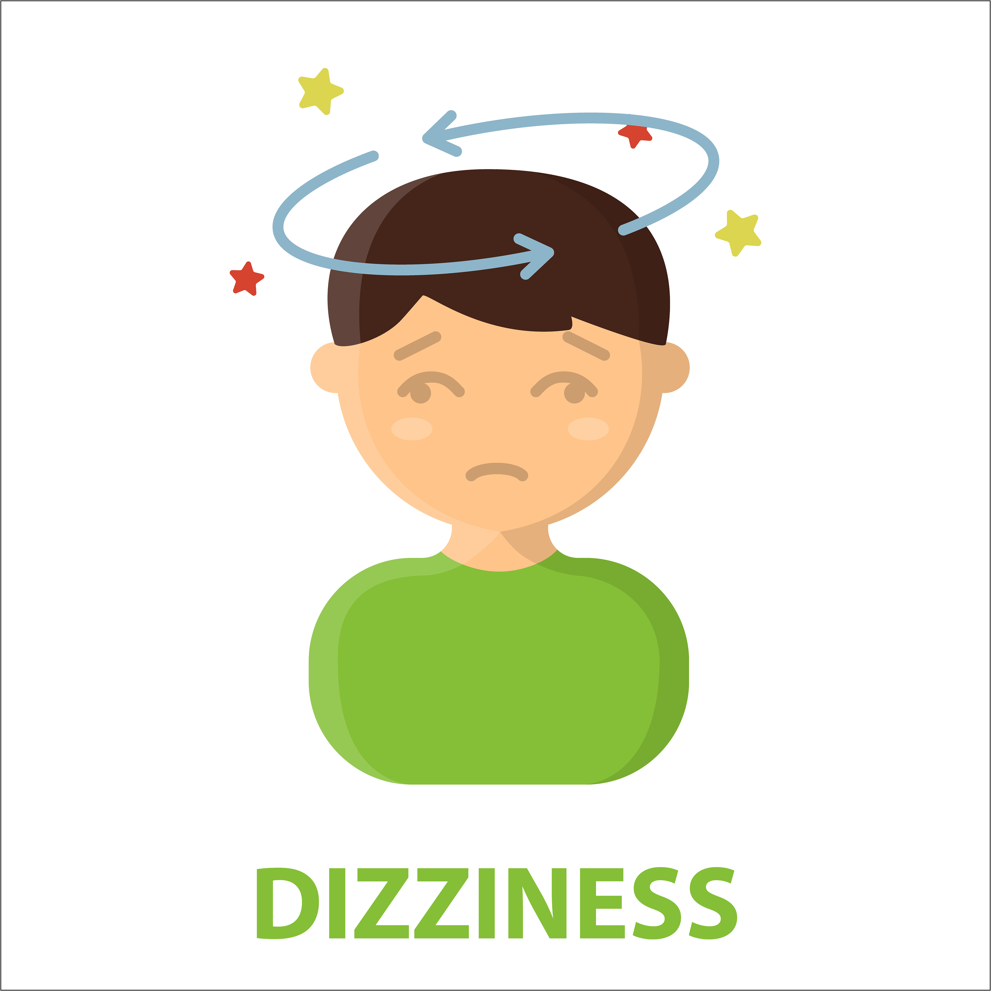
For further information, please refer to our website at https://alderhey.nhs.uk/services/audiology
How to help:
- Provide reassurance
- Take control; explain the sounds to your child
- Behavioural desensitisation: help break down the association between the noise and fear

Noise sensitivity

8
The child may shy away from or become uncomfortable when confronted with loud noises.

What is it?
It is not uncommon for children to be sensitive to sounds. It can affect people of all ages, including adults, but it is most common in young children under the age of six.

About us…

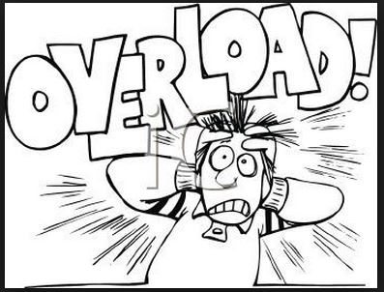 |  | Department Opening Times  Monday to Friday  08:30am to 17:00pm  Contact information: Please see back of leaflet  We are a Peadiatric Audiology department with an Audio Vestibular Medicine service. We are committed to providing the highest standard of care to our patients aged 0-19 years of age.  Our team is made up of:  - 2 Audiovestibular Consultants  - 16 Audiologists  - 2 Audiometricians  We run clinics in Alder Hey, Garston, Southport and May Logan.  If you have hearing concerns for your child, you will need to obtain a referral into audiology from your GP or other healthcare practitioner.
 |  |  | 1



Communication skills

Our services

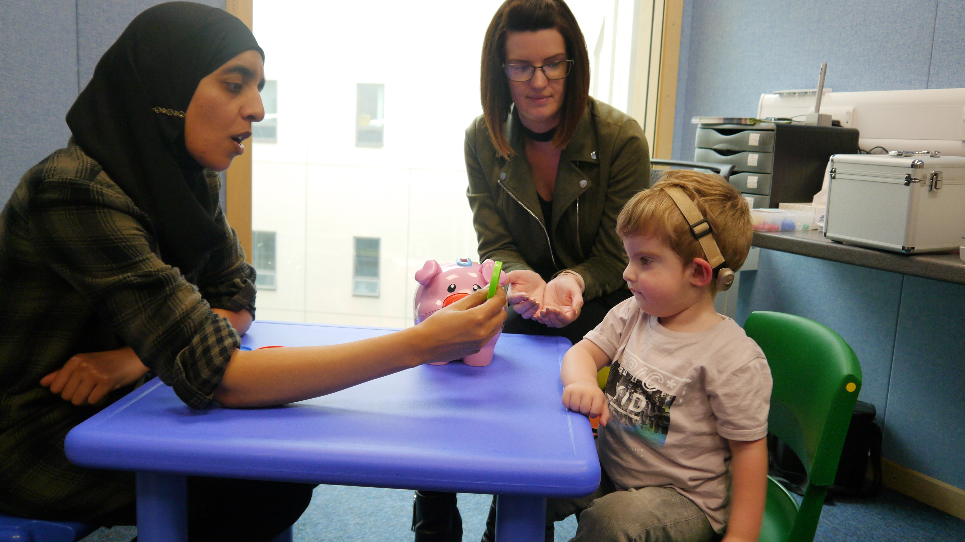
Good communication and listening skills are important for everyone even with normal hearing but extra important for those with a hearing impairment. Here are some tips.

Hearing assessments for children ages 0-18
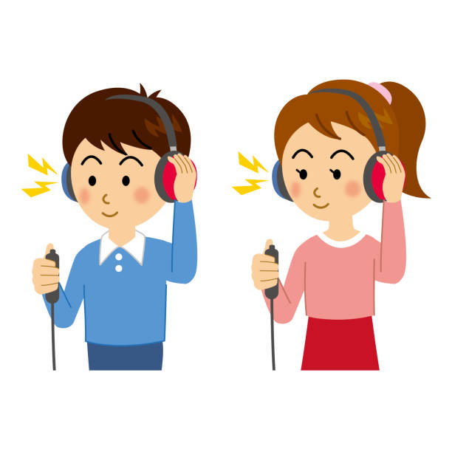

Make sure you can see people’s faces clearly

We assess hearing in various ways depending on the development and age of the child.

hfhghf
Minimise background noise

One person speaks at a time

Hearing aid fitting and servicing
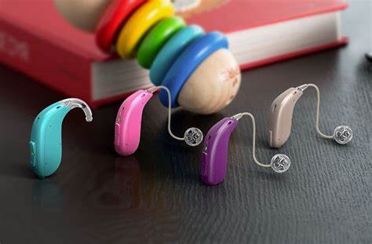
Speak up, but do not shout

We provide and fit different types of hearing aids specifically to meet the needs of the child.
When something goes wrong with the hearing aids, we will take care of it.
Slow down speech

Tell the speaker you have difficulty hearing

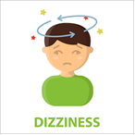
For further information please refer to our website on https://alderhey.nhs.uk/services/audiology
7
2
Use hand gestures and facial expressions

Repeat, rephrase, or write it down

Vestibular assessment and management
Our audio vestibular consultants assess and manage certain types of vestibular symptoms and disorders.
    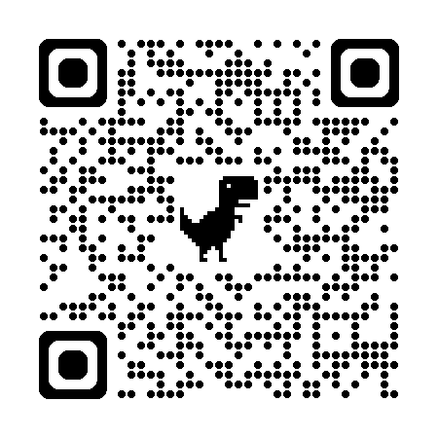    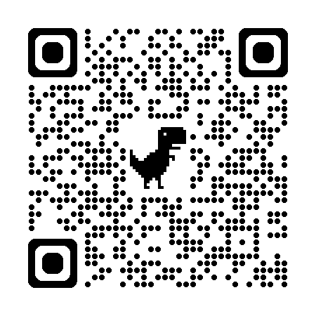    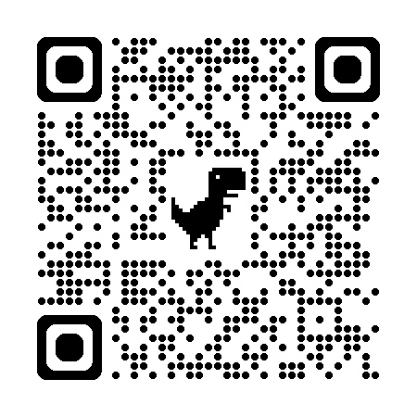  Deaf active, Liverpool  www.deafactive.org  British Deaf association  www.britishdeafassociation.org.uk  Merseyside Society for Deaf People  www.msdp.org.uk |    |   YOUR COMMITMENT TO US…  - Provide services that meets each patient’s individual needs  - Ensure our patients feel confident and happy with their hearing aids  - Offer help whenever there are problems relating to the hearing loss or hearing aids  - Provide a service that works in partnership with health, education, social and voluntary services with you and your child at the centre  - Make every effort to attend your appointments and be punctual  - Inform us as soon as you know that you will be unable to attend an appointment  - Respect our staff  TO YOU…
  2 |  |  | 



Alder Hey Audiology
www.alderhey.nhs.uk
National Deaf Children’s Society
www.ndcs.org.uk

British Tinnitus Association
www.tinnitus.org.uk

Useful websites:

Our commitment

3
6

Local contacts

We will make every effort to be as quick as possible in assisting with your repair/supplies etc.

Hearing support services
Liverpool: 0151 233 5970
Sensoryservice@liverpool.gov.uk
Sefton: Hearingneeds@sefton.gov.uk
West Lanc’s: Inclusion.South@lancashire.gov.uk

Merseyside Society for Deaf People
Tel: 0151 228 0888
Email: reception@msdp.org.uk

Liverpool Deaf Children’s Society
Tel: 0151 280 7204
Email: contact@ldcs.org.uk

4
5
BY APPOINTMENT ONLY:
Please phone as soon as you notice any problem with the hearing aid(s) and we will make every effort to arrange the earliest available appointment at your convenience.

Tel: 0151 252 5933 / 0151 252 5943
Email: AudiologyMail@alderhey.nhs.uk
If we are unable to answer the phone, please leave a message on the answerphone.
Hearing Aid Supplies
Batteries, tubing, drying capsules and other supplies can be given without an appointment if you call in or phone the department and request them to be posted home to you.

Hearing aid repairs/ Earmould service

