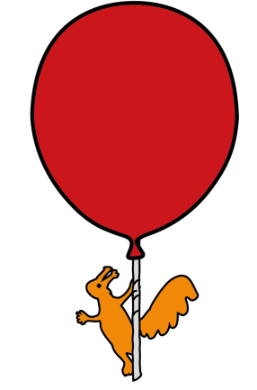


Department of Ophthalmology

Childhood Cataracts Surgery

Information for parents / guardians / carers

Introduction

This leaflet is for parents/ caregivers of children who have been diagnosed with a cataract and are to undergo cataract surgery. This should be read in conjunction with the leaflet entitled ‘Cataracts in Babies and Children’.

What is Cataract surgery?

Cataract surgery is the process for removal of the cataract, and in children this is performed under general anaesthetic. This surgery takes place anywhere from the age of six weeks onwards, and your doctor will help to guide you as to the appropriate time when surgery should take place.

On the day of surgery your child will receive drops into both eyes to widen (dilate) the pupil. Measurements of the eyes are performed with the child asleep. The next steps of surgery that are performed will depend on your child’s age and other health conditions.

- Children <2 years of age, with small eyes or inflammatory eye disease: The cataract is removed through a small cut in the cornea (lensectomy) and a small amount of the vitreous gel is removed (anterior vitrectomy). At this stage an artificial lens is NOT placed in the eye, and this will be discussed further.

- Children between 2 years and 5 years of age: Along with the lensectomy and anterior vitrectomy, an artificial lens (called an intra-ocular lens or IOL) is usually placed in the eye at the time of surgery.

- Children with an age >5 years: After the lensectomy, the IOL lens is placed in the eye. An anterior vitrectomy is usually NOT performed.
Your doctor will discuss with you the different steps of the surgery, and the surgery will be tailored towards your child’s requirements. If your child has cataracts in both eyes, then usually both eyes have their surgery on separate days.

What are the benefits of surgery?

The aim of the surgery is to remove the cataract from the eye. In young children, this is to allow the vision in the eye to develop as best as it can. In older children this is to help improve the vision in the eye so that the eyesight is clearer.

However, sometimes, the risk of surgery outweighs the benefits of trying to improve vision. Your doctor will go through this with you in clinic.

What will happen if we decide not to have the surgery?

In the situation that that the doctor feels surgery would be beneficial, they will have a discussion to ensure the surgery does take place. This is because, if surgery does not occur, there is a higher risk of poor visual development or an effect on general day to day vision.

In the case that the cataract is very small, and not affecting vision, then it may be advisable to not go ahead with surgery yet. Your doctor will observe the visual development and re-visit the decision in the future. At that time they may also discuss and start treatment, such as glasses wear and occlusion therapy (patching of one eye to improve vision in the other).

What will happen before surgery?

Before the operation, your child will be seen in the clinic by your consultant or a member of the team.

The doctor will ask you about the problem, any other medical problems and any medications that your child takes.

The doctor will examine your child’s eyes with special emphasis on visual development. Your child will see an orthoptist (they are specialists in assessing vision and visual function) and an optometrist prior to making a surgical decision.

If you are to proceed with surgery, the operation will be discussed in detail. This will include any risks or possible complications of the operation. All procedures in children are performed under general anaesthesia.

You will be asked to read and sign a consent form after having the opportunity to ask any questions. After this, you will be asked to attend the pre-operative service clinic on the ground floor (next to Pharmacy).

What does the eye look like after surgery?

After surgery, your child’s eye(s) may appear red and the pupil may appear enlarged. They may be sensitive to bright light. However, on the whole, they should be comfortable and will open their eye spontaneously.

What are the risks and possible complications of surgery?

Infection: Infection inside the eye (called endophthalmitis) is very rare but can cause severe damage to the eye. Keeping the eye clean and using antibiotic eye drops help to prevent it. It is important the child does not touch or rub the eye. If they have an infection, their eye will appear very red, the front of the eye might appear cloudy (or white), and the child may not want to open the eye at all.

Inflammation: This can make the eye quite painful, appear bright red and sensitive to light. Steroid eye drops will help to prevent it. Occasionally more drops may be required to help it settle down.

Glaucoma: Glaucoma is where pressure inside the eye is increased which can gradually damage the nerve of sight and cause loss of vision. It may require treatment with drops, medicine or even surgery. The front of the eye may appear cloudy and they eye may be extremely watery.

Different eye appearance: Surgery can cause the shape of your pupil to look a bit different afterwards. It may become oval or appear off-centre, but this will usually not affect their vision.

Further surgery: Occasionally your child may require further surgery to help the eye settle after surgery or to improve vision development. Your doctor will go through with you regarding these procedures if they are required. Also, your child may require an examination of their eyes under anaesthetic as a routine assessment of their eyes.

These are the most common complications that can occur after cataract surgery; however, this is not an exhaustive list. Your doctor will discuss with you the risks and benefits of surgery.

What should I expect after surgery?

Initially there will be very frequent appointments to ensure the eye is settling well from surgery and to assess the development of the vision. These appointments tend to be long because your child is seen by an Orthoptist and an Optometrist. If any complications do develop, your doctor will go through them with you and start treatment as appropriate.

All children who have had cataracts removed require long term follow up. This takes place in the eye clinic where your child’s vision will be tested on a regular basis by the Orthoptist and Optometrist, and any changes can be dealt with as soon as possible.

The majority of children who have had cataracts removed will require glasses and/or contact lenses. If it is decided that contact lenses are the preferred option, you will be shown how to insert, remove and take care of them, as well as disinfect them. Despite this, your child may require patches (occlusion therapy) and regular monitoring for several years after surgery.

The treatment of cataracts is complex and varied. Modern surgical techniques and lens implants have greatly improved the visual outcomes in childhood cataract surgery. With regular long-term follow up, the use of glasses or contact lenses, and the use of occlusion therapy, most children tend to have good vision. Some children may have poor vision, though it is rare for a child to have no vision. The majority of children attend mainstream school, with some requiring educational support, and are able to lead an independent life.

Your child will always need for their eyes to be checked regularly once everything is stable. Initially this will be in the eye clinic here at Alder Hey. Once stable, your child may be followed up in your local eye department or with the community optometrist. Where required, your child may be transferred to an eye department that sees adults (transition of care).

Instructions for after Cataract Surgery

After surgery, a patch and a plastic shield is placed over the eye to protect it. Next day, in clinic, the patch is removed. The plastic shield should ideally be used day and night for the first week, and then at night only for the following week.

Your child will be prescribed the following treatment after surgery:

- Steroid eye drops – to reduce inflammation in the eye; usually to be given every hour initially
- Antibiotic eye drops – to prevent infection in the eye
- Dilating eye drops – to reduce pain, and prevent iris sticking down
- Solution/tablets to reduce eye pressure
It is important that the medication is taken as prescribed. It is also important to keep the area around the eyes clean by avoiding your child touching their eye. You can clean around the eye with cooled boiled water.

All children are reviewed 1 day after surgery, 3-4 days after surgery and then 1 week after surgery. Further appointments will be made depending on how the eye is settling from surgery.

If there are any concerns, please get in touch with the secretary or clinic and we will arrange to see you as appropriate:

Hospital telephone number: 0151 228 4811
Extension for clinic: 2215
Extension for secretary: 2839 / 3595 / 2961
www.alderhey.nhs.uk

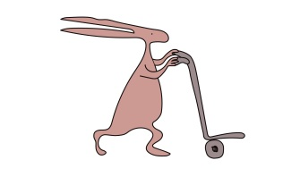
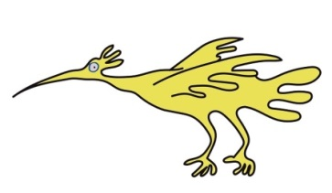

This leaflet only gives general information. You must always discuss the individual treatment of your child with the appropriate member of staff. Do not rely on this leaflet alone for information about your child’s treatment.

This information can be made available in other languages and formats if requested.

Alder Hey Children’s NHS Foundation Trust
Alder Hey
Eaton Road
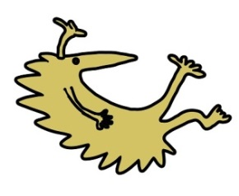
Liverpool
L12 2AP

Tel: 0151 228 4811
www.alderhey.nhs.uk

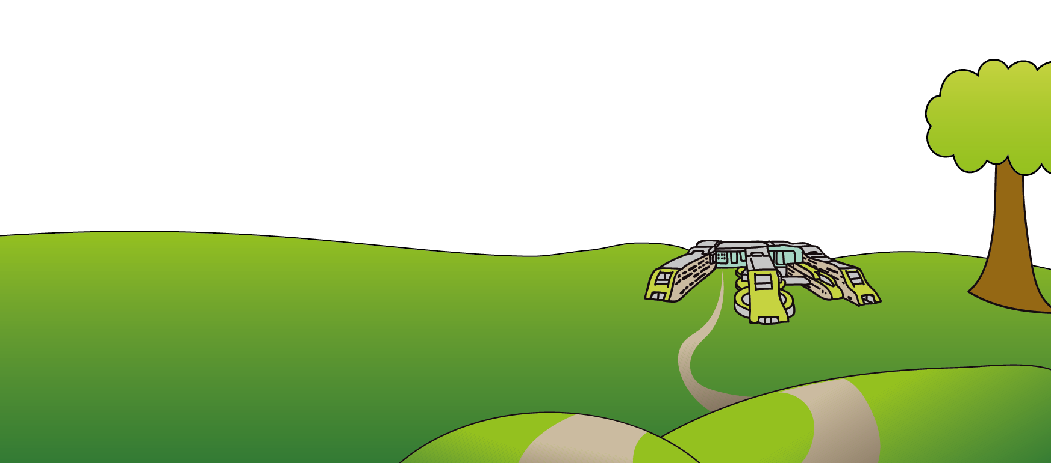
© Alder Hey Review Date: Jan 2028 PIAG: 356

