


Physiotherapy Department – Oncology Unit

Chemotherapy Induced Peripheral Neuropathy (CIPN)

Information for parents

Introduction

The leaflet is aimed at providing parents and carers with information about a condition called chemotherapy induced peripheral neuropathy (CIPN).

What causes this condition?

Some of the chemotherapy drugs can sometimes damage nerves around the body. This is known as chemotherapy induced peripheral neuropathy. Peripheral nerves are those outside the brain and spinal cord. It is more common to get problems in the extremities i.e. hands and feet.

What are the signs and symptoms of CIPN?


- Pain described as shooting / stabbing / burning
- Tingling or pins and needles
- Loss of feeling or numbness
- Constipation
- Muscle weakness
- Change in voice or swallow
- Change in walking pattern
- Difficulty picking up objects
What treatment(s) are available?

- Your child may be referred to physiotherapy / occupational therapy / orthotics
- The physiotherapist will look at muscle strength and mobility and may recommend an exercise / activity programme
- The occupational therapist will look at functional tasks and recommend any activities/advise on equipment
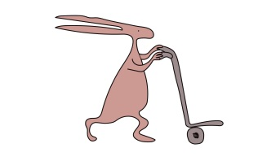
- The orthotics team or gait lab may advise on footwear / insoles if required to help with walking
- Medication may be required for pain relief
- Chemotherapy dose may be reduced in certain cases
What can patients with CIPN do for themselves?

- Report any problems early to your oncology team (even if these problems come and go after chemotherapy)
- If your child has altered sensation be careful with temperature of the bath
- Still try and keep as active as possible
- Heel walking can be a good exercise to practice
- Even if your child is on bed rest they can do activities such as popping bubbles / kicking a balloon with their hands and feet
- If your child is too young to do specific exercises play activities can be used to help keep them active
Who to contact for further information or support?
This leaflet only gives general information. You must always discuss the individual treatment of your child with the appropriate member of staff. Do not rely on this leaflet alone for information about your child’s treatment.
This information can be made available in other languages and formats if requested.

Alder Hey Children’s NHS Foundation Trust
Alder Hey
Eaton Road
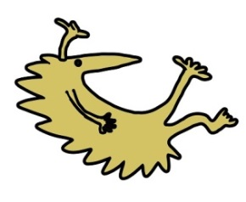
Liverpool
L12 2AP


Tel: 0151 228 4811
www.alderhey.nhs.uk

© Alder Hey Review Date: May 2027 PIAG: 0037

