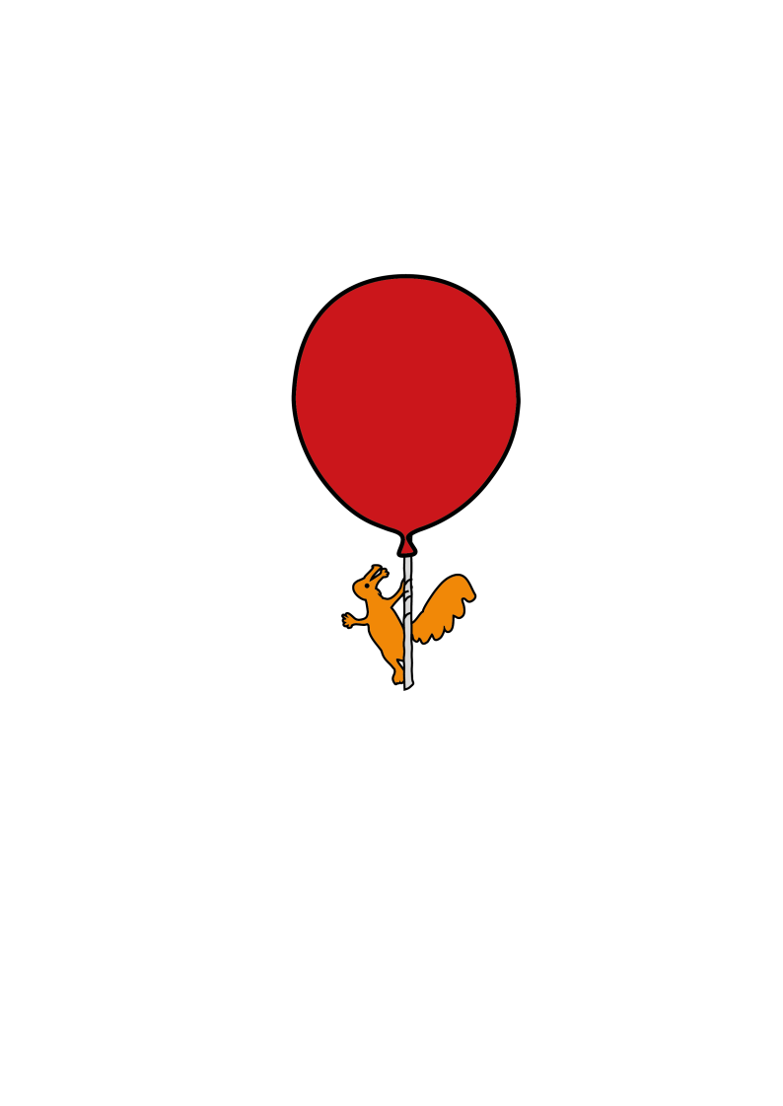

Outpatient Parenteral Antimicrobial Team (OPAT)

**Caring for your child’s long line at home**

Information for parents and carers

**What is a long line?**

If your child needs intravenous (IV) antibiotic treatment for more than 2 or 3 days then the OPAT (Outpatient Parenteral Antimicrobial Therapy) team will discuss putting in a long line. A long line is a very thin, long, flexible tube which is threaded into a vein. Long lines can last much longer than cannulas. Putting in a long line in is very similar to a cannula but can take a little longer, and the same types of pain relief are available.



Photograph showing long line in place

**Looking after the long line at home**

It is very important that the long line and dressing stays clean and dry as this will prevent infection, so just bathe your child in a shallow bath and cover the dressing/bandage to protect from splashes. If the dressing does become wet – dry it with a clean towel.

Do not take your child swimming until the line comes out.

It is best if the line can remain covered, clothes with long sleeves are good for this and can help prevent a long line getting caught or pulled.

**Signs of Infection**

The nurse (or the parent/carer if they are administering IVs) will look at your child’s long line before each dose. In between this you should watch out for possible signs of infection – these include

* Temperature (hot)
* Pain, heat or redness around the entry point of the line or up the arm

**What happens if the long line comes out or I think it’s moved?**

If the long line bleeds when it comes out then apply pressure for 30 seconds – 1 minute and put a plaster on. Call the OPAT team or your community nurse. If you lose the line or think it’s moved overnight you can wait until the morning to inform anyone.

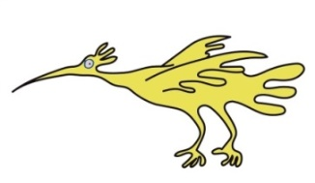The nurse will contact OPAT team who will make a decision about:

* Reviewing or replacing the line (you would need to come to hospital for this)

or

* to change your child’s treatment from IV to oral antibiotics. .

You can discuss with your nurse or the OPAT nurse about whether you wish to use a local hospital or return to Alder Hey where an OPAT nurse will be able to put in a new long line if needed.

**Can my child attend school or nursery?**

If they are well enough this should be fine. Check with your school/nursery first – some schools may want to know a little bit about caring for the long line. We are happy to talk to the school with your permission – you or your nurse can contact the OPAT team to do this. Your child can take part in most normal activities at school or nursery, however they should avoid vigorous exercising and contact sports, such as rugby, hockey and water play at nursery.

**Who to contact for help or further information**

The OPAT nurses can be contacted between 08.30am-4pm Monday - Friday for advice and replacement of lines

0151 228 4811 ex 3251

If you can’t contact the OPAT team call 0151 228 4811 and ask switch to bleep the IV/OPAT team for you.

Outside of these hours contact your community nurse/ local children’s unit.

If you are administering IVAB to your child then contact your local A&E who can arrange to review your child.

This leaflet only gives general information. You must always discuss the individual treatment of your child with the appropriate member of staff. Do not rely on this leaflet alone for information about your child’s treatment.

This information can be made available in other languages and formats if requested.

Alder Hey Children’s NHS Foundation Trust

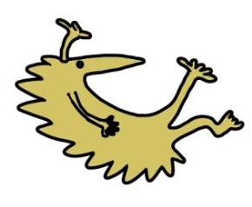Alder Hey

****Eaton Road

Liverpool

L12 2AP

Tel: 0151 228 4811

[www.alderhey.nhs.uk](http://www.alderhey.nhs.uk)

**© Alder Hey Review Date: August 2028 PIAG: 08**