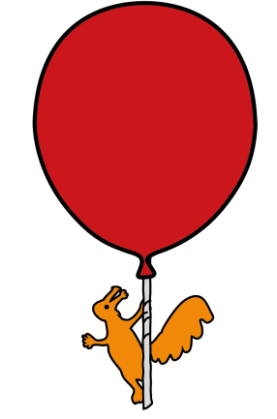


Urology Department

Suprapubic Catheter

Information for parents and carers

Introduction

You have been advised that your child needs to have a suprapubic catheter. This leaflet aims to support the discussion you had with the Doctor and to enable you to make an informed decision.

What is a suprapubic catheter?

A suprapubic catheter is a thin, plastic tube used to drain urine from the bladder. When the catheter is first inserted your child will need a general anaesthetic. Whilst they are under anaesthetic the catheter will be inserted through a small incision (cut) in your child’s abdomen (tummy). The catheter is held in place inside the bladder by a balloon filled with water.

What are the benefits of my child having a suprapubic catheter?

A suprapubic catheter is usually used when a child is having difficulty emptying their bladder. The suprapubic catheter does not stop your child voiding (weeing) normally, if they can do so. A suprapubic catheter is easily reversible. If it is no longer needed, it can be removed easily and the hole will quickly heal. Your child can swim, go to school and continue their normal sporting activities as long as the catheter is well secured.

Will the suprapubic catheter hurt my child?

Your child will be under anaesthetic whilst the suprapubic catheter is inserted. They should be given regular pain relief following surgery and until they are fully recovered. The catheter entry site can be sore for approximately one week after the operation. If the pain does not improve or gets worse you should contact the Urology Nurses at Alder Hey for advice (see telephone numbers at the bottom of the leaflet) for advice.

Are there any alternatives to this procedure?

Your child may be able to use clean intermittent catheterisation as a way of emptying the bladder of urine if weeing is difficult or impossible. It involves passing a catheter (thin, plastic tube) through the urethra (wee tube) into the bladder. Medication may also sometimes help the bladder empty better in some cases.

There are other more permanent surgical options to help with bladder emptying. You should discuss alternatives with your child’s doctor/nurse

What will happen if I decide my child will not have a suprapubic catheter?

Your Doctor/Nurse will discuss alternative procedures as indicated above.

How long will this procedure take?

The operation usually takes approximately one hour. Your child will be in recovery for approximately one hour. They should be back on the ward between two and three hours.

What should I expect when my child comes back from theatre after having insertion of a
suprapubic catheter?

When your child comes back from theatre the catheter entry site will be covered by a dressing. This should stay in place for one week. Your child’s urology nurse or your local continence or community nurse will then remove it. Arrangements to do this will be organised before your child is discharged. After one week your child can bathe or shower as normal. There is no need for a dressing to be applied. However, if your child prefers they can have a small dry dressing. The catheter may have a stitch securing it to your child’s tummy. This stitch will fall out on it’s own and should not be removed unless it is causing discomfort.

The suprapubic catheter will be attached to a large (overnight) drainage bag. This is to ensure that the catheter is draining. The drainage bag should be left in place for 48 hours following surgery. After this your child’s doctor/nurse will advise you how often the catheter should be drained. The urine draining from the suprapubic catheter may be blood stained at first. This is normal and will settle after the first few days.

How long will my child be in hospital?
Your child will usually be admitted to the Surgical Daycase Unit. Some children may need to stay overnight. Your doctor will give you inform you how long your child is likely to stay in hospital. You will be taught how to care for your child’s suprapubic catheter before they are discharged home. Your child will be discharged once they are eating and drinking normally, their catheter is draining and your child is comfortable on painkillers taken by mouth.

What are the risks of my child having a suprapubic catheter?

- Risks associated with a general anaesthetic
Please see separate information leaflets entitled “Consent for general anaesthesia information for parents and carers” and “General anaesthetic discharge information”.

- Bladder spasms
A suprapubic catheter can irritate the bladder and this may cause spasms. Your child may complain of cramping pains in their tummy or pain in their bottom. They may also complain of the need to pass urine (wee) through their urethra (wee tube). Medication can be given to help these spasms so please inform the urology nurses if you think your child is having bladder spasms. It is also important to check that the catheter is in the correct position, as spasms can occur when the catheter is too far into the bladder

- Urinary tract infection (UTI)
All children who have a catheter in place will have a small amount of bacteria in their urine. Antibiotic treatment is only prescribed if your child becomes unwell with symptoms of urinary tract infection.

Symptoms of urinary tract infection include:

- Offensive smelling urine
- Cloudy urine
- Lethargy (tiredness)
- Nausea (feeling sick)
- Loss of appetite
- Temperature

If your child has any of these symptoms it is important to seek medical advice as soon as possible.
A sample of urine must be taken before antibiotic treatment is started. Encouraging your child to drink lots of fluids can help prevent urinary tract infections by reducing the amount of bacteria in the urine. Good hygiene, including thorough hand washing before touching catheter, is also important. If your child is using a catheter drainage bag this should be changed every five to seven days according to manufacturers guidelines.

If your child has recurrent urinary tract infections an ultrasound of the bladder may be requested.

- The catheter may become blocked or fall out.
If your child’s catheter falls out put a clean towel or other clean absorbent material over the catheter site and go to your nearest Emergency department as soon as possible. If the catheter cannot be easily replaced your child may need a general anaesthetic to have a new catheter inserted.

Your child should avoid riding a bicycle or straddling toys as the catheter may become tangled.

- Overgranulation or infection of catheter site
Overgranulation is an overgrowth of tissue around the suprapubic catheter. It is a common problem. Healthy overgranulation looks like a pink coloured, moist, cauliflower structure. Sometimes the overgranulation may bleed. It does not necessarily need treatment unless there are signs of infection. Symptoms of infection include redness, pain and discharge. You should contact your Urology Nurse to check if treatment is necessary. Securing the catheter to the body can reduce friction and this can help prevent overgranulation. The catheter should be secured to the body in a way that is comfortable, helps with drainage and stops the catheter being pulled. Your child’s Urology Nurse will show you how to do this correctly.
Once the suprapubic catheter site has healed dressings are not necessary unless there is an infection or discharge. Your child should be encouraged to wash around the catheter site with mild soap and water as part of their daily washing routine. Antiseptic or soap with perfume should not be used. A shower is better than a bath.
- Blockage of the catheter.
The catheter may become blocked. Flushing may clear the blockage but sometimes it may need to be replaced. You will be shown how to flush your child’s catheter before they are discharged. You should always ensure that the catheter is not allowed to kink. If your child uses a catheter drainage bag this should always be at a position that is below bladder level. Please encourage your child to drink plenty of fluids. This helps to keep the urine draining and reduces the risk of an infection developing.

Caring for the suprapubic catheter at home

Before your child is discharged you will be supplied with enough equipment to last for one week. Your child’s Urology Nurse will arrange home delivery of further equipment. The delivery company will contact your GP for a prescription. You should contact the delivery company for further supplies approximately one week before you run out. Contact details will be supplied with the first delivery. Some GP’s may prefer that you obtain further supplies from your local pharmacy.

Equipment needed includes:

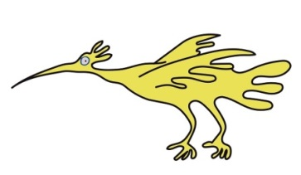
- Tape to secure catheter
- Urine collection bag
- Flip flow valve
- Alcohol pads for cleaning catheter
- Gauze
- Saline (sterile salt water)
- 60ml syringe with catheter tip

Important points to remember

- Keep the catheter taped securely to your child’s abdomen (tummy) so it does not get accidently pulled. The tape should be replaced if it becomes loose or dirty.

- Keep the catheter as straight as possible to prevent kinking and blockage of catheter.

- If your child’s catheter is draining into a bag the bag should be kept below waist level (to encourage drainage) and off the floor (to prevent infection and catheter being accidently being pulled out). Leg bags, which can be secured to leg beneath trousers or skirt, can help. The bag should be emptied before it is ¾ full or at least 4 times per day so you can observe that the catheter is draining.

- If your child is using a flip flow valve for drainage your child’s urology nurse will inform you how often this should be done. Your child may need a catheter bag for overnight drainage.

To empty the catheter bag or flip flow valve

- Wash your hands with liquid hand soap and dry on kitchen towel

- Stand or sit your child near the toilet.

- Clean the valve at the bottom of the drainage bag with alcohol pad. If using a flip flow valve clean the opening of the valve.

- Open the valve at the bottom of the bag. If using a flip flow valve move the clamp to the open position.

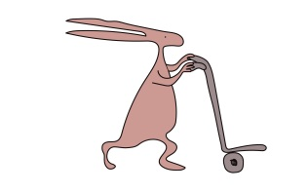
- Drain the urine from the bag or flip flow valve into the toilet

- Close the valve

- Clean the valve with an alcohol pad

Changing the collection bag or flip flow valve

You should do this once a week, or if the bag becomes disconnected. You will need: A new collection bag and/or flip flow valve. Alcohol pads. A clean towel.

- Wash your hands with liquid soap and dry with kitchen towel.

- Open the packet containing the new collection bag or flip flow valve and put it on a surface cleaned with an alcohol pad.

- If applicable remove tape securing catheter to body.

- Put a clean towel under the catheter.

- Gently bend the catheter over to stop urine leaking.

- Gently twist the tube of the old bag or flip flow valve and remove from the catheter.

- Clean the end of the catheter with an alcohol pad.

- Remove the protective cap from the new collection bag. Attach the new collecting bag or flip flow valve without touching the part going into the catheter.

- Straighten the catheter and re-secure. Ensure the flip flow valve is in the off position.

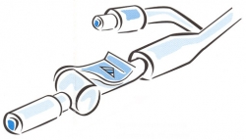
Diagram showing Flip flow valve with Clamp in off position

Flushing the suprapubic catheter

You will be shown how to flush your child’s catheter before discharge. You should flush the catheter if it is not draining or if it appears to be blocked. You should only flush regularly if you have been advised to do so by your child’s doctor or urology nurse.

You will need: A 60ml syringe with catheter tip. Alcohol pads. Saline (sterile salt water). Gallipot
- Collect the equipment and put it on a surface cleaned with an alcohol pad.
- Wash your hands with liquid soap and dry on kitchen towel.
- Remove the gallipot from the package.
- Open the saline packet and empty it into the gallipot.
- Remove the syringe from the packet. Put the packet to one side.
- Use the syringe to draw up the saline. Your child’s urology nurse will advise you how much to use. It is usually between 10 and 20mls.

- Place the syringe back in the packet to keep it sterile (free from germs). Do not touch the tip of the syringe or let it touch anything else..

- Put a clean towel under the catheter
- If there is a bag attached to the catheter, remove the bag and clean the catheter with an alcohol pad. If there is a flip flow valve attached clean the end of the valve with an alcohol pad.

- Connect the syringe to flip flow valve or the end of the catheter.
- Unclamp the flip flow valve.
- Gently push on the plunger of the syringe. This will insert the saline into the bladder. Continue until all the fluid is inserted then gently withdraw the plunger of the syringe. If fluid is easily withdrawn then stop. Remove the syringe and clean the end of the catheter with an alcohol pad then re-attached the drainage bag. If using a flip flow valve move the clamp to the off position and clean with an alcohol pad. Your child can then empty their catheter into the toilet.

- If the saline won’t go in do not force it. Instead gently try to withdraw fluid from the catheter by pulling the plunger of the syringe with one hand. If there is any resistance stop.

- If you can’t remove any fluid or urine from the catheter contact your doctor or Urology Nurse as soon as possible.
Discharge information

You should seek advice if:

- Catheter that falls out

- The catheter becomes blocked and you are unable to unblock the catheter with flushing. If the catheter is blocked no urine or very little urine is draining from the catheter even though your child is drinking.

- Urine leaking around catheter

- Your child has symptoms of urine infection see list

- Your child complains of stomach ache or their bladder that feels full or painful

- Your child has signs of an infection around the site including redness, swelling or discharge

Further appointment information.

Your child will continue to have regular follow up with their Urology Consultant. If there are any problems in the meantime you may contact the Urology Nurses or your local Continence Nurse.

For further information.

Please contact the Urology Nurses on 0151 252 5852.

This leaflet only gives general information. You must always discuss the individual treatment of your child with the appropriate member of staff. Do not rely on this leaflet alone for information about your child’s treatment.
This information can be made available in other languages and formats if requested.

Alder Hey Children’s NHS Foundation Trust
Alder Hey
Eaton Road
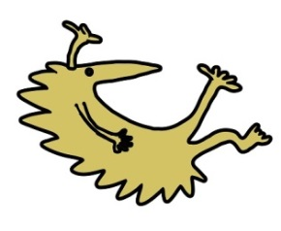
Liverpool
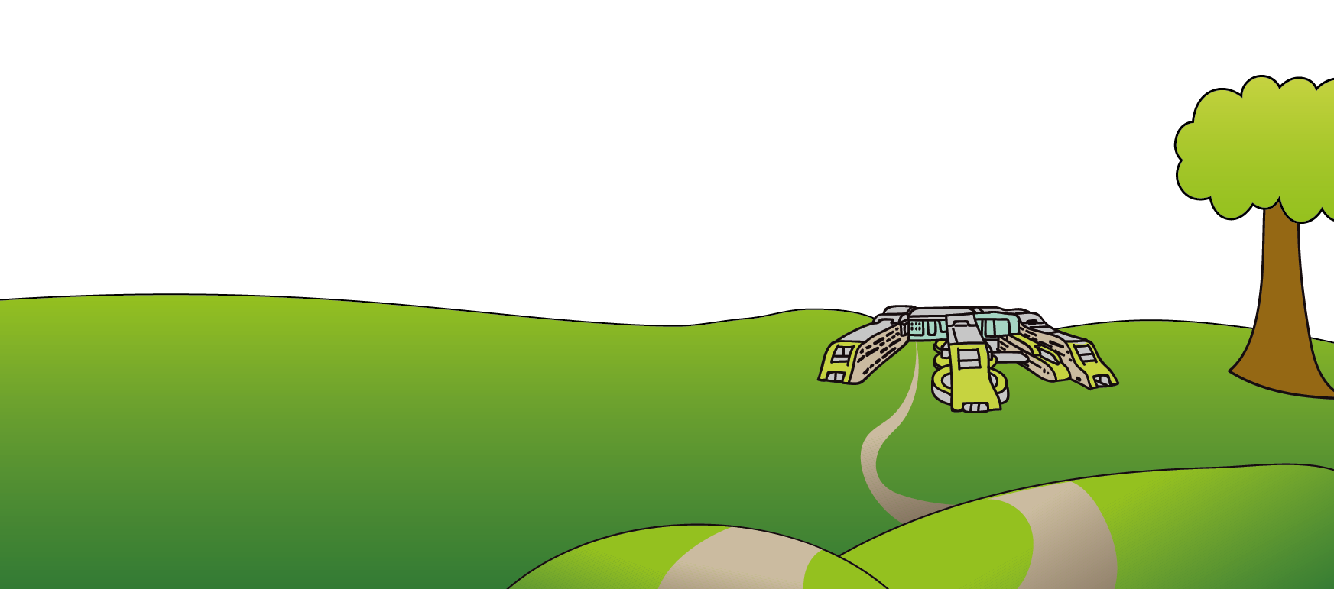
L12 2AP

Tel: 0151 228 4811
www.alderhey.nhs.uk

© Alder Hey Review Date: December 2027 PIAG: 062

