How does my child go to sleep?
If a needle is inserted while your child is awake, some medicine can be given into the needle to make your child sleepy. This normally takes about 10-20 seconds. Alternatively, the Anaesthetist may get your child to breathe in a mixture of gases which will make them sleepy over 30 seconds to a minute.
What happens during the scan?
Once asleep the anaesthetist will escort your child into the MR scan room, ECG leads will be put on your child’s chest and a light rectangular plastic device containing radio frequency coils over these leads. These coils receive the MR signal and send it to the computer to be converted into pictures.
CT scanning also requires the use of ECG leads so the scan can synchronise with the heart rhythm for clear pictures. The Anaesthetist continually observes and monitors your child throughout the procedure, and gives anaesthetic medicines as they are required.
If my child has to have an injection will it hurt?
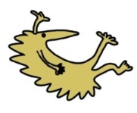
If your child needs a needle to allow medicines and fluids to be given during the scan, it is usually painless, because the anaesthetic cream applied during your assessment numbs the skin over the vein after 45 mins.

What happens after the scan?
When the scan is finished your child will recover in our recovery area, you will be called from the waiting room or ward to be with them. It usually takes around 10 mins for children to wake up but they may remain drowsy for some time afterwards. You will then accompany them back to the SDC (Surgical Day Care) or Ward 1C to recover fully. Please be prepared to wait on the ward for between 2-4 hrs until your child is fully recovered and able to eat and drink.
Your child will then be discharged home by a doctor or a nurse. Some children, usually those with more complex conditions or other health problems, will need to stay in hospital longer or overnight. If this is the case the anaesthetist or other doctors will explain the reason for this.
This leaflet only gives general information. You must always discuss the individual treatment of your child with the appropriate member of staff. Do not rely on this leaflet alone for information about your child’s treatment. This information can be made available in other languages and formats if requested.

Alder Hey Children’s NHS Foundation Trust
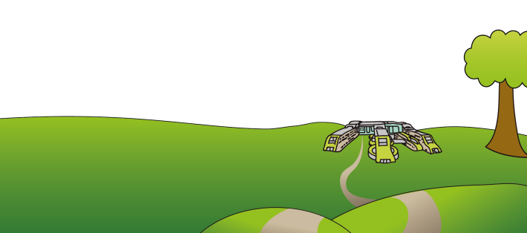
Eaton Road
Liverpool
L12 2AP
Tel: 0151 228 4811
www.alderhey.nhs.uk
© Alder Hey
Review Date: January 2028 PIAG: 236


Radiology Department
Cardiac MRI and CT scan under General Anaesthetic


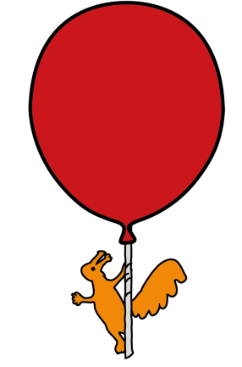

Information for parents
and carers

Cardiac MRI and CT scan under General Anaesthetic

Introduction
This leaflet has been designed to give parents and carers as much information as possible about their child’s visit to Alder Hey for a cardiac Magnetic Resonance Imaging (MRI) and Computerised Tomography (CT) scans under general anaesthetic.
MRI is a way of looking inside the body without using x-rays. It is a very safe imaging method with no known side effects. It uses a super-conducting magnet which produces a very strong magnetic field. MRI scanning can acquire images from almost every angle with the patient lying supine.
For safety reasons, you are asked to remove all metallic objects (Hearing aids, clips, jewellery etc) before an MRI scan. It is also important that we are aware of any metal inside your child’s body (surgical clips, pacemakers etc). If your child is having an MRI scan, please complete the safety checklist which accompanies this leaflet, and bring it with you when you come for your scan.
CT uses several beams of X-ray at the same time, from different angles, to give a detailed picture of the inside of the body. CT is very quick but does deliver a dose of radiation. Soft tissue detail is much clearer on MRI than on a CT scan. Occasionally it is not possible to obtain all the information required from either type of scan alone.

If this is the case we will move the child from one scan room to the other whilst still asleep
Why is a general anaesthetic needed?
Cardiac MRI takes between 60-90 mins, during this your child needs to lie very still and be able to control their breathing. This means being able to hold their breath for periods of time so the heart and blood vessels remain in the same place whilst the scans are being acquired. Children above the age of 10yrs can usually achieve this, but younger children need an anaesthetic.
Cardiac CT is much quicker but your child must be able to hold their breath as the heart and blood vessels need to be in the same place for the scan, so the anaesthetic will be much shorter.
Before your appointment
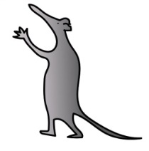
Your child will not be able to eat or drink for a number of hours before their anaesthetic. Your appointment letter contains fasting instructions. Fasting reduces the risk of vomiting during and after the procedure, which can cause severe and long term lung damage. If your child is on any essential medication, this should be taken as normal (with a sip of water, if necessary) on the day of your child’s scan.

What happens on arrival?
You should attend either ward 1C or the Radiology Department, as instructed on your letter Here you will be prepared for the anaesthetic and your child will be weighed, observations recorded and local anaesthetic cream applied if required. You will be seen by the Anaesthetist who will be looking after your child during the scan, who will explain the procedure and get your consent.
Waiting with your child
We encourage you to bring along your child’s favourite toy / activity to help them relax. You may be in the hospital for several hours. We do our best to avoid long waiting times, but there are some delays which cannot be avoided. Scans can take longer than expected, or emergency cases sometimes need to be added to the list at short notice. You will be kept informed of any delays. Two parents / carers can stay with your child in the ward, but there is only room for one parent in the anaesthetic room with your child. As soon as your child is asleep, you will be asked to return to the ward.
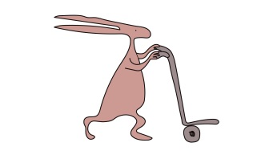
Two parents / carers will be called to the recovery area as soon as your child has woken up.

