Care of the boots and bar

- It is your responsibility to bring the device to the orthotics department for any relevant repairs or reviews as and when necessary in-between review appointments.

- Also check that the screws on the bar are all tight, if they are not, contact the department as the position of the boots or bar may have changed and will need to be corrected.

What issues do I need to be aware of?

- Some marking of the skin is normal, as is a build-up of some hard skin. Provided this is not excessive or painful and discolouration clears, this is nothing to worry about. Sometimes they can lead to sores, blisters, pain or rubbing, if any of this arises, STOP WEARING THE BOOTS AND BAR and contact the department. You can also provide photos via the Orthotics email address.

Contact us

If you have any problems or questions please contact a member of
the team who will be happy to discuss them with you.

Telephone: 0151 252 5318
Email: orthotics@alderhey.nhs.uk

This leaflet only provides general information. You must always discuss the individual treatment with the appropriate staff member.
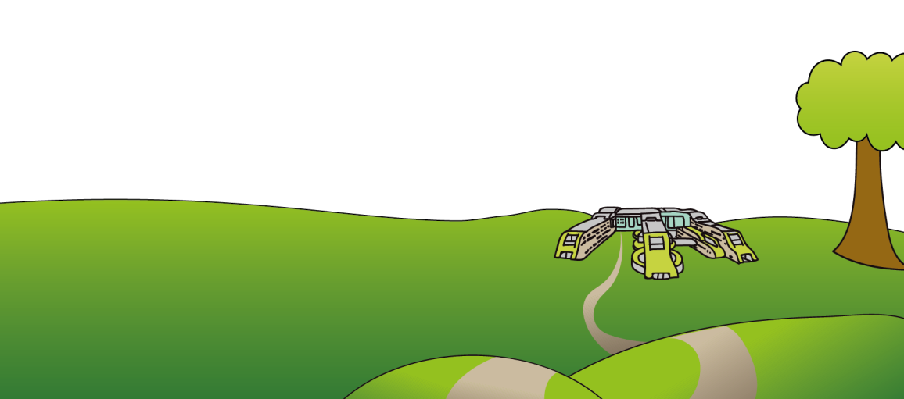
Do not rely on this leaflet alone for information about the treatment. This information can be made available in other languages and formats if requested

Alder Hey Children’s NHS Foundation Trust
Eaton Road
Liverpool
L12 2AP

Tel: 0151 228 4811
www.alderhey.nhs.uk
© Alder Hey Review Date: July 2027 PIAG: 95


Orthotics Department

Boots and Bar
Ponseti Treatment

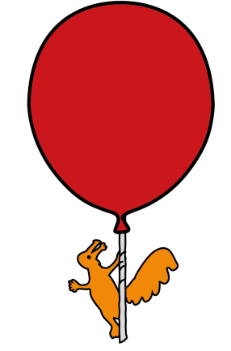

Information for
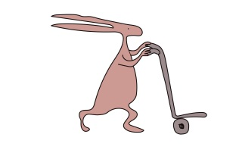
patients, parents and carers

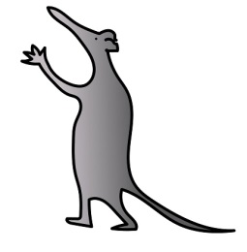
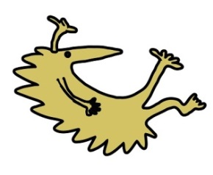

What is the Ponseti treatment? What is it for?
What do the boots and bars do?

- The Ponseti treatment is to treat a child with Talipes (Club foot). Club foot is when the foot points down, inwards and the sole of the foot faces backwards. It consists of manipulation of the child’s feet alongside a period of plaster casting to correct the position of the feet.

- Some children require a tenotomy which is a small procedure to lengthen the tendon to allow the foot to achieve the correct position.

- Following this procedure and once your consultant is happy with the foot position, you will be referred to the Orthotics department to be fitted with a foot abduction brace (boots and bar).

- These are to hold the feet in the position achieved via casting and help to prevent them relapsing back their original position. They also help to stop the ligaments and muscles becoming tight again.

- The boots are held in the required position by the bar itself. The boots are set to the required angle based of whether one foot or two feet are affected. The bar MUST be worn with the boots for the boots to have effect.

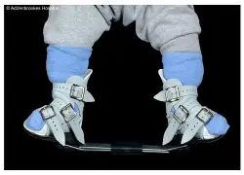
How are the boots and bar fitted, and wearing the boots and bar.

- The boots and bar will be fit by one of our trained Orthotists in clinic who will advise you on proper fitting of the device.

- Please attend clinic with socks for your child as the boots must be worn with socks at all times to prevent damage to your child’s feet.

- The Orthotist will ensure the bar is the correct length based off your child’s shoulder width. The bar and size of the boots needs to be checked and adjusted as necessary at every check-up, so please bring the bar, as well as the boots, to EVERY review appointment.

- The boots should be removed every 3-5 hours for the first week to prevent the development of skin pressure sores.

- You will be advised of when and how long they need to be worn for, however standard practise is 23 hours a day for the first 12 weeks. This may then be reduced to night time and nap time, which will continue until advised by your Consultant. (usually around 5 years of age)

- During the hour out of the boots, it is important to check your child’s feet. You can also prevent relapse by using this hour to soak their feet in a warm bath then follow this with massaging their feet. You know your child better than anybody and you are likely to be the first to become aware of any issues, including a tightening of muscles, tendons etc. If you do become aware of any issues, contact the department or A&E if outside of clinic hours.

- To fit the boots and bar, take the bar out of the boots. Bend your child’s knee and hold their foot by their toes and forefoot and place the heel into the back of the boot first. Then hold the foot in the boot whilst you do up the straps. Whilst you don’t want the straps to cause pain, they do need to be tight enough to hold the feet in the boots. There is a viewing hole at the heel for you to check that the heel has remained at the back and bottom of the boot. If it has not, you will have to take them off, and start again. Once both boots are on correctly, clip the bar into them.

