
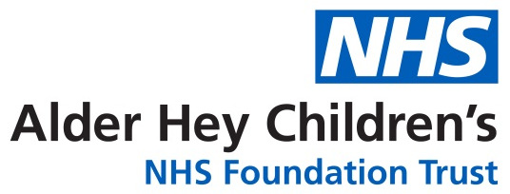

Anaesthetic Pre-Op Service

Consultant-Led Clinic Appointment

Information for parents and carers

Introduction

This leaflet provides information about the Anaesthetic Pre-Op Clinic and what to expect when you and your child or young person attend. The appointment allows you and the team to discuss their planned admission ahead of surgery.

What will happen at this Pre-Op Clinic appointment?

The consultant anaesthetist will meet with you and your child or young person to review their medical history and gather any other necessary information before admission. You’ll be asked about any regular medications, such as inhalers, creams, or eye drops. Blood pressure, height, and weight will be checked before the consultation.

You’ll also receive information about any tests or investigations needed before or after surgery, along with leaflets on preparing for surgery, the procedure itself, and the anaesthetic process. We’ll begin planning your child or young person’s recovery to ensure any necessary equipment or supplies are arranged in advance.

How long will the Pre- Op clinic appointment last?

The appointment could take up to 60 minutes. To avoid any delays on the day of operation / procedure and reduce the risk of cancellation your child or young person may need to attend other departments for further investigations. Please allow up to three hours for your visit.

What further tests and investigations may my child need?

Your child may require tests / investigations in other areas of our hospital for example:

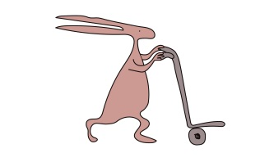
- Blood tests
- MRSA Screening
- X-Ray
- Ultrasound
- ECG/ Echocardiogram

Where do we need to go for our appointment?

The Pre-Op Clinic takes place within the outpatients department at Alder Hey Hospital. On arrival please report to the self-check in screens located within the main atrium on the ground floor. Once you have completed the self-check in you will then be directed to the specific area within out-patients where your appointment will take place.

What do I need to bring with me?

Please bring any medications your child or young person is currently taking, including inhalers, as well as their red book if available. If they are under the care of other specialties at hospitals outside Alder Hey, please bring copies of their most recent clinic letters.

What should we do if we cannot attend the appointment?

If the appointment date or time is not convenient, please contact the Pre-Op Service on
0151 252 5845 and another appointment will be arranged.

Please note: If you do not attend the Pre-Op Clinic appointment your child’s admission could be delayed or even cancelled.

If my child or young person is worried about being admitted can you offer help?

Yes, we can arrange for a Play Specialist or other team members to help prepare your child or young person for their admission.

Who can I contact for information?

Your admission letter will advise you who to contact if you have any problems with your admission time and date. For other Medication / Anaesthetic queries please contact the Pre-Op Office on:

Telephone: 0151 252 5845
Between the hours of 8am – 6pm
Monday to Friday.

Car Parking

There is a multi-storey car park located at the East Prescot Road entrance. There is no longer a ticketing system in place. A token will be provided on entrance to the car park and payment can be made at the designated pay machine located in the main atrium near to the entrance of the car park.

This leaflet only gives general information. You must always discuss the individual treatment of your child with the appropriate member of staff. Do not rely on this leaflet alone for information about your child’s treatment.
This information can be made available in other languages and formats if requested.

Alder Hey Children’s NHS Foundation Trust
Alder Hey
Eaton Road

Liverpool
L12 2AP

Tel: 0151 228 4811
www.alderhey.nhs.uk

SAT Nav Code: L14 5AB

© Alder Hey Reviewed Date: June 2026 PIAG: 182

