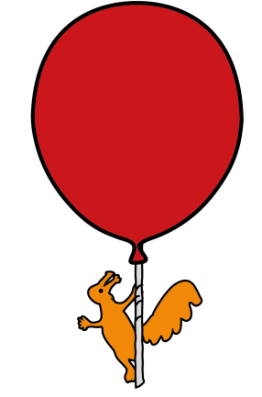


Department of Pharmacy
Amiloride 5mg Tablets
Amiloride 5mg / 5ml Oral Solution
Information for parents and carers

Why is it important for my child to take this medicine?
Amiloride belongs to a group of medicines called diuretics (water tablets); more specifically it is a ‘potassium-sparing’ diuretic. It is important that your child takes amiloride regularly as prescribed by the doctor as it helps to control the amount of fluid (and potassium) kept in the body to help conditions such as heart failure, high blood pressure and respiratory problems.
What is Amiloride available as?
Amiloride is available as 5mg tablets and a 5mg in 5ml oral solution.
When should I give Amiloride ?
You will usually give your child amiloride twice each day, morning and bedtime. This however may change and depends upon what the medication is treating.
Your doctor will tell you when to give each dose of the medication and this will be printed on the pharmacy label on the bottle or the tablet packet.
How much should I give?
Your doctor will work out the amount of amiloride (the dose) that is right for your child. The dose and frequency (how often it is to be given) will be shown on the medicine label.
How should I give it?
If using tablets, they should be swallowed whole with a glass of water or juice. If using the liquid, measure out the correct amount of liquid using a medicine spoon or oral syringe. Oral syringes given out by Alder Hey will be marked with the correct dose. Do not use a kitchen teaspoon as it will not give the right amount.
When should the medicine start working?
The medicine should start working within a few days. Your child may not feel any different by taking this medication, but the doctor will know if it is working by completing regular checks. Therefore it is important to attend clinics with your child when on this medication.
What if my child is sick (vomits)?
If your child is sick less than 30 minutes after having a dose of amiloride, give them the

same dose again.

If your child is sick more than 30 minutes after having a dose of amiloride, you do
not need to give them another dose. Wait until the next normal dose.

What if I forget to give it?
For TWICE-daily dosage:
If you miss a dose and remember up to 4 hours after you should have given a dose, give your child the missed dose. For example, if you usually give a dose at about 7am, you can give the missed dose at any time up to 11am. If you remember after that time, do not give the missed dose. Wait until the next normal dose.
What if I give too much?
If you think you have given your child too much amiloride, contact your doctor or phone 111. If you telephone for advice, have the medicine container with you as the information on the label will be useful.
Are there any possible side effects?
Like all medicines, amiloride can cause side effects, although not everybody gets them.
The most common side effects include: abdominal pain, feeling sick, constipations, mild skin rashes and some confusion.
Rare side effects include: hair loss, headache, dizziness, muscle cramps, difficulty sleeping.
Please tell your doctor if your child experiences any of these side effects and they will advise you what to do.
STOP giving your child Amiloride and seek medical help immediately if they have any of the following reactions:
Signs of an allergic reaction: difficulty breathing or swallowing, swelling of the face, lips, tongue or throat, severe itching of the skin with a red rash or raised lumps.
Can other medicines be given at the same time as Amiloride?
Tell your doctor / pharmacist if your child is taking any other medication, including over the counter medicines.
You can give your child medicines that contain paracetamol or ibuprofen, unless your doctor has told you not to.
Is there anything else I need to know about this medicine?

Amiloride is often given at the same time as other diuretics (water tablets).
Where should I keep this medicine?
Keep out of reach and sight of children
General advice about medicines
• Only give this medicine to your child. Never give it to anyone else, even if their condition appears to be the same, as this could do harm.
• If you think someone else may have taken the medicine by accident, contact your doctor straight away.
• Make sure that you always have enough medicine. Order a new prescription at least 2 weeks before you will run out.
• Make sure that the medicine you have at home has not reached the ‘best before’ or ‘use by’ date on the packaging. Give old medicines to your pharmacist to dispose of.
• This leaflet should be read with any manufacturers’ patient information. You must always discuss individual treatment with the appropriate member of staff.
How do I get further supplies of Amiloride?

Amiloride tablets and oral solution should be available from most pharmacies. You will need to request a prescription from your doctor in plenty of time before your supply of medication runs out.

Who to contact for further details
If you have any questions about your medication whilst you are in hospital, please do not hesitate to ask one of the Pharmacy Team, alternatively you can telephone us on 0151 252 5311.

This leaflet only gives general information. You must always discuss the individual treatment of your child with the appropriate member of staff. Do not rely on this leaflet alone for information about your child’s treatment.
This information can be made available in other languages and formats if requested.

Alder Hey Children’s NHS Foundation Trust
Alder Hey
Eaton Road
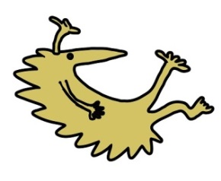
Liverpool
L12 2AP
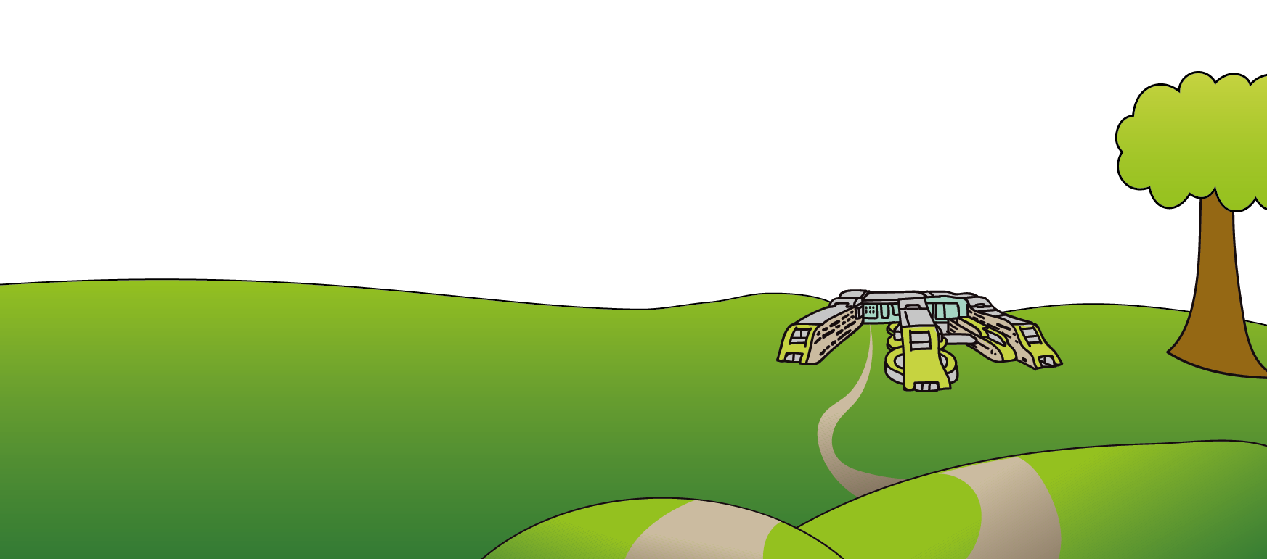
Tel: 0151 228 4811
www.alderhey.nhs.uk

© Alder Hey Review Date: January 2028 PIAG: M8

