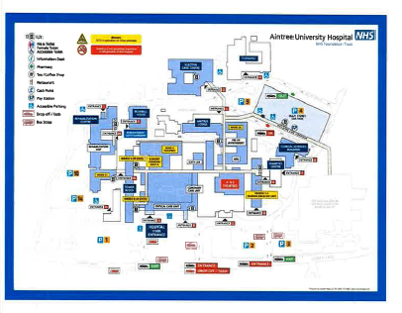

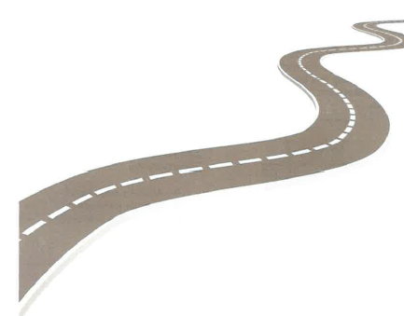

Aintree Hospital Address:
Aintree University Hospital NHS Foundation Trust
Aintree University Hospital, Longmoor Lane, Liverpool L9 7AL

Main Hospital Switchboard: 0151 525 5980
Aintree Hospital Website: www.aintreehospitals.nhs.uk

This information can be made available in other languages and formats if requested.
Alder Hey Children’s NHS Foundation Trust
Eaton Road, Liverpool L12 2AP

Tel: 0151 228 4811
www.alderhey.nhs.uk

© Alder Hey
Review Date: July 2026
PIAG: 170


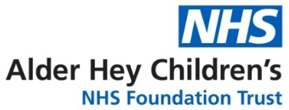

Craniofacial Team
Aintree University Hospital Craniofacial Service

Information for patients

Aintree University Hospital

The team will now refer you over to Aintree Hospital where you will have any further appointments or procedures you may require.

Alder Hey Children’s Hospital Aintree University Hospital
Pre-op Appointments:

You will attend a pre-op appointment with your surgeon (the same surgeon you see at Alder Hey) around 3 weeks before your surgery. This appointment will consist of taking your height, weight, blood pressure and a swab for MRSA.

You will also meet a link nurse, who will look after you during your stay at Aintree. This link nurse will be able to show you around the ward and answer and questions you many have.

Consenting for your surgery:
Before you have surgery at Aintree you will be asked to sign a consent form. Your parents would have done this on your behalf before any surgery you had at Alder Hey. A consent form is to ensure that:

- You have been told everything you need to know about your surgery.

- You are happy for the surgery to take place.

Where can my family stay whilst I’m at Aintree?
There are several hotels nearby if you want your family to stay nearby during your visit.
These include:
- Aintree Lodge Hotel
- Premier Inn Aintree
- Travelodge Stonedale Park

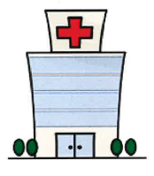

Maxillofacial Ward

The Maxillofacial ward is where you will be staying during your visit to Aintree Hospital: A medical word meaning anything to do with the head, face, jaw and neck.

Staff on the Maxillofacial Ward:
When you arrive on the ward, you will be met by staff nurses who will plan for your care during your stay.
The ward staff and Cleft Team are available to talk if you have any worries or concerns about your stay on the ward. There will be a link nurse at your pre-op appointment, who you can also speak to.

Other patients on the ward:
There may be patients who are recovering from surgery. Others may have come via Accident & Emergency, with problems including tonsillitis, ear infections, nose bleeds and fractures of the jaw/cheekbone.

Visiting Hours:
The specific visiting hours for the Maxillofacial Ward are:
- 2.30pm-4.00pm
- 6.00pm-7.00pm
Facilities at Aintree
Aintree Lodge entrance:
- Main hospital dining room serving hot and cold food (Monday-Friday 9:30am-2:15pm)
- Costa Coffee (Monday-Friday 7:30am-8:30pm and Saturday-Sunday 8:00am-8:00pm)
Car Parking:
Aintree Hospital’s multi-storey car park, located at the Aintree Lodge entrance, consists of 1,250 spaces for Blue Badge holders.

Main Hospital entrance:
- Starbucks (Monday-Friday 7:00am-8:00pm and Saturday 9:00am-8:00pm).
- Café Fresh serving wraps, smoothies and salads (Monday-Friday 8:00am-6:00pm).
- Retail shop (Monday-Friday 7:00am-7:45pm and Saturday-Sunday 8:00am-8:00pm).

