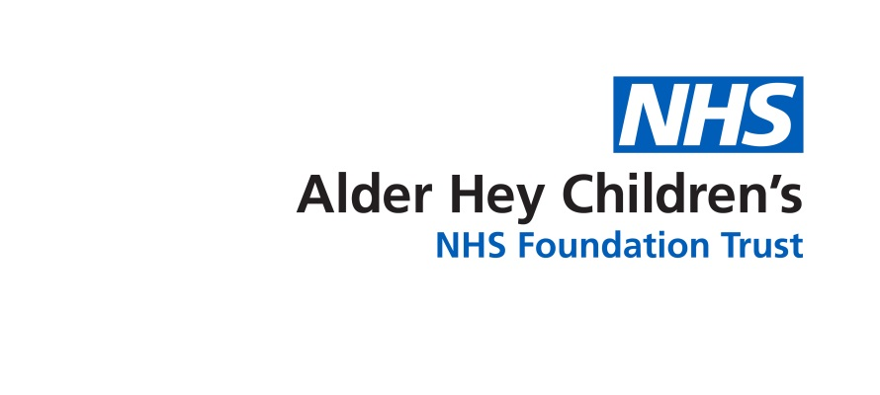

Inherited Bleeding Disorders Team

**After transition with an Inherited Bleeding Disorder**

Information young adults

**Transition to adult services when you have an inherited bleeding disorder**

**You have completed the transition programme in preparation to move to the adult Inherited Bleeding Disorder services. This is a reminder of some phone numbers and what happens next.**

**Contact details adult Inherited Bleeding Disorder services at the Royal Liverpool University Hospital**

**Nurse Specialists for clinical advice**

Direct dial 0151 706 3397 or

Switchboard 0151 706 2000 Bleep 4158

**Haemophilia secretary for appointment queries and alterations**

Direct dial 0151 706 4322

From January 2020 non urgent advice [haemophilia.liverpool@nhs.net](mailto:haemophilia.liverpool@nhs.net)

**Last appointment**

You have attended your last clinic appointment at Alder Hey, and we have informed you that we have almost completed the process of transitioning you to adult services.

You should receive a letter for your first appointment with the adult team three to six months after your last appointment at Alder Hey.

If you cannot attend your appointment with the adult services try to reschedule it.

Once you have been seen in the adult services DO NOT keep your Alder Hey appointment as you have successfully transitioned.

Please only use your Alder Hey back-up appointment if you are unable to attend the adult services for your first appointment.

**I have been transitioned, I have a problem - who do I contact?**

You remain under the care of Alder Hey until you have attended your first appointment with the adult services. If you have any problems or concerns, your points of contact continue to be with the Inherited Bleeding Disorder Nurse Specialists at Alder Hey 0151 252 5070

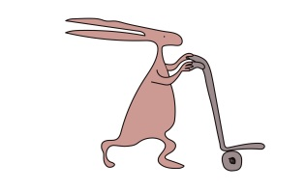Once you have been seen at the Royal Liverpool University Hospital the adult service Inherited Bleeding Disorder Nurse Specialists are your point of contact. Contact details at the top of the page.

.

This leaflet only gives general information. You must always discuss the individual treatment of your child with the appropriate member of staff. Do not rely on this leaflet alone for information about your child’s treatment.

This information can be made available in other languages and formats if requested.

Alder Hey Children’s NHS Foundation Trust

Alder Hey

Eaton Road

****Liverpool

L12 2AP



Tel: 0151 228 4811

[www.alderhey.nhs.uk](http://www.alderhey.nhs.uk)

**© Alder Hey Review Date: 01/02/2028 PIAG: 190**