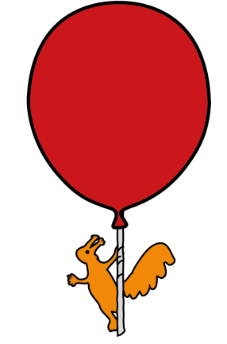
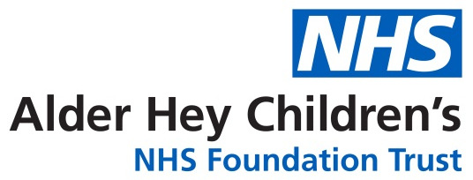
Surgical Day Care Unit
What to do after your child has had a Bronchoscopy under General Anaesthetic
Discharge information for Parents and Carers

Most children appear to be alert and active after they are discharged from hospital. However, do not be surprised if your child complains of feeling dizzy or tired.

For the rest of today
- you should encourage your child to rest
- you should make sure your child’s activities are supervised by a responsible adult
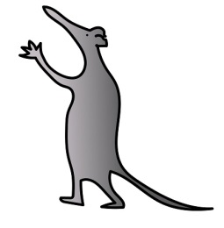
- you should offer the usual feed, fluid and a light diet
- but do not give your child any fizzy drinks
- do not give your child hard to digest foods such as chips, burgers
- do not let your child ride a bike
- do not let your child take part in any outdoor activities

Your child may complain of having a sore throat, hoarseness, cough, fever, muscle ache, or pain following Bronchoscopy under General Anaesthetic. You can give you child paracetamol.
Do not exceed the recommended dosage for your child’s age.

What to do if your child starts to vomit
If your child vomits on the way home or when you get home, do not be alarmed. Do not give your child anything to eat or drink for 1 hour. After that, you can start giving your child a small amount of plain water or juice. Then gradually start to increase the amount of fluid you give to your child. Once your child can keep fluids down, you can begin to give them light food.

What other problems might my child have?
A few children have an uncomfortable or sore throat. You can give your child paracetamol.
Some children will cough for a couple of hours. It should not take long for the coughing to settle. Drinking sips of water or juice can help.

Don’t worry if your child’s voice sounds hoarse. This is common, and their voice will usually be back to normal by the next day.

Sometimes children get a high temperature (fever) soon after bronchoscopy. If they have a high temperature and feel uncomfortable, then you can give paracetamol.

If the high temperature or coughing does not settle or you are concerned that your child is becoming unwell, please seek medical attention from your local healthcare service.

When can my child go back to school or nursery?
Your child should be able to return to usual normal activities the day after bronchoscopy. We would expect school-age children who have had a bronchoscopy to go to school as normal.
Your child should not take part in contact sports, impact sports or swimming if a Long Line has been placed for intravenous antibiotics.

When will I get the results?
The doctor will come and tell you what was seen soon after your child wakes up. Some results from the lavage will be known in a few days, but it can take several weeks for all the results to be known. You will usually be asked to come to a clinic appointment with your regular respiratory doctor to discuss the results.

If you have any concerns, please contact the Surgical Day Care Unit for advice by telephoning:
Monday to Friday, 7.00 am - 7.00 pm, please call the Surgical Day Care Unit: 0151 252 5480

If you have any problems outside of these hours, please contact Ward 3C at Alder Hey
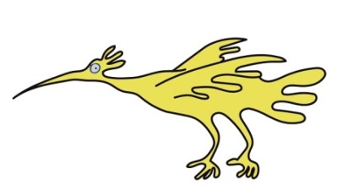
After 7 pm, please call Ward 3C: 0151 228 4811, option 1, ext 3589

This leaflet only gives general information. You must always discuss the individual treatment of your child with the appropriate member of staff. Do not rely on this leaflet alone for information about your child’s treatment.

This information can be made available in other languages and formats if requested.

Alder Hey Children’s NHS Foundation Trust
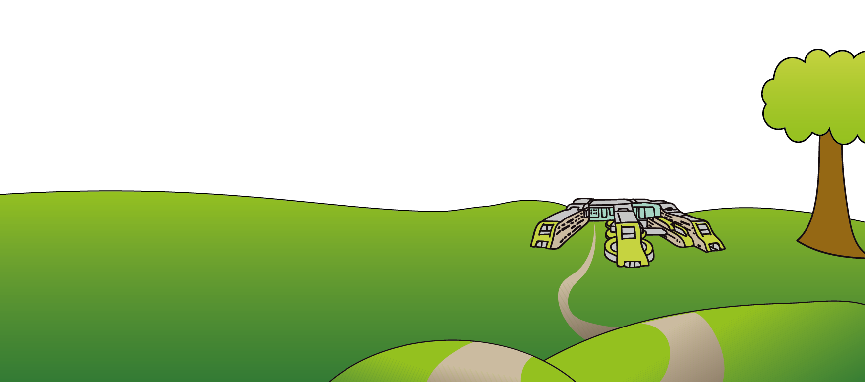
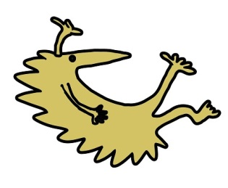
Alder Hey
Eaton Road
Liverpool
L12 2AP

Tel: 0151 228 4811
www.alderhey.nhs.uk

© Alder Hey Review Date: July 2028 PIAG: 169

