Care of the Device
- Regularly clean the device with mild soap and water, towel dry and keep away from direct heat sources i.e. radiator as the material will distort.

- It is your responsibility to bring the device to the orthotics department for repairs as and when necessary in-between review appointments which must be requested by yourself at least every 6 months.

- Do NOT attempt any repairs yourself.

What issues do I need to be aware of?
- Some marking of the skin is normal, as is a build-up of some hard skin. Provided this is not excessive, painful and discolouration clears, this is nothing to worry about. If it is any of the above, or your child’s condition changes or they begin to outgrow the device, contact the department.

- Sometimes the devices can lead to sores, blisters, pain or rubbing, if any of this arises, contact the department.

- The skin should not come into contact with the BK iron side steels, if it does, contact the department.

Contact us

If you have any problems or questions, please contact a member of
the team who will be happy to discuss them with you.

Telephone: 0151 252 5318
Email: orthotics@alderhey.nhs.uk

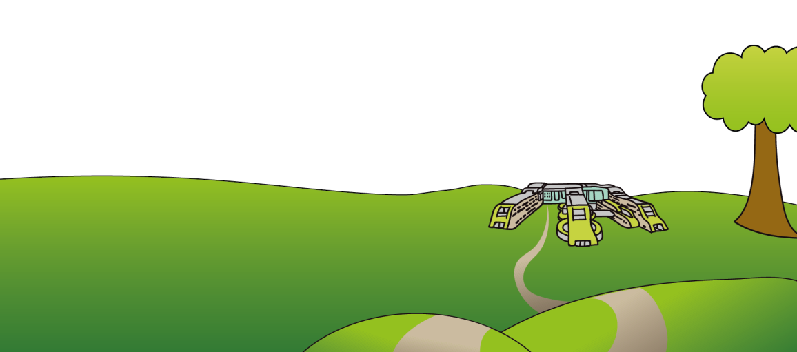
This leaflet only provides general information. You must always discuss the individual treatment with the appropriate staff member. Do not rely on this leaflet alone for information about the treatment. This information can be made available in other languages and formats if requested

Alder Hey Children’s NHS Foundation Trust
Eaton Road
Liverpool
L12 2AP

Tel: 0151 228 4811
www.alderhey.nhs.uk
© Alder Hey Review Date: August 2027 PIAG: 152


Orthotics Department

AFOs, KAFOs
and BK Irons
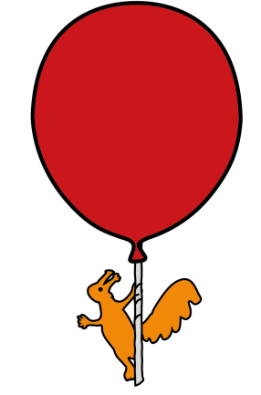

Information for
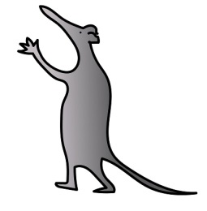
Patients, parents and carers

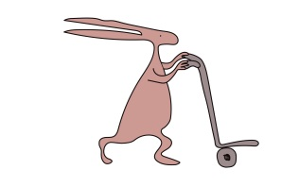
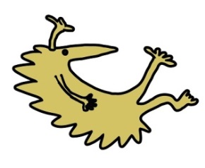

What are Ankle Foot Orthoses (AFO), Knee Ankle Foot Orthoses (KAFO) and Below Knee (BK) Irons and what is my child entitled to?
- AFO = a device, usually covering the back of the leg, around the ankle and under the foot.

- KAFO = a device, usually made of plastic in 2 sections. 1 fits around the back of lower leg and under the foot, the other straps around the thigh. The sections are connected by metal side steels. They may also be made of metal and leather and connect into sockets added to your shoes.

- BK Irons = a device usually made of a calf strap and metal side steels, that may or may not have joints, that fit into sockets added to your footwear. They are designed to:
1) Control, realign and protect the limb and/or feet.
2) limit or stop abnormal or painful motion or support a weakened limb
3) accommodate, prevent or slow down progression of deformity
4) help control abnormal muscle tone or spasticity
5) improve your childs gait (walking pattern)

• It is specifically designed for its wearers condition and problem.
This is why it is important that if your child’s condition or limb changes, you must contact the Orthotics department immediately. Also only your child must wear the device, another wearer may injure themselves or damage the device.

- Due to the regular changes and growing in children, your child will be provided with one device (or one pair if both legs are affected) at a time. A second will be provided if the original device is deemed beyond repair or no longer clinically effective by the Orthotist or the Technician within the department.

How are they fitted and wearing the device
- The device will be fit by one of our trained Orthotists in clinic

- Please attend clinic with appropriate footwear that fastens rather than slips on. It is advisable to attend with a few different styles of footwear but to not purchase new footwear until you have the device.

- The Orthotist will advise you on how to properly fit your Childs device, but when putting the device on ensure the heel is right at the back and down into the bottom of the device and the straps should be pulled tight enough to ensure the foot does not move around within the device, but not too tight so that they cause discomfort.

- On a KAFO, the knee joints should be approximately level with the middle of the wearers knee cap.

- When fitting BK irons, it is usually easiest to connect the bars to the footwear and then put both side steels on and then do the calf strap.

- The Orthotist will advise you of when and how long the device needs to be worn for.

What footwear does my child need to wear?

- Your child should always wear footwear whilst wearing their device to prevent falls.

- The most appropriate footwear for an AFO or KAFO is usually a larger size than what your child measures and should have fastenings i.e., Velcro or lace to improve control.

- A lower opening i.e. a lower tongue, the easier it will be to get the device into the shoe.

- A shoe with a removable insole also provide extra depth to accommodate the device.

- For BK irons, the shoe must have a firm and solid sole unit, i.e. trainers with air pockets in the soles are not suitable.

