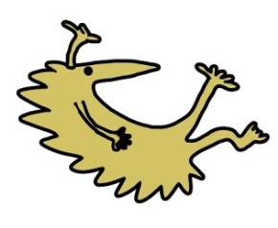**How to contact the Service**

ADHD / ASD Team

Formby Clinic

Philips Lane

Formby

L37 4AY

**Tel: 01704 395720/ 07814299025**

**Our Webpage:**<https://alderhey.nhs.uk/services/sefton-adhdasd-childrens-service> 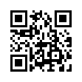

**Patient Advice and Liaison Service for Alder Hey (PALS)**

Tel: 0151 252 5161

**Complaints Team**

Tel: 0151 252 5374

This leaflet only gives general information. You must always discuss the individual treatment of your child with the appropriate member of staff. Do not rely on this leaflet alone for information about your child’s treatment.

This information can be made available in other languages and formats if requested.

Alder Hey Children’s NHS Foundation Trust

Eaton Road

Liverpool

L12 2AP

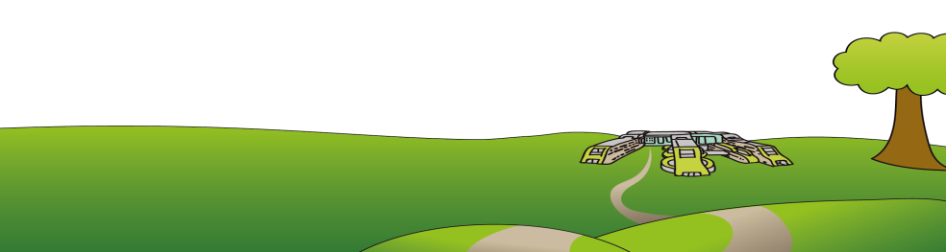Tel: 0151 228 4811 [www.alderhey.nhs.uk](http://www.alderhey.nhs.uk)

**© Alder Hey**

**Review Date: March 2028 PIAG: 175**

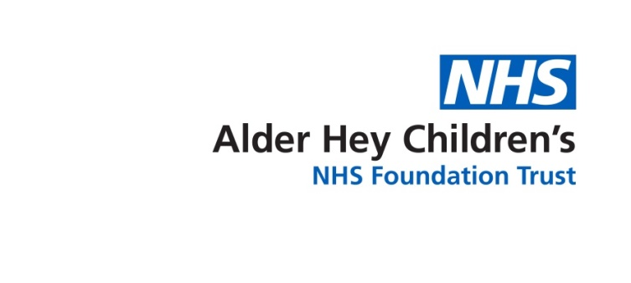

**Attention Deficit Hyperactivity Disorder (ADHD)**

**Autistic Spectrum Disorder (ASD)**

**Children’s Service in Sefton**

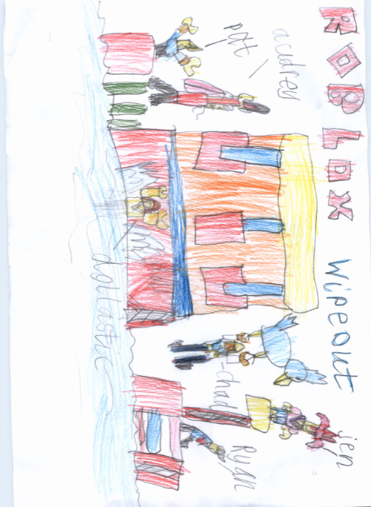 **Information for Parents and Carers**

**What is Autism?**

Autism is a lifelong condition that affects how people communicate and interact with others.

Autism affects people in different ways but most autistic people see, hear and experience the world differently from people without autism.

It is estimated about 1 in every 100 people in the UK is autistic. More boys and men are diagnosed with autism than girls and women, but it is now thought older girls and women may manage their condition differently and are therefore under diagnosed.

Although there is no “cure” for autism, with the right support many autistic people live fulfilled and active lives.

**What is Attention Deficit Hyperactivity Disorder (ADHD)?**

ADHD is an umbrella term which includes Attention Deficit Disorder with Hyperactivity (ADHD) and Attention Deficit Disorder (ADD). Someone with ADHD might have significant attention problems, appear restless, fidgety, overactive and impulsive.

ADHD is a neuro behavioural condition which can result from a number of factors which affect how the brain functions. Studies show that ADHD may affect certain areas of the brain that allow us to solve problems, plan ahead, understand others actions, and control our impulses.

ADHD can be characterised by three areas:

**Attention, Hyperactivity and Impulsivity.**

*(Mental Health Foundation, 2019)*



**What our service provides**

Our Specialist Nurse will offer an initial assessment to discuss the needs of the child or young person. This will be either a telephone consultation or face to face in a clinic setting. If a need for further intervention is identified, one of our Behaviour Support Practitioners will support the child / young person and their family with personalised strategies. This might include behaviour management or help to improve the child’s emotional wellbeing.

**Access criteria**

We only accept referrals for children/YP with a confirmed diagnosis given by an NHS provider and who are registered with a Sefton GP. Parents / carers are required to opt into the Service before an initial assessment is offered. Children / young people not requiring intervention from the Service are discharged and will remain under the care of Universal Services. Once discharged, a new referral is required.

Parents / carers can access the Service again after discharge by contacting the Team by telephone, providing they have had an initial assessment by one of the Specialist Nurses.

**Referral**

Referrals can be made by Services who are working with the child or young person (referral forms upon request).

We will also signpost and refer to other relevant Services both statutory and voluntary, as agreed with the parent / carer / child.

***Please note we are not commissioned to support school issues.***