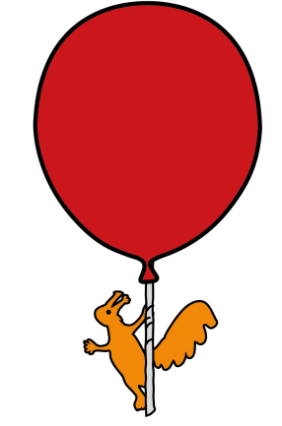


Department of Pharmacy

Acetazolamide for Eye Conditions

Information for parents and carers

What is Acetazolamide and what is it used for?
Acetazolamide is a medicine that can be used for a range of indications, most commonly for glaucoma and other eye conditions¹. Acetazolamide inhibits an enzyme (carbonic anhydrase) in the eye to reduce the production of intra-ocular fluid. By reducing the amount of intra-ocular fluid, the pressure in the eye can be decreased.

Why is it important for my child to use this medicine?
Acetazolamide reduces the pressure within the eyes, which can help to prevent or reduce the risk of damage to the optic nerve in conditions such as glaucoma.

How much should I give?
Always follow the instructions on the label provided by pharmacy on your child’s medication. Your doctor may decide to prescribe the medicine multiple times per day, depending on the requirements of the patient.

How should I give it?
The medicine Acetazolamide is readily available as a 250mg tablet. In exceptional circumstances, if your child cannot take tablets or the dose cannot be easily obtained by using tablets, the Pharmacy Department is able to make a liquid medicine of Acetazolamide.

Always follow the instructions on the Pharmacy label on the box of tablets / bottle. This label will tell you how much medicine to give and how often.

What if I forget to give it?
You should always try to give the dose as soon as remembered. However, if you remember within 2 hours of the next dose, you should skip the dose that was missed and carry on with treatment as normal.²

Are there any possible side effects?

Acetazolamide can cause some side effects. Common side effects can include^{1,3}:
- Loss of appetite
- Headache
- Diarrhoea
- Dizziness / looking flushed
- Tiredness
If you are concerned about any side effect you think your child may be experiencing, please contact your doctor or pharmacist.

How do I store Acetazolamide?
Acetazolamide tablets are stored at room temperature, below 25ºC.
Acetazolamide suspension is stored in a fridge, between 2-8ºC. The suspension only has a 30 day expiry from the date of manufacture, so will require more frequent dispensing.
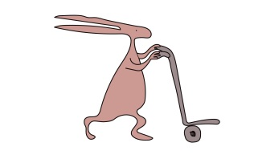
General advice about medicines
• Only give this medicine to your child. Never give it to anyone else, even if their
condition appears to be the same, as this could do harm.

• If you think someone else may have taken the medicine by accident, contact your doctor straight away.

• Make sure that you always have enough medicine. Order a new prescription at least two weeks before you will run out.

• Make sure that the medicine you have at home has not reached the ‘best before’ or ‘use by’ date on the packaging. Give old medicines to your pharmacist to dispose of.

• This leaflet should be read with any manufacturers’ patient information. You must always discuss individual treatment with the appropriate member of staff.

Who to contact for further details
If you have any questions about your child’s medication whilst they are in hospital, please do not hesitate to ask one of the Pharmacy team (on the ward or at the Outpatient Dispensary). Alternatively you can telephone The Pharmacy Department on 0151 252 4811.

References

¹MedicinesComplete. 2017MedicinesComplete. [ONLINE] Available at:
https://www.medicinescomplete.com/mc/bnfc/current/PHP7015-acetazolamide.htm?q=acetazolamide&t=search&ss=text&tot=18&p=1#_hit. [Accessed 24 October 2017].

²Acetazolamide 250mg Tablets – Patient Information Leaflet (PIL) – (eMC) . 2017. Acetazolamide 250mg Tablets – Patient Information Leaflet (PIL) – (eMC) . [ONLINE] Available at https://www.medicines.org.uk/emc/PIL.24589.latest.pdf. [Accessed 07 December 2017].

³Acetazolamide 250mg Tablets - Summary of Product Characteristics (SPC) - (eMC) . 2017. Acetazolamide 250mg Tablets - Summary of Product Characteristics (SPC) - (eMC) . [ONLINE] Available at: https://www.medicines.org.uk/emc/medicine/25572. [Accessed 07 December 2017].


This leaflet only gives general information. You must always discuss the individual treatment of your child with the appropriate member of staff. Do not rely on this leaflet alone for information about your child’s treatment.
This information can be made available in other languages and formats if requested.
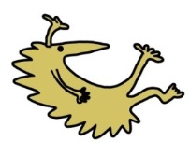
Alder Hey Children’s NHS Foundation Trust
Alder Hey
Eaton Road
Liverpool
L12 2AP

Tel: 0151 228 4811
www.alderhey.nhs.uk

© Alder Hey Review Date: May 2027 PIAG: M7

